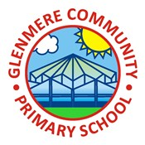
Year 2 Geography Knowledge Organiser Autumn 1
Would you prefer to live in a hot or cold place?

 | Key Vocabulary
atlas | a book that shows a variety of different maps. .
compass | A tool for finding direction
globe | a model of the Earth that shows what it looks like from space
tropical | means places near the equator
desert | A desert is a place that has very little rainfall
polar | Near the North and South poles
Knowledge

Locational Knowledge – Where are the continents?
- A continent is a very large area of land, made up of smaller countries
- The Earth is roughly a sphere but has to be ‘flattened’ so we can see it in atlases and on maps
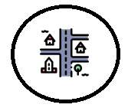 | Human & Physical Geography - Where is the coldest place on earth?  The North and South Poles, which are known as the polar regions  The Arctic Ocean is mostly covered by ice throughout the year

Human & Physical Geography - Where is the equator?

Sunlight hits the Earth most directly at the Equator so it feels very hot

The Equator runs through these continents; South America, Africa and Asia.

Place Knowledge - What is life like in a hot place?

Kenya has three types of climate: desert in the North and East, tropical along the coast and temperate in the mountains.

On arid land, it is difficult for farmers to raise animals or grow crops.
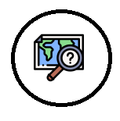 | Geographical Skills & Fieldwork – Do we live in a hot or cold place?  Places in the north usually have a slightly colder climate than the south because they are slightly further away from the Equator and closer to the North Pole.  The UK is approximately halfway between the Equator and the North Pole.

Place knowledge – Would you prefer to live in a hot or cold place?

Countries closest to the North Pole are Canada, Greenland and Russia.

Countries closest to the South Pole are, South Africa, Chile, Argentina, New Zealand and Australia.

There are 13 countries including Brazil, Kenya and Uganda on or near to the equator

