Marking and Feedback

Policy

2023
Approved by:  S Conlon |  | Date: 20.01.2022
Last reviewed on: | December 2023
Next review due: | December 2024

Our policy is underpinned by the evidence of best practice from the Education Endowment Foundation (EEF) and other expert organisations. The EEF research shows that effective feedback should:
  - Redirect or refocus either the teacher’s or the learner’s actions to achieve a goal
  - Be specific, accurate and clear
  - Encourage and support further effort
  - Be given sparingly so that it is meaningful
  - Put the onus on students to correct their own mistakes, rather than providing correct answers for them
  - Alert the teacher to misconceptions, so that the teacher can address these in subsequent lessons.
Notably, the (DfE) Department for Education’s research into teacher workload has highlighted written marking as a key contributing factor to workload. As such we have investigated alternatives to written marking which can provide effective feedback in line with the EEF’s recommendations, and those of the DfE’s expert group which emphasises that marking should be: Meaningful, manageable and motivating. We have also taken note of the advice provided by the NCETM (National Centre for Excellence in Teaching Mathematics) that the most important activity for teachers is the teaching itself, supported by the design and preparation of lessons.
Key Principles
Our policy on feedback has at its core a number of principles:
- The sole purpose of feedback should be to further children’s learning;
- Evidence of feedback is incidental to the process; we do not provide additional evidence for external verification;
- Feedback should enable children to take responsibility for improving their own work. Adults should not take this responsibility away by doing the hard-thinking for the pupil.
- Written comments should only be used as a last resort for the very few children who otherwise are unable to locate their own errors, even after guided modelling by the teacher.
- Children should receive feedback either within the lesson itself or in the next appropriate lesson. The ‘next step’ is usually the next lesson.
- Feedback is a part of the school’s wider assessment processes which aim to provide an appropriate level of challenge to pupils in lessons, allowing them to make good progress.
Within these principles, our aim is to make use of the good practice approaches outlined by the EEF toolkit to ensure that children are provided with well-timed and purposeful feedback that expands their learning, and that teachers are able to gather feedback and assessments that enable them to adjust their teaching both within and across a sequence of lessons.

Our School Learning Definition:
“Learning is the process of acquiring new knowledge and skills and having them readily available in our memory so that we can make sense of future problems and opportunities that we are faced with.”

All lessons will encourage children to consider the knowledge, skills and understanding that they are learning.
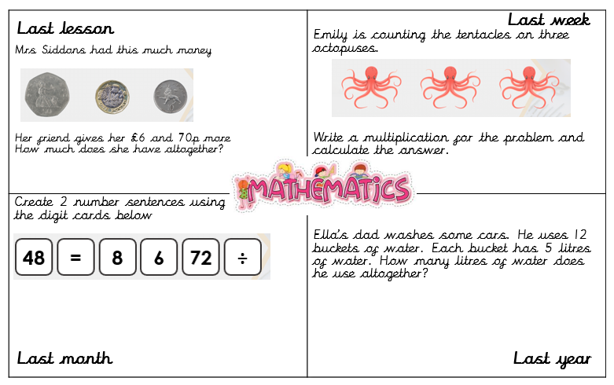
Either fast 4 grids or fast 2 grids will be used at the beginning of each lesson as a means of making knowledge ‘stick’. Children will be given “1 minute, 1 box” and then the teacher will go through each box with the children allowing them to “tick it or fix it”.

Introduction to learning
Each piece of work will begin with a learning objective including ‘We are learning to...’ for the lesson. Each subject will start with the following:
- English – as authors, we are learning to…
- VIPERS – as readers, we are learning to…
- Science – as scientists, we are learning to…
- History – as historians, we are learning to…
- Geography – as geographers, we are learning to…
- Art – as artists, we are learning to…
- Design Technology – as designers, we are learning to…
- Computing and ICR – as computer scientists, we are learning to…
- Music – as musicians, we are learning to…
- Spanish – as a linguist, we are learning to…
- RE – our question for learning is…
- PSHE – we are learning to…
This way the children will recognise that we want them to become experts in these subjects.
Examples of these learning slips can be found in the ‘Expectations for Books Across the Curriculum 2023’

Opportunity for Challenge
In lessons, there will be further challenge throughout the lesson in the form of mini challenges or deeper thinking questions so that those who have the potential to achieve Greater Depth Standard are not left waiting to begin activities.
Pupil articulation of learning
Children should be able to answer the following questions which will be displayed in each classroom and referred to in every lesson:
- What am I learning in this lesson?
- What skills or knowledge am I learning in this lesson?
- Why am I learning this (what is the final outcome) and how will it help me?
- How will I know that I have been successful in this learning?
- Where am I on the learning journey and how can I get to the next stage?
Teachers should evaluate and reflect on their lessons using the questions:
- Is there any learning going on?
- Is the learning appropriate?
- Is the learning sufficient?
- Is the learning engaging?
- What are the adults doing to help learning in the classroom?
- What is the school doing to help/hinder learning in the classroom?
Providing Feedback to pupils
At Glenmere Primary, we believe that pupils make the most gains in lessons when feedback is immediate and misconceptions are addressed at the point of learning. Therefore, we have adopted an ‘In the Moment’ feedback approach.
Throughout independent learning stages of a lesson, the class teacher and learning support staff will use their time to support and guide individuals or groups of pupils as errors occur or further challenge is required. This may lead to fluidity in ability groupings within lessons so that the needs of all children are met.
Rapid and responsive interventions may also be used and could be delivered by teachers or support staff. These may take the form of a pre-teach, in-lesson intervention and/or a post-lesson intervention.
Marking may take place at this time too – showing the children the successes they have achieved and giving extra direction to support or extend learners.

Making Sure that Learning Sticks
To ensure that children are able to apply what they have learned, to make sure that learning sticks and to assess knowledge and skills, a range of strategies will be used. In English, there will be a ‘hot write’ at the end of each unit. In maths there will be a unit assessment from White Rose printed onto blue paper and stuck into books. In the Broader curriculum books a double page spread will be used at the end of a topic. (in KS1 this will begin in the spring term)
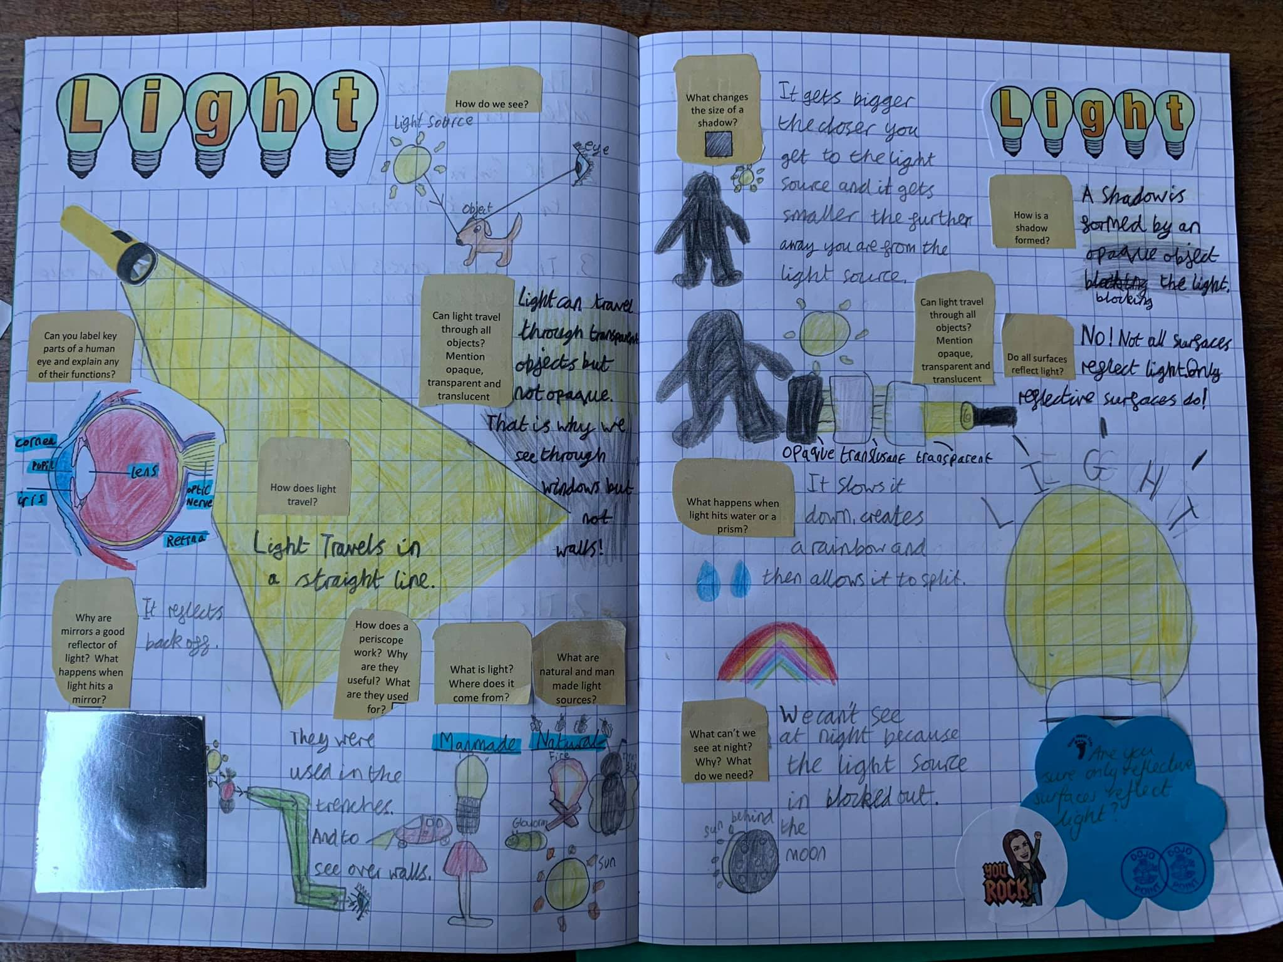
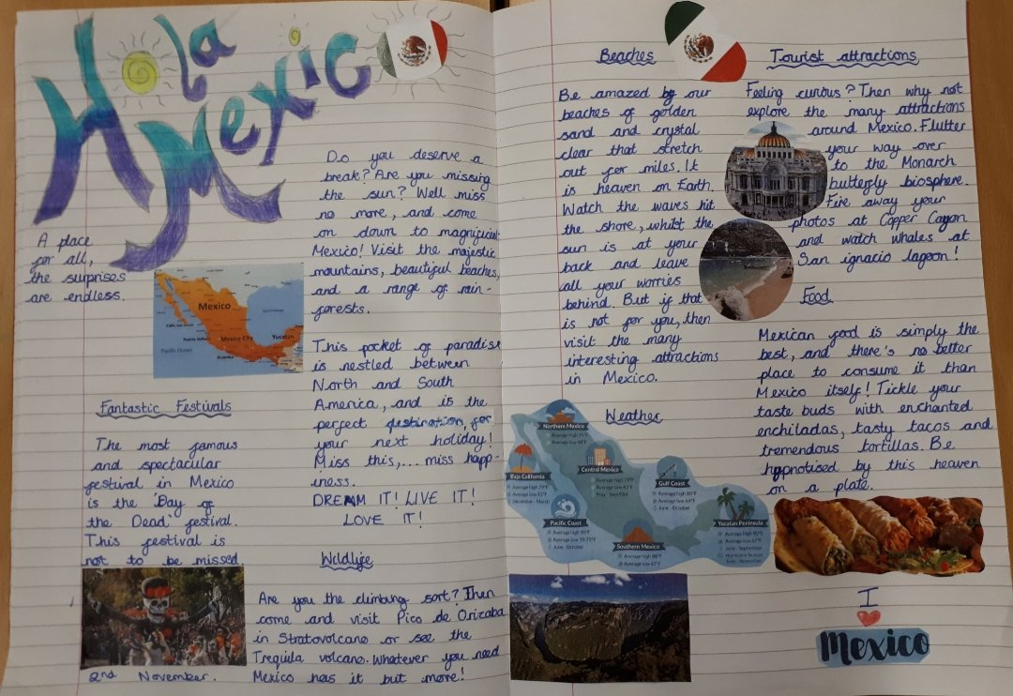

Marking
At Glenmere Primary School all work will be marked, however, due to ‘in the moment feedback’ that has been given, there is no expectation for written feedback in books beyond ‘in the moment feedback’. A lengthy next step comment is not necessary as misconceptions will be addressed in the next lesson.
However, basic skills errors must be marked and children should be given time to polish their work using their purple polishing pen. In addition, regular written praise to highlight significant achievements should also be included in all books to help children identify when they are making significant gains in their learning.
Teachers are required to identify the successes and areas for development using the agreed procedure:
- Teacher writes in green pen and successes are shared in this colour
- Children’s corrections and/or reflections are written in purple pen (polishing pens)
- Pink pen is used by adults for all incorrect answers, misconceptions and/or basic skills errors to develop. (pink to make you think)
In addition, class reward systems should be used where necessary to indicate where a child has worked very hard indeed and has shown great progress within a lesson.

Examples of meaningful marking
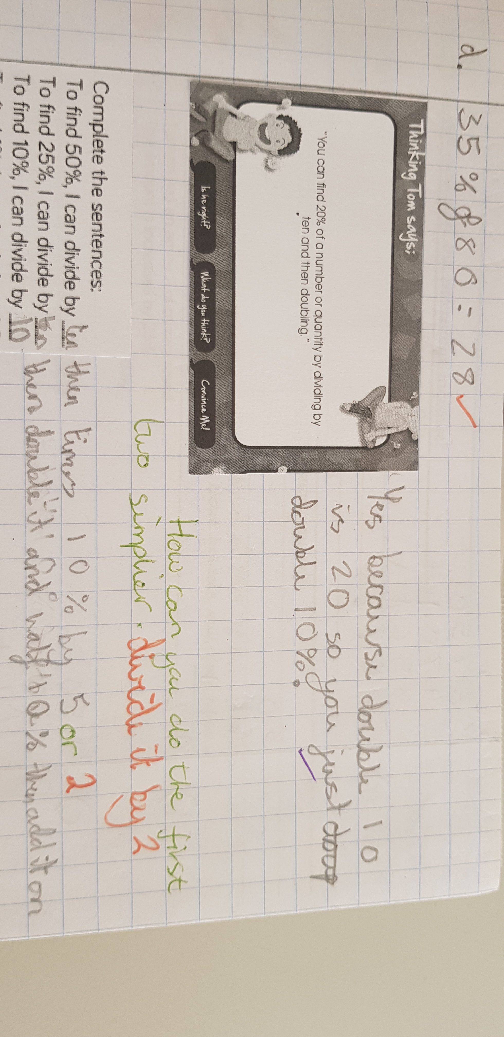

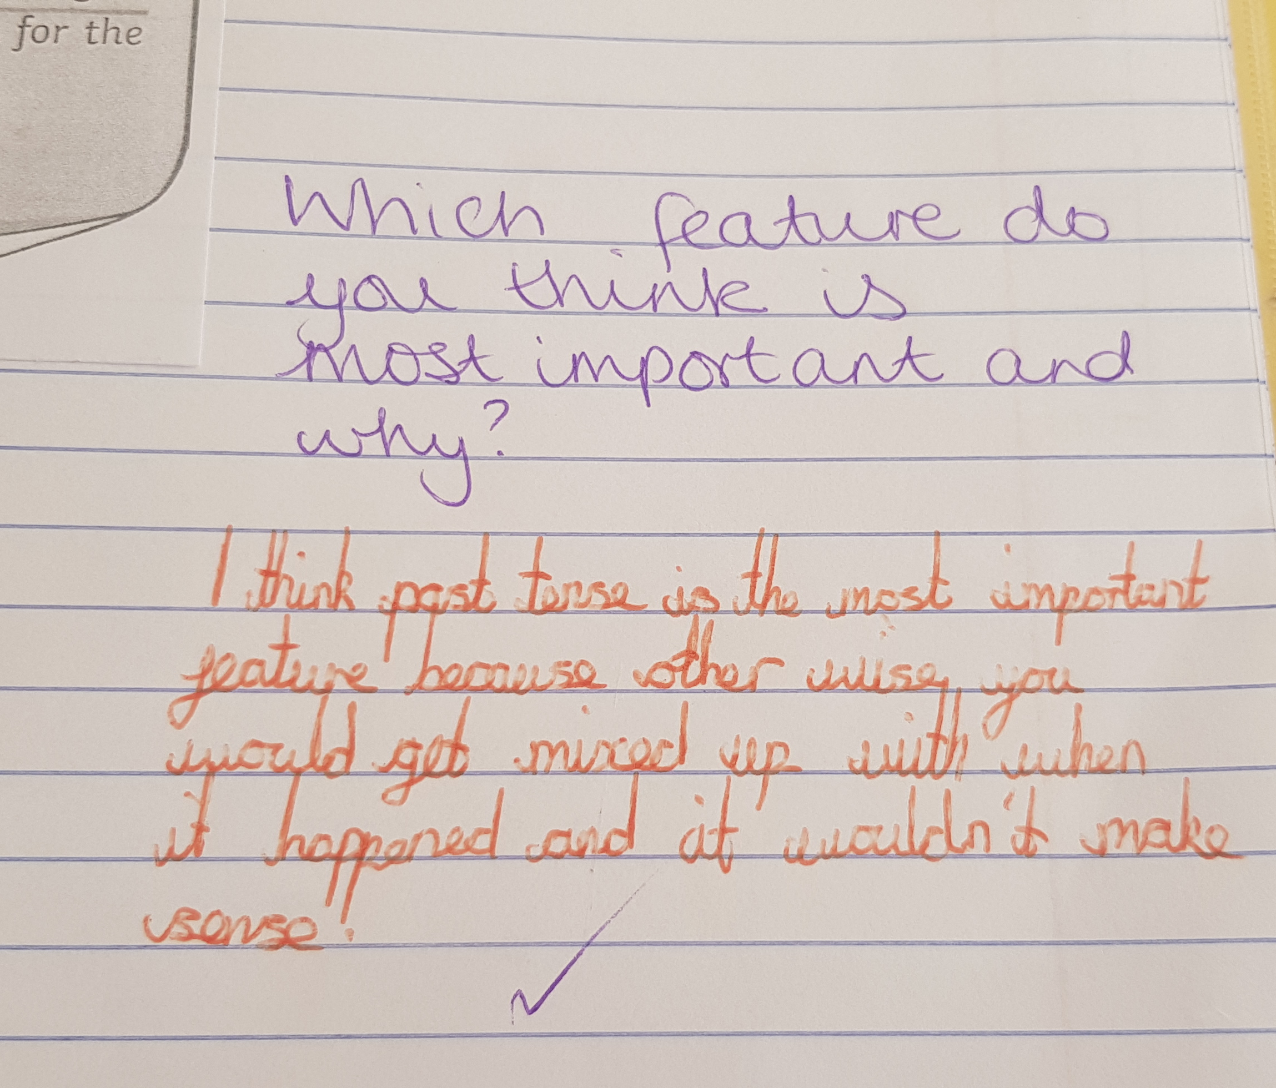
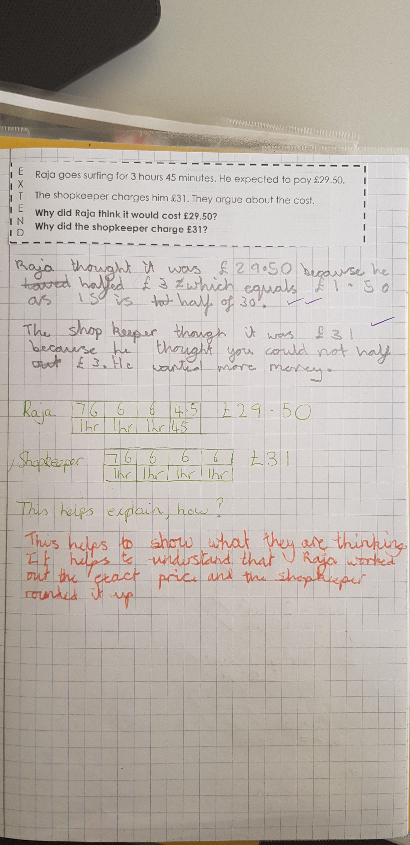

In maths and English lessons if the child has been supported the following needs to be shown.
(T) showing supported by the teacher
(S) showing supported by support staff
No code is needed if child worked independently.
Evaluating Learning
Reflections
To help the children to reflect on their learning, the ‘traffic lights’ is always included on our learning objective so that the children can evaluate where they feel they are in their learning journey. This helps the teacher to understand who may need further support and challenge in future lessons.
Our double page spread is also a good way for the children to show how they have developed their learning troughout a topic. It helps them to think more deeply about the learning process and find their own ways towards mastery. This reflection will show knowledge and understanding of the thinking processes, monitoring and evaluating learning from the of chosen strategies or methods, making connections across contexts.
Children will also receive regular opportunity to peer assess in at least one lesson a week to help support one and other on the learning journey.
At the end of lessons, children are able to use the red tray by placing their books in here to indicate they feel they need further support. This is then followed up by teacher/support staff.
Equity
Work and tasks are structured to be challenging to promote progress. We have a wealth of experience at Glenmere Primary School; Teaching Staff and Support Staff. Different groups will work with different support throughout the week and will also work independently.
Assessment Books
Assessment books are used during lessons by teachers and support staff. Within these, notes and comments are made in relation to the learning objective as well as the fast four/two grids in every lesson. Pupils are identified where further support is needed as well as pupils who have demonstrated understanding at a greater depth level. Comments should be used to inform next steps. This is a working document which is added to during the lesson.
Other points
Our Curriculum promotes independent learning and all children are expected to investigate areas of learning. There may also be times when learning takes place through practical activities which may result in no written recording, but instead, a photo may be used to demonstrate the learning that took place. If a practical activity takes place, the learning objective will still feature in the child’s book and assessed by the teacher.
Progress and attainment will be evaluated by the subject leaders and head teacher on a termly basis and will ensure that marking and feedback is being used to develop learning
The Headteacher and senior members of staff will conduct termly work scrutiny and lesson observations to monitor that the Feedback Policy is being effectively applied and that procedures are promoting progress for all pupils regardless of ability and position.

KS1 marking codes
Red – I found this difficult and needed a lot of help
Orange – I only needed a little help with this work
Green – I was able to do this independently
 | Finger space
 | Full stop
ABC | Capital letter. This will be identified by a circle in year 1 and early in year 2.
WOW! | Adjectives/Adventurous word choice
+ | Conjunctions (and, because...)
ph | Look at the letters, make the sounds and blend the sounds together
Sp x3 | Spelling mistake- copy the correct spelling three times in the margin
^ | Missing word
CAT | Come and talk about this

KS2 Marking Code

I have a responsibility to work hard and present my work to a high standard at school in every lesson and I have the right to know what I am doing well and what I need to do to improve.

My teacher has the responsibility to mark my books to tell me how to improve.

I have a responsibility to check through my teacher’s comments and think about (reflect) on what he/she has written. I will use the comments to improve and my correct my mistakes.

I have the right to know how my teacher will mark my work. I have a responsibility to check and remind myself of the codes that are being used.

Code | What it means
 | Red - In my self –assessment, I don’t think I achieved the Success Criteria
 | Orange - In my self –assessment, I think I partly achieved the Success Criteria
 | Green - In my self –assessment, I think I fully achieved the Success Criteria
√ | Great- my work is correct
 | I’ve missed out some punctuation or a capital letter.
SP | I made a spelling mistake of a word I should know how to spell
Sp x3 | I need to correct my spelling mistake and write it out three times using my best joined up handwriting in the back of my book
 | I’ve missed a word out
NP | I should have started a new paragraph
CAT | Come and talk to me

In addition to ‘in the moment’ marking the following ‘triangle’ codes will be used to assess the learning that has taken place:
This will be placed on the right side of the learning objective.

Learning objective has almost been met

Learning objective has mostly been met

Learning objective has been fully met

Vipers, Marking and Feedback
The same triangle code used for English, Maths and Broader Curriculum will be used in the VIPERS, books. The reading domain pictures will be used and discussed with the children in order to support their understanding of the domains that they are learning about. This can be done in a number of ways. When one or a few domains are being focused on the domain picture will be used in conjunction with the picture, question or statement. When a set of questions are being used, the table including the questions will be accompanied by the domain picture. Ensure that the more able are challenged to go deeper into the text and provide opportunities for analytical thinking. (See English policy)

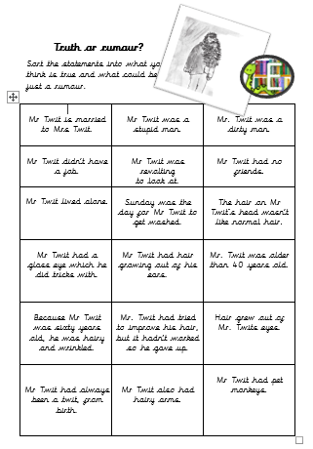
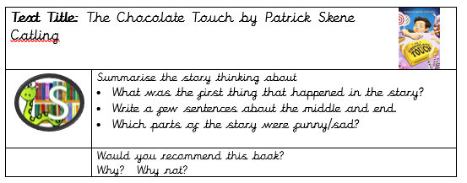
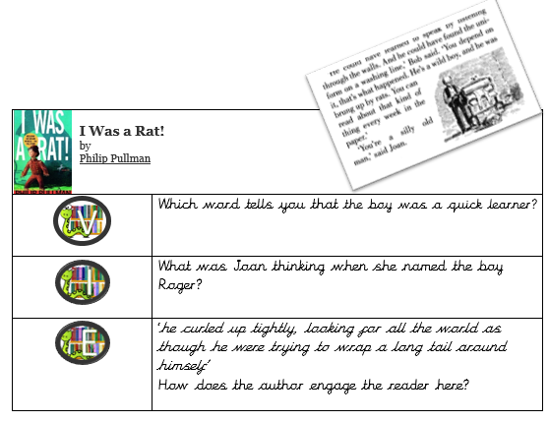
Examples:
