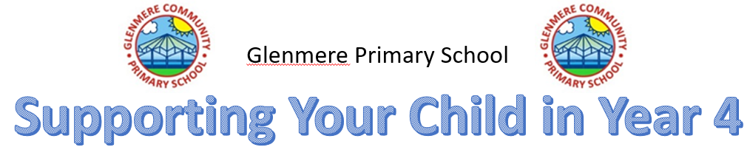
Autumn Term 2023
Dear Parents and Carers
I hope you all enjoyed your summer holiday and managed to have a bit of relaxation and family time. It has been lovely welcoming your children into year 4, they are already working hard, so I have high hopes for the year ahead. Here is an overview of what we are covering over the Autumn Term in Year 4 and ideas of how you can support your child.

English
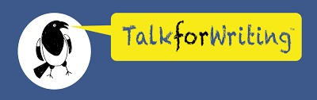
This term we will focus on explanation texts and narratives using our whole school ‘Talk for Writing’ approach. We will continue to develop our grammar skills and spellings to produce really good pieces of writing.

Here are some useful websites for you to explore with your child to help support them at home;
Instructions
https://www.bbc.co.uk/bitesize/topics/z2yycdm/articles/zfxkg7h
https://www.literacywagoll.com/instructions.html
Grammar
https://home.oxfordowl.co.uk/english/primary-grammar/grammar-year-4-age-8-9/
https://www.bbc.co.uk/bitesize/topics/zwwp8mn/year/z63tt39
Spelling
https://www.topmarks.co.uk/english-games/7-11-years/spelling-and-grammar
https://www.bbc.co.uk/bitesize/topics/zt62mnb/year/z63tt39

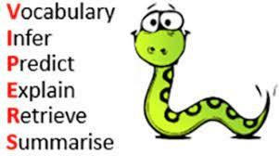
Vipers (reading skills)
It is essential to ensure that the children understand what they are reading and can find examples from the text when explaining a point, as well as infer about the text and characters.
Please remember to log onto the app to record the children’s reading as they are quite fond of extra playtime!
- Enjoy stories together – reading stories to your child is equally as important as listening to your child read. They will learn how to use expressive voices and pause at the right places.
- All reading is valuable – it doesn’t have to be just stories. Reading can involve anything from fiction and non-fiction, poetry, newspapers, magazines, football programs, reading subtitles.
- When reading their book, encourage the children to ask you questions about the characters or story line and ask them questions to discover whether they understand the text instead of just reading it.

BOOKLIST
Children in year KS2 are encouraged to read a range of books, from poetry e.g. Roald Dahl’s Revolting Rhymes, to The Hobbit!
I have included examples of the types of books cover each genre the children need to be reading. These particular books don’t need to be read, but it states the ‘type’ of book.
- Aesop’s Fables, Michael Rosen, Fables
- Horrid Henry, Francesca Simon, Stories in familiar settings
- How to Train Your Dragon, Cressida Cowell, Fantasy
- The Usborne Complete Book of Art Ideas (or Usborne Book of Art Skills, or Usborne book of Art Ideas), Fiona Watt, Instructions and Explanations

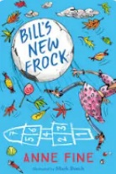
Author of the Half Term
Our author of the half term is Anne Fine. We are reading the story ‘Bill’s New Frock.’ It is a
great book, which tells the hilarious story of a young boy called Bill. One morning, a horrified
Bill wakes up in the body of a girl! He’s sent to school in a frilly pink frock with fiddly shell
buttons, and finds that life is suddenly very different.

Maths
The children will be learning how to apply the skills they have learnt in year 3, as well as
building upon them this year in the topic areas; ‘Place Value, Addition and Subtraction,
Multiplication and Division and Measurement.’ There will be opportunities for the children to
complete reasoning and problem-solving activities in every lesson, which will stretch and challenge their skills and understanding. We will also be completing a times tables test every day in preparation for the official times tables check in the summer term. I endeavour to ensure the children enjoy their tables and have fun learning them, while helping them to answer the questions accurately within the 6 second time limit.
Try these websites to engage your child in these topic areas too.
https://www.youtube.com/watch?v=cIreAEHmCaw - video on digits
https://www.bbc.co.uk/bitesize/topics/zt8dmp3/articles/zgn7wnb - Decimals
https://www.bbc.co.uk/bitesize/topics/zm982hv/articles/zn9wjhv - Decimals
https://www.bbc.co.uk/bitesize/topics/z8yv4wx/year/z63tt39 - Money
https://www.bbc.co.uk/bitesize/topics/zkfycdm/year/z63tt39 - Time
https://www.bbc.co.uk/bitesize/topics/zvmxsbk/year/z63tt39 - 2D Shapes
https://www.bbc.co.uk/bitesize/topics/zt7xk2p - 3D Shapes
https://www.bbc.co.uk/bitesize/topics/z7rcwmn/year/z63tt39 - tables, graphs and charts
https://www.bbc.co.uk/bitesize/topics/z2dqrwx/year/z63tt39 - Position and direction

History (First half term)
Ancient Greeks
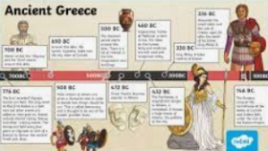
The children will be studying where the ancient Greeks come on the timeline, how they lived, what they believed in and how they have been so influential in our lives. They will link the British Value of Democracy to their work, as they will discover about it’s ancient Greek origin.

Geography (Second half term)
The Rainforest
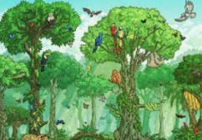
The children will discover the climates, biomes, animals and species of the rainforest. They will learn the layers and what lives in them and how the rainforest is essential to our way of life. They will learn how important it is to protect the rainforest and all that lives within it.

Science
Electricity and Sound
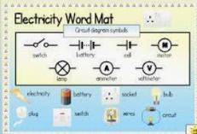
The children will be investigating and creating open and closed circuits and understanding the components to make a bulb light, a motor run and a buzzer sound. They will test materials for conductors and insulators and remind themselves of safety around electricity. In the second half of the term, they will be investigating sound and how it travels.
https://www.bbc.co.uk/bitesize/topics/zj44jxs (electricity)
https://www.youtube.com/watch?v=Dx3RpXdJw2k (electricity)
https://www.bbc.co.uk/bitesize/topics/zgffr82 (sound)
https://www.bbc.co.uk/teach/class-clips-video/music--science-ks2-what-is-sound/zbnmhbk (sound)
https://www.youtube.com/watch?v=aWieHpsZ7ik (this one links to music)
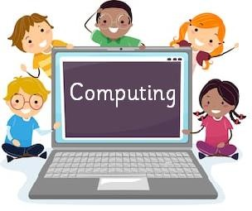
- all topic areas can be accessed and games and activities can be played and completed on here for all areas of science so the children can revise and further their learning.

Computing
The children will describe the parts of a network and how they connect to each other to form the internet. They will use this understanding to help explain how the internet lets us view the World Wide Web and recognise that the World Wide Web is part of the internet which contains websites and web pages. They will also recap their understanding of internet safety.

RE
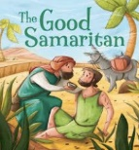
In RE this term, we will be studying Christianity and the Gospels to try to answer the key question, ‘What kind of world would Jesus want?’ We will be learning about the stories shared in the bible, like The Good Samaritan, to help us understand how we can be kind to others and treat everyone with respect. We will also be investigating into how organisations can help support people in their communities and all around the world.

Spanish
Our topics this term are seasons and vegetables. The children will learn how to discuss
the seasons using the correct vocabulary and will be able to formulate sentences about what they are like. We will encourage the children to develop their written, listening and verbal skills in Spanish.
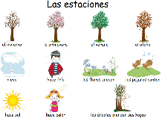
The children learn lyrics so quickly, so singing songs is a great way to learn the vocabulary
in Spanish.
https://www.youtube.com/watch?v=6sVqqDHjrYI

PE
We will be doing gymnastics on a Wednesday (so the children will need indoor kit) tennis on a Thursday and tag rugby on a Friday – if children have football boots please can they bring them and they will need warm outdoor kit. We will also have Active Maths and English through the week, so trainers will be needed for this too. Children need to come to school in their kit on a Wednesday, but please ensure your child’s kit is in school every day. Children are not allowed to wear jewellery in PE and must have a water bottle to hand if we are outside. Regarding weather, we go outside regardless, so please ensure your child has the correct and appropriate clothing on. They should have a school PE kit, or be just plain, there should be no motifs on any clothing if your child does not have a Glenmere embossed piece of kit. Thank you.

More Able / Children who require support.
Children who would like to further challenge themselves, there are many activities which can be accessed online to engage and challenge them. Why not try some from the site below.
https://www.stem.org.uk/system/files/elibrary-resources/2020/09/50%2B%20STEM%20activities%20for%20any%20classroom%20-%20Primary.pdf

Those who require support, there are many activities that the children can access through BBC bitesize. There is also the link below, which leads to an interactive learning platform. It is American, however grades 1,2,3,4 etc are the same as our year 1,2,3,4 and the bright colours, little helpful monsters and way of communicating to its audience would be fun and engaging for all children.
https://www.adaptedmind.com/Math-Worksheets.html?utm_medium=cpc&utm_source=google&campaignid=19815638762&campaign_type=&placement=g&utm_content=&adid=651089272719&adset_id=147312351775&utm_term=4th%20grade%20games&ad_position=&device=c&gclid=EAIaIQobChMIkJzS7oq7_gIV4-jtCh2ZpA0zEAAYAiAAEgKDzPD_BwE

ART/DT
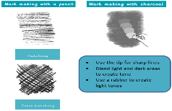
We start our new topic of drawing. We will be studying techniques such as 3D drawing, proportion, pattern, collage, pattern and contrast and printing. They will learn how to make textured marks with charcoal and pencil and they will learn how to appraise each-other’s artwork.

Personal Development including PSHE
We will be using our Everyone’s Welcome curriculum, as well as our PSHE curriculum to support the children with their understanding of themselves, mental health, protected characteristics and the British Values. We will be revisiting internet safety and focusing on Families and Relationships this half term and Health and Wellbeing next half term.

Homework
Homework this term sees the start of our new learning platform ‘Doodle Learning.’ It’s really important that your child works independently, as the app learns your child’s areas of strength and weaknesses so that it can calibrate to the right level for each user. Once the baseline assessment is complete, simply open the app and start answering questions. Any questions, please do not hesitate to ask.

Here’s to an amazing autumn term. Any questions, please contact me via Class Dojo.

Mrs. Dorrington

