Science Focus | Electricity | Year 4 | Autumn 1
Key Knowledge
What is electricity? | • Electricity is created by generators which can be powered by gas, coal, oil, wind or solar. • The electrical energy can be converted into other types of energy such as light, heat, movement or sound.  • Electricity is dangerous, so be careful when using electrical appliances.
What are common appliances that run on electricity? | Any appliances that need to be plugged in run on electricity.  For example: Television, Computer, Microwave, Lights
A series circuit | • Electricity can flow through the components in a complete electrical circuit.  • A circuit always needs a power source, such as a battery, with wires connected to both the positive (+) and negative (-) ends. (A battery is made from a collection of cells connected together).  • A circuit can also contain other electrical components, such as bulbs, buzzers or motors, which allow electricity to pass through.  • Electricity will only travel around a circuit that is complete. That means it has no gaps
What is a switch? | • You can use a switch in a circuit to create a gap in a circuit. This can be used to switch it on and off. • When a switch is open (off), there is a gap in the circuit. Electricity cannot travel around the circuit. • When a switch is closed (on), it makes the circuit complete. Electricity can travel around the circuit
Conductors | • Many metals, such as iron, copper and steel, are good electrical conductors.
Insulators | • Wood, glass, plastic and rubber are good electrical insulators. That is why they are used to cover materials that carry electricity.
Key Vocabulary
Generator | A machine that make electrical energy
Component | A part of something
Circuit | A path through which an electrical current flows
Current | The flow of electrical charge
Connected | Something that is joined
Possible Experiences
- Set up circuits and predict whether the bulb will light or not.
- Set up circuits and experiment with ways to make the bulbs brighter.
- Set up a circuit to test materials that are conductors or insulators.

Diagrams and Symbols
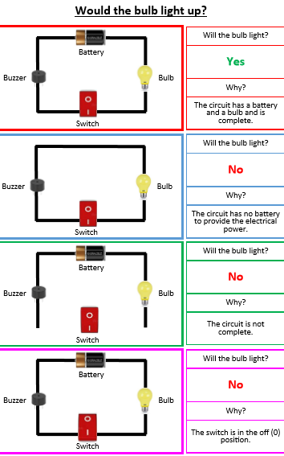
Greater Depth Thinking

