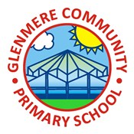
Year 2 Art & Design Knowledge Organiser Autumn
Drawing: Tell a Story
Knowledge
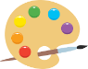 | Charcoal Mark Making  - Charcoal is a drawing material. It is wood that has been burnt. It is black and snaps easily.  - Charcoal is good for drawing but can be messy.
Creating Texture
- Different objects and different tools can create a range of texture.

Observational Drawing
- Sketching means holding the pencil lightly and using the natural movement of the wrist to draw lines.
Creating Characters
- We can show expression by drawing eyes, eyebrows and mouths in different ways.
Illustrations to Tell a Story
- Using different marks creates texture to bring illustrations to life.
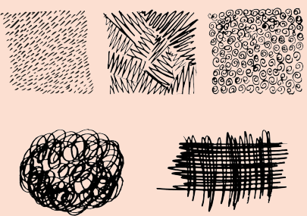

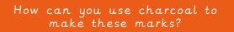

Key Vocabulary
Stippling | Making quick up and down hand movements to make dash and dot marks on paper
Hatching | Drawing lines that all go the same way
Cross-hatching | Drawing lines crossed over and close together
Scribbling | A drawing that is done quickly
Blending | Smoothing colours into others
Concertina | Folding something backwards and forwards

