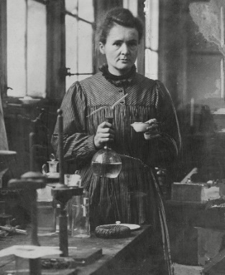

**Focus Scientist: Marie Curie** was a Polish and naturalised-French physicist and chemist who conducted pioneering research on radioactivity. She was the first woman to win a Nobel Prize.

|  |  |
| --- | --- |
| **Question for Learning;**  **What is the role of a skeleton?**   * Animals can be grouped into 2 groups. **Vertebrates** – an animal with a backbone. **Invertebrates**- an animal without a backbone. * Animals with a backbone have an endoskeleton. An endoskeleton is a skeleton on the inside of the body. * Animals without a backbone have an exoskeleton or no hard skeleton. An exoskeleton is a skeleton on the outside of the body. * A joint is where more than one bone meets, allowing a range of movement. |  |
| **Question for Learning;**  **Can you recognise the main bones in the body?**   * A skeleton provides support, movement and protection. * The ribcage protects the heart and lungs and the skull protects the brain. * We can use a measuring tape to measure the length of our bones. * Some of the main bones in a skeleton: skull, spine, ribs and pelvis. |  |
| **Question for Learning;**  **How do muscles help us move?**   * Humans have over 600 names muscles in the body. There are 3 types: skeletal muscle, smooth muscle and cardiac muscle. * Some of the main joints in a body are: elbow, wrist, knee, shoulder. * A conscious muscle: bicep. * A subconscious muscle: heart, small intestine, stomach, blood vessels. |  |
| **Question for Learning;**  **How is food an essential energy source for animals?**   * Diet is what an animal usually eats. * In a food chain, producers are at the start; arrows moving up the food chain; each living things eats the one before it. * A carnivore and omnivore both eat meat. A herbivore and omnivore both eat plants. * Adults need a larger energy demand than children. |  |
| **Question for Learning;**  **What are the main nutrient groups?**   * The main nutrient groups: carbohydrates, protein, fats and oils, fibre, vitamins, minerals, water. * Food in the diary food group are a good source of calcium. * Diary food contain milk e.g. yoghurt and cheese. * Carbohydrates and fats give us energy. |  |
| **Question for Learning;**  **What makes a balanced diet?**   * In 1929, a Nobel Prize was awarded to two scientists for their discovery pf vitamins. * The scientists were Christiaan Eijkman and Sir Frederick Gowland Hopkins. * Flemmie Pansy Kittrell was the first African- American woman to earn a PHD in nutrition. * We should have lots of fruit and vegetables in our diet as they contain fibre, carbohydrates, vitamins and minerals. |  |

|  |  |
| --- | --- |
| **Key Words** | |
| Endoskeleton | A skeleton on the inside of the body. |
| Exoskeleton | A skeleton on the outside of the body. |
| Balanced diet | A diet that includes all seven nutrient groups in the right amounts. |
| Muscle | Something that can shorten and cause movement. |
| Nutrient | A substance that is essential for survival and growth. |
| Protection | Keeping something safe. |

