

**Year 3 Design and Technology Knowledge Organiser Summer 2**

**Mechanical system: Pneumatic toys**

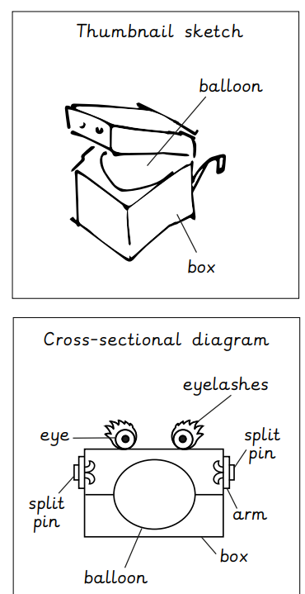

|  |  |
| --- | --- |
| **Knowledge** | |
|  | **Exploring pneumatics**   * Machines can work with the use of wind, water and human energy. * Turbines are big drums that water, wind or steam turn to make electricity. |
|  | **Designing a pneumatic toy**   * Thumbnail sketches: Good for making sense of your ideas, in a series of quick sketches. * Exploded – diagrams: Used to show how the different parts of a product fit together. |
|  | **Making pneumatic toys**   * We can use split pins to create motion. * Use scissors safety by cutting away from your body slowly. |
|  | **Decorating and assembling my toy**   * We can add detail by attaching googly eyes, curl up coloured paper, use pipe cleaners, tissue paper, add feathers, pom poms. |
|  | **Evaluating**   * Evaluating is saying what we like and can improve about a product. |

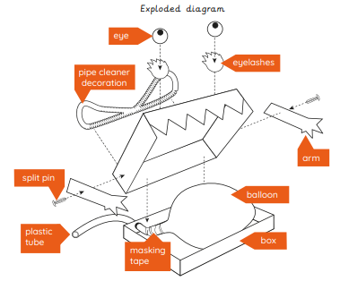

|  |  |
| --- | --- |
|  | **Key Vocabulary** |
| **Input** | Input is the motion used to start a mechanism. |
| **Lever** | This helps us lift loads with lesser effort. |
| **Linkage** | Lengths of material that are joined together by pivots, so that the links can move as part of a mechanism. |
| **Pneumatic system** | A mechanism that runs on air or compressed air. |
| **Motion** | The movement an object makes when controlled by an input or output. (left , right, up, down) |
| **Net** | A 2D flat shape, that can become a 3D shape once assembled. |

