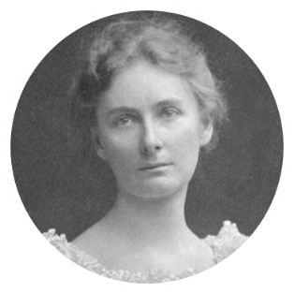

**Focus Scientist: Florence Bascom** was the first professional female geologist to survey Mount Desert Island. She was a pioneer for women as a geologist and educator in the 1800s.

|  |  |
| --- | --- |
| **Question for Learning;**  **How are rocks formed?**   * Rocks are a naturally occurring material made from materials and/or other rocks and organic materials. * Crystals are shiny pieces in a rock. * There are 3 groups of rocks: sedimentary, igneous, metamorphic * Force of nature, such as wind, rain and ice, cause larger rocks to break apart. | **Screen Clipping** |
| **Question for Learning;**  **How can we group rocks?**   * Rocks vary in hardness and softness. * Rock that are hard, impermeable and do not react to acid rain, like granite, are suitable for buildings because the weather won’t wear them away. * Rocks that are softer, permeable and that do react to acid rain are used because they look nice. For example, marble will wear away over time. * Chalk can be used to write with because it is soft. | **Screen Clipping** |
| **Question for Learning;**  **How are fossils formed?**   * The tiny pieces that wear away become sediment, which goes on to form sedimentary rocks. * If a living thing becomes buried under a layer of sediment, like mud, sand or volcanic ash, it can become a fossil. * Human-made objects cannot become fossils. * Rocks can be worn away by rainwater, rivers and streams, waves, wind, ice, plants and animals. | **Screen Clipping** |
| **Question for Learning;**  **What does a paleontologist do?**   * Mary Anning is a whole famous paleontologist. * The role of a paleontologist is to find fossils and use them to find out about the Earth’s history. * Fossils can tell us about the types of creatures in different eras: what the environment was like, how living things have changed over time, the climate, how old rocks are, extinction events and animal behaviours. | **Screen Clipping** |
| **Question for Learning;**  **What are some types of soils?**   * Soil is formed when rocks are broken down into sediment and mixed with other materials. * Soil is a mixture of grain of sediment, organic matter, air and water. * Soil is the top layer of the Earth’s surface. * Soil types: clay, sand, silt, loan, sandy, peaty. | **Screen Clipping** |
| **Question for Learning;**  **What are the layers in a sedimentation jar?**   * Earthworms are soft-bodied invertebrates that live in the soil. * They benefit the soil by: digging tunnels to let air and water into the soil, dragging organic matter down into the soil, leaving castings, making soil looser and softer. * Sedimentation can be used to compare the layers of different soils. | **Screen Clipping** |

|  |  |
| --- | --- |
| **Key Words** | |
| Clay soil | A soil with lots of clay grains and some organic matter. |
| crystal | A mineral with a shape that makes it shiny. |
| Fossil | A fossil is an imprint or the remains of a living thing from a long time ago that has turned to rock. |
| Impermeable | A material that does not let water pass through it. |
| Acid rain | Rain that has harmful chemicals in it which can change or damage rocks. |
| absorbency | How well a material can soak up water or liquids. |

