Question for Learning;  What is a light source?  - Examples of light sources and luminous objects: light bulbs, the sun, and glow sticks.  - Non-luminous objects: shiny diamonds, mirrors and road signs.  - The moon is not a light source.  - Darkness is the absence of light and we need some light to be able to see.  - It is important to protect our eyes from harm, including not looking directly at the sun and other bright light sources. |   Research
Question for Learning;  What is reflection?  - Light bounces off a surface when it reflects.  - Rejective surfaces or materials: mirrors, glass or metallic objects.  - The smoothness or how still the surface is will affect the quality of the reflection. | 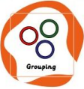  Identifying, grouping and classifying
Question for Learning;  Where do shadows come from?  - Shadows form when light is blocked by a material (usually opaque).  - Opaque materials form darker shadows or translucent and transparent materials form lighter, fuzzier shadows.  - The colour, position and material of an object can affect the way a shadow appears. | 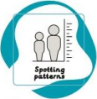  Pattern seeking
Question for Learning;  Do shadows change during the day?  - The position of the light source (the sun) causes shadows to change throughout the day.  - Shadows are longer when the sun is low in the sky, such as sunrise or sunset.  - Shadows are much shorter when the sun is high in the sky. | 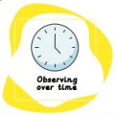  Observation over time
Question for Learning;  Can the distance of the light source affect the size of its shadow?  - The distance or the angle of the light can change the size of a shadow.  - The closer a light source is, the larger the size of the shadow. | 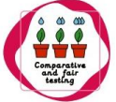  Comparative / Fair Testing
Question for Learning;  How do different people work with light and shadows?  - Opaque materials are most appropriate to make a shadow puppet as they block out light.  - To get a shadow, the puppet needs to go between the screen and the light source. | Researching / Problem Solving

Key Words
Light source | Where light comes from
Opaque | A property of a material where no light can pass through
Transparent | A property of a material where most light can pass through
Translucent | A property of a material where some light can pass through
Reflective (shiny) | A surface that light bounces off more.
shadow | A dark area caused by something blocking the light.

