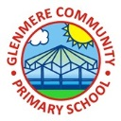

Supporting Your Child in Year 3

**Autumn Term 2025 - 2026**

Dear Parents,

Welcome back. I hope you have had an enjoyable summer holiday and are ready for the year ahead. I have had a wonderful first week with your children and I am very much looking forward to the year ahead. Year 3 have come back with a positive attitude and are showing me they are ready for the new challenges we will face together!

**English**

We will be focusing on grammatical features and then a structured approach to help us create narrative and expository writing. We will be revising previous learning and will also work hard on learning new grammar and spelling skills to help support our writing in class.

**Here are some useful websites that you could visit with your children to support their English work:**

Spelling and grammar:

<https://www.bbc.co.uk/bitesize/topics/zqqsw6f/year/zmyxxyc>

<https://www.bbc.co.uk/bitesize/topics/z88t97h/year/zmyxxyc>

<https://www.bbc.co.uk/bitesize/topics/zt62mnb/year/zmyxxyc>

<https://ictgames.com/mobilePage/spookySpellings/index.html>

Adventure story:

<https://www.bbc.co.uk/bitesize/topics/zx339j6/articles/zp4k3j6>

<https://www.bbc.co.uk/bitesize/topics/zprrd2p/articles/zwmt4qt>

**Vipers (reading skills)**

It is important for children to understand what they are reading as well as can give their own opinions about the text.

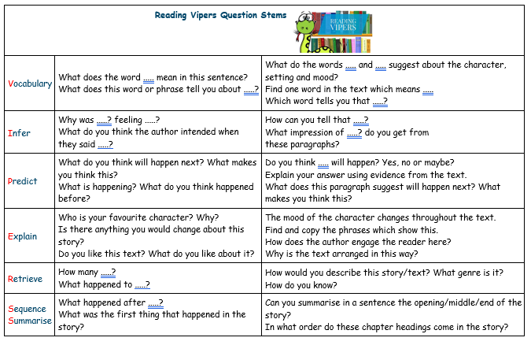We are aware that you have busy lives and it’s not always easy to listen to your child read each day, but we do know how important it is. Even if your child reads to you while you are preparing dinner, doing household chores or driving into school in the morning it will expose them to the text.

**Please remember to log their reading into GoRead/ BoomReader, the children love seeing their scores when we share them as a class.**

**Booklist:**

Here are some year 3 text recommendations **(more is provided on the year 3’s page on the school website).**

* Hawkins, E- Hamster in Danger, Monster of a Hamster
* King-Smith, D- The Guard Dog, Happy Mouseday, Invisible Dog, The Hodgeheg, The Magic Carpet
* Tomlinson, J- The Cat Who Wanted to Go Home, The Otter Who Wanted to Know, The Owl Who was Afraid of the Dark
* 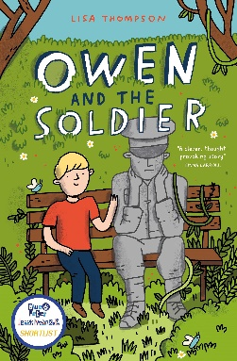Ahlberg, A- Ten in a Bed
* Cookson, P- Let's Twist Again; Teachers' Pets; Tongue Twisters & Tonsil Twizzlers

**Author of the half term**

This term our author will be Lisa Thompson and we will be using the book ‘Owen and the Solider’ as our class reading for pleasure book.

**Maths**

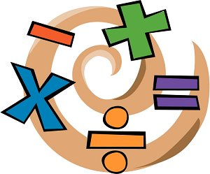This the first term we will be learning place value, and addition and subtraction. In the second term we will be learning multiplication and division. We will continue to recall our 3, 4 and 8 timetables and take part in a weekly ‘beat the clock’ timetables game as well as a variety of timetables games. Children will be exposed to reasoning and problem-solving activities. **Examples of these can be found on the year 3 page on the school website**.

**Here are some useful websites that you could visit with your children to support their maths work:**

[**https://www.timestables.co.uk/**](https://www.timestables.co.uk/)

[**https://www.topmarks.co.uk/maths-games/7-11-years/times-tables**](https://www.topmarks.co.uk/maths-games/7-11-years/times-tables)

[**https://www.mathschase.com/**](https://www.mathschase.com/)

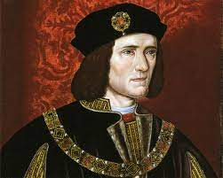[**https://ictgames.com/mobilePage/index.html**](https://ictgames.com/mobilePage/index.html)

**History**

Our history this term is called ‘Richard the Third’ which is linked to local history. The children will be working creatively to understand how archaeologists work and who was Richard the III. We will be learning about how his death changed British history, as well as learning all about the War of the Roses and the timeline around the Plantagenet and Tudor era.

**Science**

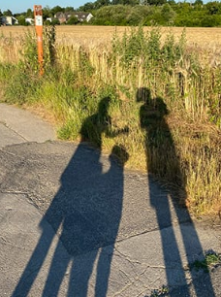This term we will be learning about ‘light and shadows’ and ‘rocks and soil’. We will be using the KAPOW scheme to support our learning in class.

**Here are some useful websites to explore with your child:**

[**https://www.bbc.co.uk/bitesize/topics/zmnqfdm/articles/z9wm7yc**](https://www.bbc.co.uk/bitesize/topics/zmnqfdm/articles/z9wm7yc)

[**https://www.bbc.co.uk/bitesize/topics/zmnqfdm/articles/zy34r2p**](https://www.bbc.co.uk/bitesize/topics/zmnqfdm/articles/zy34r2p)

[**https://www.bbc.co.uk/bitesize/topics/zsghcxs/articles/zgj9r2p**](https://www.bbc.co.uk/bitesize/topics/zsghcxs/articles/zgj9r2p)

[**https://www.bbc.co.uk/bitesize/topics/zsghcxs/articles/zgqkcmn**](https://www.bbc.co.uk/bitesize/topics/zsghcxs/articles/zgqkcmn)

**Computing**

This term our units will be ‘connecting computers’, this is where children will understand how computers are connected to each other and how information can be stored and passed between digital devices. Becoming familiar with the terms ‘system’ and ‘computer server’. Our second unit will be ‘stop-frame animation’ where we will use a range of techniques to create a stop-frame animation on a digital device.

**Here is the programme that we use for the animation:**

https://www.cateater.com/

**Religious Education**

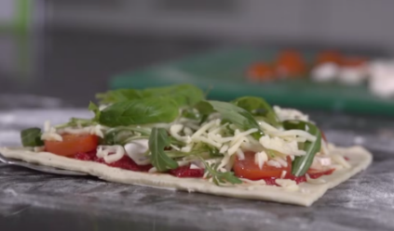This term we will be answering our overarching questions ‘What do Christians learn from the creation story?’ and ‘What do Hindus believe God is like?’ We will be focusing on Christianity in the first term and Hinduism in the second term, children will use their learning about the different religions learnt so far this year to understand how God is important across religions.

**P.E.**

Children will continue to be involved in a range of different sport activities. The lesson will either be in the playground or on the field. **They will need to come to school in PE kit on a Wednesday and Friday and have their kit to change into at lunchtime on a Tuesday**. It is essential that all children have their PE kit in school all week however, just in case we are offered extra PE slots. They will also need a spare bag available for muddy trainers. It is vital that the children have the correct kit and footwear for the weather and to be able to join in with every lesson.

**Art and DT**

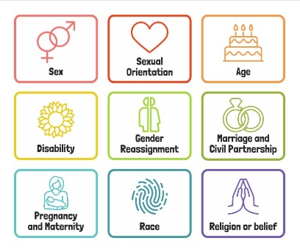Children will be looking at drawing in the first term, they will understand how to use shapes to form a basis of a detailed drawing in pencil. In the second term for DT, children will be learning how to eat seasonally. They will understand how to follow a recipe to create a variety of different dishes.

**Personal Development including PSHE**

In our personal development lessons we will understand what discrimination means with the book ‘This is our house’ and to understand conflicting feelings with the book ‘We’re all outsiders’. In PSHE we will be learning that all families are different, understand that people can have similarities and differences, and understand what a stereotype is. In the second term, we will understand how to keep ourselves healthy. We will also have our weekly Picture News assemblies to keep us to date with important topics around the world. As well as our British Values lessons.

**MFL (Spanish)**

This term we will be looking at the topic ‘I am learning’ where we will learn to count from 0-10 in Spanish and to recognise colours. In the second term, we will be looking at the topic ‘animals’ where we will identify and say different animals in Spanish. **(Children are able to use their student login to access games and songs on Language Angels).**

<https://www.languageangels.com/schools/login>

**Here are some useful songs to explore with your child:**

<https://www.youtube.com/watch?v=6FEyfy5N3Nc>

[**https://www.youtube.com/watch?v=-jf5WnqcePQ**](https://www.youtube.com/watch?v=-jf5WnqcePQ%20)

**Homework**

This term continues our learning platform ‘Doodle Learning’ It’s really important that your child works independently, as the app learns your child’s areas of strength and weaknesses so that it can calibrate to the right level for each user. Once the baseline assessment is complete, simply open the app and start answering questions. Any questions, please do not hesitate to ask.

**More able/ Children who require more support**

In the year 3 class, there are children with a variation of different need, which is supported by differentiation lessons and activities to meet these needs. **Here are some links to support the more able.**

<https://www.stem.org.uk/elibrary/resource/29243>

**Here are some links to explore with your child if they require more support:**

<https://www.bbc.co.uk/bitesize/subjects/zgkw2hv/year/z7s22sg>

<https://www.teachyourmonster.org/>

**If ever there are any issues, worries or concerns, please do not hesitate to ask me. I’m here to help! Thank you for your support in your child’s learning. I hope this year will be as happy for you as much as it will be for the children. Here is to a great year 3!**

**Mrs. Dorrington**