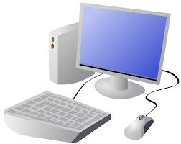
COMPUTING: DATA AND INFORMATION- Flat-File Databases
KNOWLEDGE ORGANISER
Y5

Overview |  |  | Using a Computer Database
Flat-File Databases  -Data is raw numbers and figures. Information is what we can understand from analysing data.  -There are lots of different ways that we can collect, log and interpret data, including by using databases.  -Databases organise data so that it can be easily added to, amended, stored and accessed. Computer databases can allow large amounts of data to be sorted, filtered and edited more easily. |  |  | -Computer databases often contain large amounts of data. We can find the data that we need by using the ‘search’, ‘filter’ and ‘sort’ functions. Search functions allow us to type in the exact word/s that we are looking for. This can be useful if we are looking for a particular record.  -If we are looking for records that share certain information we can filter out data by different fields. For example, we filer in the ‘age’ field for all students aged 23. The database will then present only the students aged 23.  -We can also sort records by the data in particular fields. e.g. we may sort by the students’ ages, from youngest to oldest. The youngest student will then appear at the top.  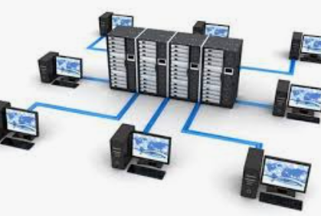  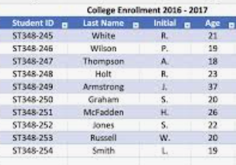
Types of Databases
Database: A database is a collection of organised data that is easily stored and used. Databases often structure data in logical ways (e.g. in columns, rows and tables) so that it can be accessed by those who need it easily. Databases are made up of individuals records, which contain information in different fields (categories).
 |  |  | Presenting Data | Using Databases
 |  |  | 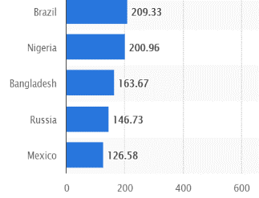  -Data can be shown visually, by using graphs and charts. This allows users to quickly and easily find answers to the questions that they need. It helps the user to easily see trends and to sequence information.  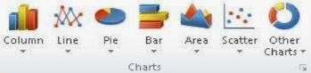  -Charts and graphs can be created by selecting the charts icon and selecting which fields to display in the x-axis and y-axis. | -Remember that databases are used in order to quickly and easily find information. Databases are only able to do this if the data is organised logically into clear records and fields.  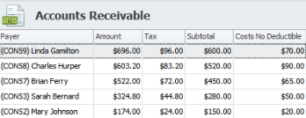  -Databases are used in most institutions across the world. Think about: medical records, school student information, flight logs and business accounts.
-Paper Databases: Paper databases require the creator to manually write in individual records, and to sort the records in an appropriate order. Paper records can still be useful in small databases, particularly where information is not changing and does not need to be amended frequently. However, most large databases are now stored on computers. | -Computer Databases: Many computer programs allow us to create databases, e.g. j2data or Microsoft Excel.  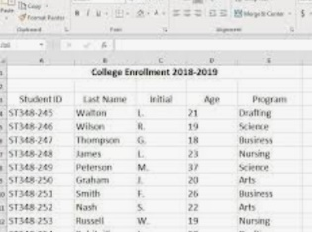  Computer databases have become more popular than paper databases, as data can be easily and quickly added or removed, sorted, filtered, edited, or viewed at any time.
Important Vocabulary

Database Record Field Sort Order Group Value Criteria Graph Chart Axis Compare Filter

