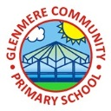
Supporting Your Child in Year 5

Spring Term 2021
Happy New Year! We hope you had an enjoyable Christmas.
English  We started this term, by studying the narrative poem ‘The Highwayman’ by Alfred Noyes. This retells the story of an unnamed highwayman who is in love with Bess – the landlord’s daughter. Within this we will look at the use of different voices and perspectives whilst looking at formality and tenses.  We will continue to develop our understanding of grammar and punctuation, in particular starting to look at more complicated sentence structures and use of punctuation.  We will also, linked to our topic, carry out debates, using this to form an understanding for our discussion texts. This is always something which children particularly enjoy. In addition to this, we will be working hard on our reading and comprehension skills. In doing this, we will have whole class comprehension sessions, regular reading intervention, whole class reading at the end of everyday – our current book is Brightstorm – and individual reading during Book Talk sessions. | Maths  This term in math we will be continuing to embed work surrounding from last term as well as introducing formal written methods for multiplication and division, fractions, decimals and percentages and some work surrounding statistics.  As well as this, there will be a particular focus on times tables with regular multiplication work being set on Times Tables Rockstars. The importance of timetables is incredible, especially preparing for Year 6. Knowing these with speed and fluency makes the rest of maths that little bit easier.  We will begin to look at using addition and subtraction within fractions as well.
History  Our curriculum continues to develop a whole host of subjects. With this letter is the Crime and Punishment Knowledge Organiser. This shows all the different areas we will be covering and what children will be learning. In particular, we will be studying how crime and punishment has changed over the past 800 years, starting in the medieval times. Children will be sent home with their own homework knowledge organiser where they will be challenged to learn to knowledge on it over the term. | Science  Our science for this term includes studying materials and their properties where we will learn about different properties, including soluble, transparent, insulators etc. we will investigate how to separate different mixtures and look at reversible and irreversible changes. Take a look at the science knowledge organiser for more information
Design & Technology  In DT this term, our focus area will be Textiles. We will be looking at how different items of clothing, bags and cushions are made, what type of fabric has been used, how they have been joined together and how seams have been created. There will be a lot of hands-on activities, with the final outcome being a re-useable shopping bag, which each child is going to design and make by themselves to take home. | Music  In music this term we will be studying Pop Ballads with the song ‘Make You Feel My Love’ at the centre of the unit. As well as learning to sing, play, improvise and compose with this song, children will listen and appraise other Pop Ballads.
PSHE  We are starting a new teaching scheme called “Jigsaw” which allows us to have the same PSHE theme across the school for all pupils. Our theme for this term will be “Celebrating Differences” and it will be a great way to encourage the children to show understanding for our differences and embrace how each and every one of us is unique.  Next half term will be Dreams and Goals! | RE  RE we will focus on Christianity, learning about different stories from the Bible to do with love, forgiveness and generosity. We will learn about how Christians live their lives based on the idea of ‘What would Jesus do?’
Personal Growth

Our next theme is ‘Investors’. The aim of this is to work on developing children’s life skills so here we will be developing skills in relation to growing money and the importance of saving and investing. Keep your eyes peeled for money making around school.

PE
Year 5 will continue to have Swimming Wednesday Basketball/Tennis on Thursday and running on Friday. Children will need to ensure they have football boots and shin pads as well as needing a darker t-shirt for outdoor PE and then the Glenmere sport PE T-shirt.

Homework
Homework will continue to be set. This term we will set it on a Monday, in for the following Monday. Spellings tests will continue to be on Tuesday. The class were excellent at the spelling shed – and have even worked on them during the holidays which is amazing so let’s be sure to keep it up. It is then up to the child to manage their own time in order to handing it in the following week where it will be marked in school. We will also be setting weekly times tables. Children should have their login for Times Tables Rockstar. In addition to this, children will be learning elements from the Crime and Punishment homework knowledge organiser!

Home Reading
I cannot reiterate enough how important reading is – both at home and at school. As children progress into KS2, they become fluent readers but we need to continue to develop this by exposing them to more challenging books with wide vocabulary in. Still listening to even those extremely confident readers is important as it is a change to identify words mispronounced or discussion of new vocabulary. And remember, reading at home = points which = prizes
Recommending Reading Books
As your child grows in confidence with their reading, it is essential that they are given the opportunity to read a wide variety of book. Why not try some of the books below which are some of the recommended books to read in Year 5 and 6
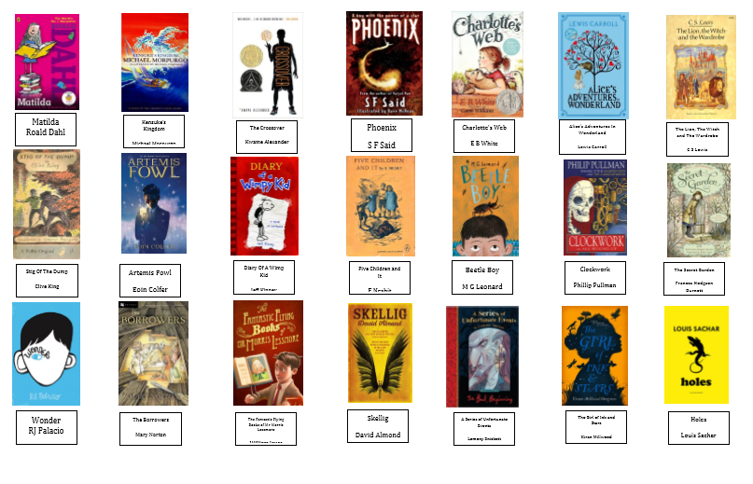
Suggested Author:
We have recently been reading Brightstorm by Vashti Hardy. Vashti Hardy has written a number of books within the Brightstorm series including Dark Whispers, Wild Spark and The Griffin Gate. Why not try one of these at home?
Useful resources to get your children writing
- The Literacy Shed is a fantastic website with a range of different stimulus to encourage children to write. Let your child explore and write a range of different genres. http://www.literacyshed.com/
- I also would advise using films that your children enjoy watching. Get them to re-write the story from a different character’s point of view, write a diary entry based on one of the events, or even create a movie trailer, using ipads and other technology
We ask that you support us by listening to your child read whenever possible as this will help support the comprehension work in class. This includes questioning the children as they read to you. There are a variety of different question types you can ask: -
- Open ended questions – encourage children to give a range of responses and shows their deeper level of understanding.
- Literal questions – encourage children to recall facts or make simple comprehension where the answer is clearly stated in the text.
- Higher order questions – are excellent to challenge and move able readers on. They encourage children to think beyond what is written in the text.
Supporting your child with maths
When adding and subtracting fractions with different denominators you need to make the denominators the same.
4 + 2
5 3
Find the lowest common multiple
Lowest common multiple = 15
Turn both fractions into a fraction with the same denominator
4 + 2 = __ + __
5 3 15 15
Then I would see how many times 5 and 3 go into 15
Then in multiply the top number by the same as the bottom
4 + 2 = 12 + 10 = 22
5 3 15 15 15

I then look if I can simplify or turn into a mixed number.

Other activities you could use to support your child in maths:
- Kaboom – a game which can be used to practice their times tables. Ask your child to show you how to play this game – we have been using it lots already this term.
- Snap for equivalent fractions, decimals and percentages.
- A Pack of card fractions. Play in pairs. Each person picks two cards: one would be the denominator and one the numerator. Pairs compare. Highest fraction wins. This could be adapted to simplifying fractions or turning fractions from improper to mixed numbers. The opportunities with packs of cards are endless. Try typing it into Google and see what variations you can find.
For the confident mathematicians
For those children who are extremely confident with maths, I would advise them to start to use these skills on a mastery level, solving a range of puzzles and problems. The nrich, NACE and ncetm websites provide a range of different activities.
Encourage your child to create problems which involve working systematically. Get them to create problems for you to solve.
They also need to develop their ability to reason. Use problems like the one below to encourage them to prove a theory right or wrong.
Other techniques I use for this include…prove it; always, sometimes and never true and odd one out.
Finally, encourage children to find mistakes in calculations and give advice on how the mistake could be corrected.
Across Glenmere and in class we are really working on encouraging good manners: holding doors for others, allowing others to pass by, remember our pleases and thankyous. Points will be awarded on class dojo for these, so if you notice they have been awarded points for this, please do ask your child what it was for and continue to reinforce this at home as well!

If you have any queries, please do not hesitate to come and speak with us at the start or end of the school day or via class dojo

Many thanks,
Mrs Carton and Mrs Buschbeck

