Class 5
Theme: Garden to Table
Personal Growth Curriculum: Sustainability

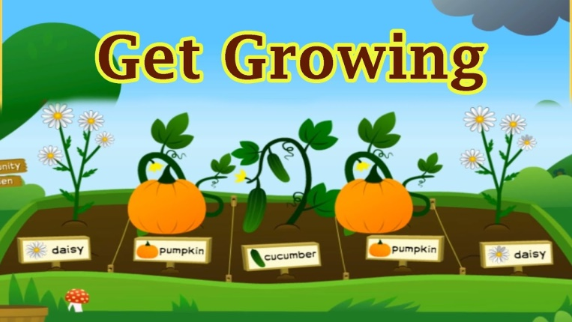
Life skills I will be covering:
Persistence
Well-being
Health
Resilience

Vocabulary
Sustainability | The ability to be maintained at a certain rate or level
Harvest | The process or period of gathering in crops
Produce | Natural products
Seasonal | Relating to a particular season of the year
Preparation | The action of preparing for use
Processes | A series of steps taken in order to achieve a particular end
Decay | Rot through the action of bacteria and fungi
Edible | Fit or suitable to be eaten
Key Knowledge
Know the processes food goes through before reading us | Know which foods are best for different times of year
Know how to select and use the most appropriate equipment to plan and cook a range of dishes | Know how to modify existing recipes
Know how food can spoil and decay and what causes this | Explain how we process food at home to make it edible and safe
Explain how food is processed on a larger school to make it edible and safe to eat. | Know how to weigh and measure with accuracy
Know how to demonstrate good food hygiene when cooking | Explain how to use date marks and storage instructions on food packaging

Engaging and practical experiences
Sorting a range of products to assess their suitability
Modifying recipes given to them, weighing and measuring accurately
Compost pile activity – sorting decomposable rubbish
Life as a factory worker

