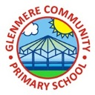
Supporting Your Child in Year 5

Summer Term 2022
We hope you had a restful Easter Holiday and are looking forward to the final term in Year 5. We would like to welcome Miss Pickering who will be working within Year 5 for the remainder of the term too! Below is a breakdown of what we will be learning about this term with some further information: happy reading!
English  English we will begin to look at the more complex skills of the Year 5 curriculum, preparing them for Year 6. The way their writing has developed already this year is incredible. We have been working on ‘If I had Wings’ a poem by Pie Corbett where we looked at poetic style used, going on to create our own ‘If I had…’  We will also be writing our own biographical accounts of inspirational people within Britain and writing persuasive letters to develop our understanding of formal writing.  We will also study the book Holes by Louis Sacher, creating a range of different pieces! | Maths  In maths this term, we will continue our work on decimals. We will expand our skills to not only add and subtract decimals with the same number of decimal places, but also use these operations on decimals with a different number of decimal places. We will be learning to multiply and divide by decimals 10, 100 and 1000.  Next, we will be moving on to measurement and learn to use a protractor to measure, draw and calculate angles.  Then we will be expanding our skills of reading and writing coordinates off a grid, and learn to translate shapes with coordinates and also find and draw their reflection.
Geography  This term our focus will be geography based. The focus will be North America and the Rockies, looking and learning about how mountains are formed, using our understanding from earlier in the year with work on tectonic plates. Much of initial work will be based upon geographical skills, such as reading and interpreting different maps. We will study the different climate zones within North America. | Science  Our Science topic this term will be Living things and their Habitat. During this unit we will be learning about different parts of the plan and how they reproduce. We will then look at how fertilisation occurs within animals, sorting animals into different categories. The life cycle of different animals will be studied as well as different gestational periods.
DT  In DT this term, our focus will be on cooking healthier food. We will take a look at how food labels can tell us a lot about what a product contains, but how they can also be misleading at times. We will be comparing Bolognaise sauces regarding their flavour as well as nutritional value and finally write our own – healthier versions – of a Bolognaise recipe. | Art  In the final half term, we work on Every Picture Tells a Story, studying the work on Banksy, Andy Warhol, John Singer Sargent, studying the different skills and techniques being used and applying these in work of our own!
Personal Growth  Our next theme is ‘Escape Rooms’ and through these lessons the children will be learning about the 7 Cs of Resilience and how they can help us to deal with difficult situations. We are going to look at different ways to approach a problem and learn what strategies can be helpful to reduce anxiety and build confidence and perseverance. | RSE  As you are aware, this term we will be teaching our Relationships and Sex Education. Within this there is a big focus on the different types of relationships, how boys’ and girls’ bodies change during puberty and understanding everyone has different limits and how to use our voice to express our limits. You should have received a letter before Easter outlining the lessons.
Music  During music this term we will be studying Motown with a focus on ‘Dancing in the Street’, moving on to ‘Reflect, Replay, Rewind’ where we will study the history of music, look back and consolidate learning from earlier in the year whilst also learning some of the language of music | Spanish  In Spanish, we continue to build on our vocabulary, only this time we will be linking it to history and six periods of British history from the la edad de Piedra to los vikingos.  Then later in the term begin to understand different verbs and activities in Spanish
RE  In RE we look at big questions – our questions this term focus on Islam and Christianity:  What does it mean to be a Muslim in Britain today?  What do Christians believe Jesus did to save people? | ICT  In ICT, we will be using our skills to create our own games which we are sure the class are going to thoroughly enjoy Game creator. We will design settings and characters whilst also considering animations and sound for effect. Children will then evaluate each other’s with formative feedback

We ask that you support us by listening to your child read whenever possible as this will help support the comprehension work in class. This includes questioning the children as they read to you. There are a variety of different question types you can ask: -
- Open ended questions – encourage children to give a range of responses and shows their deeper level of understanding.
- Literal questions – encourage children to recall facts or make simple comprehension where the answer is clearly stated in the text.
- Higher order questions – are excellent to challenge and move able readers on. They encourage children to think beyond what is written in the text.
Supporting your child with maths
When working with decimals, it is essential that children know the value of each decimal place. A common error for example, could be that a child thinks 0.4 is smaller than 0.09, because 4 is less than 9.
It is important to emphasize that decimals represent PARTS of a WHOLE. Children who struggle with this concept may find it helpful to work with a hundred chart.
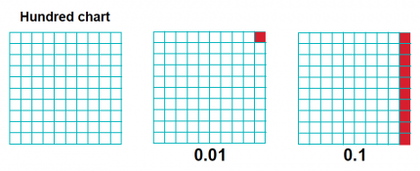
This grid is made up of 100 little cubes. One out of 100 would be called one hundredth and written as 0.01, while ten out of 100 would be called one tenth written as 0.1 Simply shading decimals like this can help children to visualise them better.

If a child is really confused about decimals, converting decimal numbers into money is a great way to make things clearer. For example: a child may be asked to say how much bigger 1.3 is than 0.9. If they convert these decimals into money (£1.30 and 90p) they may find that they can do this calculation very quickly in their head, getting the answer 40p which they convert back into the decimal, 0.4.

When adding and subtracting decimals using the column method, children need to make sure numbers are lined up correctly, i.e.

2.5 NOT 2.5
+ 4.34 + 4.34

Challenging and extending pupils
As previously stated, the NRICH website is filled with brilliant reasoning and problem-solving resources for your child to work on. Primary Students (maths.org) – provides children with different activities to be able to challenge and extend their thinking. Problem solving is a great way to deepen understanding.
To deepen understanding in reading, develop a dialogue about reading – talk with your children, make connections and comparisons, look at the vocabulary, re-read stories to understand them on a deeper level and find a love for reading!

Suggested Author: Polly Ho-Yen
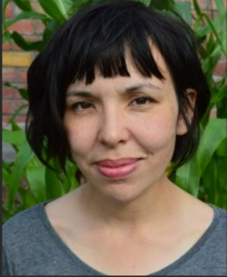
In class we have been reading the book ‘Boy in the Tower’ – a story of a boy and his mother whose world is changed when strange plants begin to appear from nowhere. They are no longer safe and are trapped with no way out. Other books include ‘Fly me Home’ and ‘How I Saved the World in a Week’

PE
Year 5 will continue to have Swimming on Wednesday, Basketball/Tennis on Thursday and Running on Friday. Please ensure they bring their PE kits to school every day. Children will need to ensure they have football boots and shin pads as well as needing a darker t-shirt for outdoor PE and then the Glenmere sport PE T-shirt – or plain PE kit.

Y5 Production
All children were given the script for our summer production of ‘Jungle Book’ before the Easter holidays and auditions have taken place this Thursday. We have tried to make sure that every child who wanted a speaking part has been given one, and that those children who would rather not appear on stage will be given other important parts to support the play. Once your child’s role has been confirmed, we would be very grateful if you could start thinking about their costume. We don’t expect it to be extravagant – just clothes in the right colour will be fine. Thanks so much.
Homework
Homework will continue to be set. This term we will set it on a Monday, in for the following Monday. Spellings tests will continue to be on Tuesday. It is then up to the child to manage their own time in order to handing it in the following week where it will be marked in school. We will also be setting weekly times tables. Children should have their login for Times Tables Rockstar. If they have lost it or can’t remember their login details – please let us know and we can give out a new one.

Useful Websites
Geography for Kids. World maps and countries. (ducksters.com)
World geography for kids | National Geographic Kids (natgeokids.com)
Times Tables Rock Stars (ttrockstars.com)

Home Reading
As a class, year 5 enjoys reading and we love books Reading and being read to is still an important part of your child’s development – no matter how confident a reader they are by now.
We know that most of the class read at home on a regular basis, but many children still forget to put it in their recording record, or don’t bring their records to school! In year 5 we expect children to be responsible enough to remember to have their records signed – but sometimes a little nudge by a parent might be needed. Remember, reading scores points which will get you prizes.
Recommending Reading Books
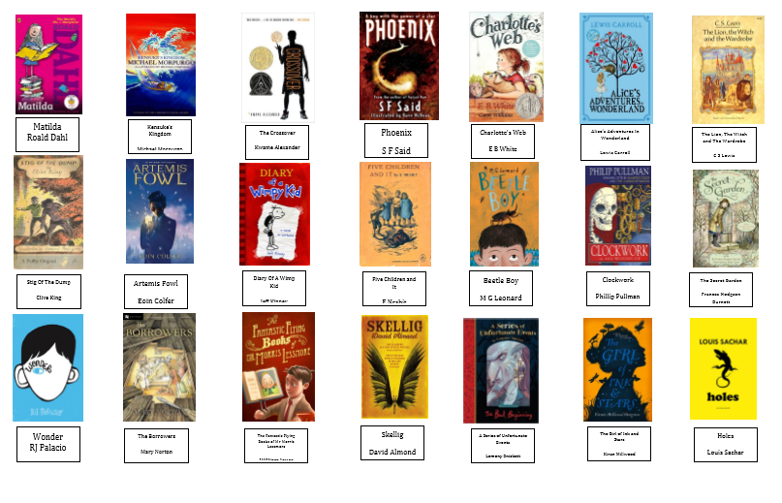
If you have any queries, please do not hesitate to come and speak with us at the start or end of the school day.

Many thanks,
Mrs Carton and Mrs Buschbeck

