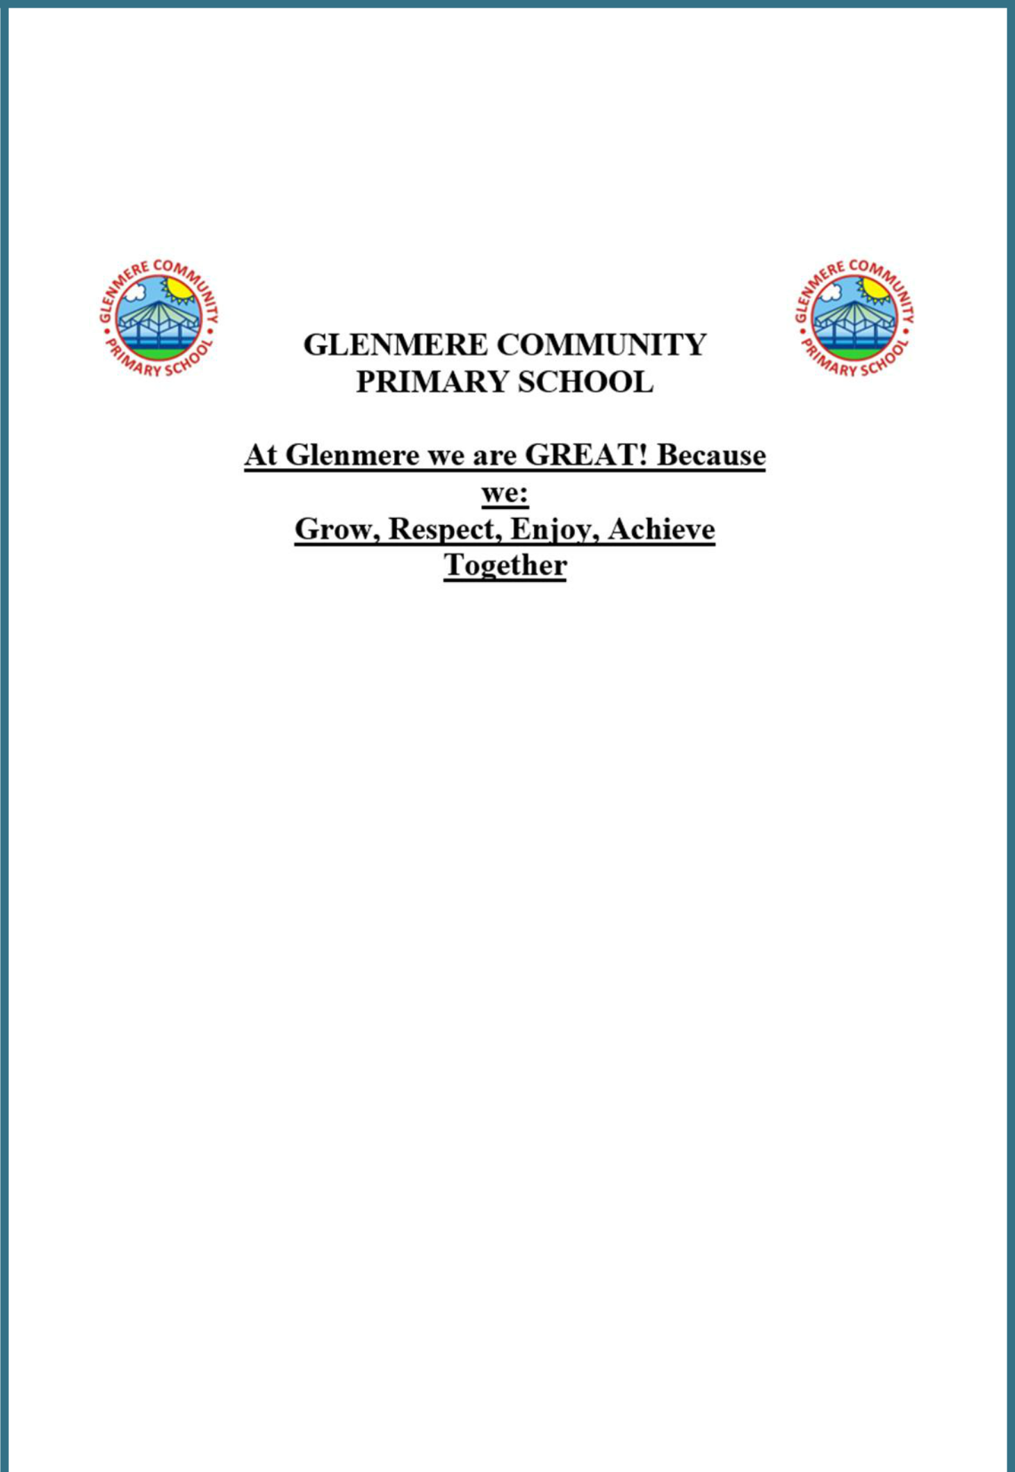

Intimate Care Policy

Last updated: June 2022

Contents:

Statement of intent

- Legal framework

- Definitions

- Health and safety

- Staff and facilities

- School responsibilities

- Parental responsibilities

- Safeguarding

- Swimming

- Offsite visits

- Policy review

Appendices

- Record of Intimate Care Intervention

- Toilet Management Plan

- Agreement between Pupil and Personal Assistant

Statement of intent

Glenmere Primary School takes the health and wellbeing of its pupils very seriously. The school aims to support pupils with physical disabilities and illnesses to enable them to have a full and rich academic life whilst at school.

The governing body recognises its duties and responsibilities in relation to the Equality Act 2010, which states that any pupil with an impairment affecting his/her ability to carry out normal day-to-day activities must not be discriminated against.

Pupils will always be treated with care and respect when intimate care is given, and no pupil will be left feeling embarrassed.

Signed by:

Headteacher Date:

Chair of governors Date:
- Legal framework

1.1. This policy has due regard to relevant legislation and guidance, including, but not limited to, the following:

DfE (2018) ‘Keeping children safe in education’ The Children and Families Act 2014

The Education Act 2011 The Health Act 2006
The Equality Act 2010

- Definitions

2.1. For the purpose of this policy, intimate care is defined as any care which may involve the following:

Washing Touching
Carrying out an invasive procedure

Changing a child who has soiled themselves Providing oral care

Feeding

Assisting in toilet issues

Providing comfort to an upset or distressed pupil

2.2. Intimate care tasks are associated with bodily functions, body products and personal hygiene that demand direct or indirect contact with, or exposure of, the genitals.

2.3. Examples of intimate care include support with dressing and undressing (underwear), changing incontinence pads, nappies or medical bags such as colostomy bags, menstrual hygiene, helping someone use the toilet, or washing intimate parts of the body.

2.4. Pupils may be unable to meet their own care needs for a variety of reasons and will require regular support.

- Health and safety

3.1. Glenmere’s Health and Safety Policy lays out specific requirements for cleaning and hygiene, including how to deal with spillages, vomit and other bodily fluids.

3.2. Any member of staff that is required to assist a pupil with changing a medical bag will be trained to do so.

3.3. Staff will wear disposable aprons and gloves while assisting a pupil in the toilet or while changing a nappy, incontinence pad or medical bag.

3.4. Soiled nappies, incontinence pads and medical bags will be securely wrapped and disposed of appropriately.

3.5. Where one pupil requires intimate care/toileting; nappies, incontinence pads and medical bags will be disposed of in an ordinary bin, as per health and safety guidelines.

3.6. Where more than one pupil requires intimate care, nappies, incontinence pads and medical bags will be disposed as follows:

Details of disposal process.

3.7. The changing area or toilet will be left clean.

3.8. Hot water and soap are available to wash hands.

3.9. Paper towels are available to dry hands.

- Staff and facilities

4.1. Staff members who provide intimate care are trained to do so, and are fully aware of best practice. Suitable equipment and facilities will be provided to assist pupils who need special arrangements following assessment from a physiotherapist or occupational therapist. This may include the following:

Adjustable bed Changing mat Non-slip step Cupboard

Adapted toilet seat or commode seat Hoist

Swivel mat

Disposable gloves/aprons

Nappies, pads and medical bags

Tissue rolls (for changing mat/cleansing) Supply of hot water

Soap

Barrier creams

Antiseptic cleanser for staff

Antiseptic cleanser for the changing bed/mat Clinical waste bag

Spillage kit

4.2. Glenmere has one extended disabled toilet facility with a washbasin.

4.3. Mobile pupils will be changed while standing up.

4.4. Pupils who are not mobile will be changed on a changing mat on the floor.

4.5. Staff will be supported to adapt their practice in relation to the needs of individual pupils, taking into account developmental changes such as the onset of puberty or menstruation.

- School responsibilities

5.1. Arrangements will be made with a multi-agency to discuss the personal care needs of any pupil prior to them attending the school.

5.2. Pupils who require intimate care will be involved in planning for their own healthcare needs wherever possible.

5.3. In liaison with the pupil and parents/carers, an individual intimate care plan will be created to ensure that reasonable adjustments are made for any pupil with a health condition or disability.

5.4. Regular consultations will be arranged with all parents/carers and pupils regarding toilet facilities.

5.5. The privacy and dignity of any pupil who requires intimate care will be respected at all times.

5.6. A qualified member of staff will change the pupil, or assist them in changing themselves if they become wet, or soil themselves.

5.7. Any pupil with wet or soiled clothing will be assisted in cleaning themselves and will be given spare clothing, nappies, pads, etc., as provided by the parents/carers.

5.8. Members of staff will react to accidents in a calm and sympathetic manner.

5.9. Accurate records of times, staff, and any other details of incidents of intimate care will be kept, and they will be stored in the first aid room.

5.10. Arrangements will be made for how often the pupil should be routinely changed if the pupil is in school for a full day, and will be changed by a designated member of staff.

5.11. A minimum number of changes will be agreed.

5.12. The family’s cultural practices will always be taken into account for cases of intimate care.

5.13. Where possible, only same-sex intimate care will be carried out.

5.14. Parents/carers will be contacted if the pupil refuses to be changed, or becomes distressed during the process.

5.15. Excellent standards of hygiene will be maintained at all times when carrying out intimate care.

- Parental responsibilities

6.1. Parents/carers will change their child, or assist them in going to the toilet, at the latest possible time before coming to school.

6.2. Parents/carers will provide spare nappies, incontinence pads, medical bags, wet wipes and a change of clothing in case of accidents.

6.3. A copy of this policy will be read and signed by parents/carers to ensure that they understand the policies and procedures surrounding intimate care.

6.4. Parents/carers will inform the school should their child have any marks/rashes.

6.5. Parents/carers will come to an agreement with staff in determining how often their child will need to be changed, and who will do the changing.

- Safeguarding

7.1. Only members of staff who have an enhanced DBS certificate with a barred list check are permitted to undertake intimate care duties.

7.2. Wherever possible, staff involved in intimate care will not be involved in the delivery of sex education to the pupils in their care as an extra safeguard to both staff and pupils involved.

7.3. Individual intimate care plans will be drawn up for pupils as appropriate to suit the circumstances of the pupil.

7.4. Each pupil’s right to privacy will be respected. Careful consideration will be given to each pupil’s situation to determine how many carers will need to be present when the pupil requires intimate care.

7.5. If any member of staff has concerns about physical changes to a pupil’s presentation, such as marks or bruises, they will report the concerns to the DSL immediately.

- Toilet Training:

8.1. Starting at an early year's setting is always an important and potentially challenging time for both children and their parents, it is also a time of growth and very rapid developmental change for all children. As with all developmental milestones in the Early Years Foundation Stage (EYFS), there is wide variation in the time at which children master the skills involved in being fully toilet trained.

For a variety of reasons children may:

Be fully toilet trained

Have been fully toilet trained but regressed for a little while due to the excitement and stress of starting at a setting

May be fully toilet trained at home but have accidents in the setting, or vice versa

May be nearly there but needs some reminders and encouragement Not toilet trained, but responds well to a structured toilet training
process

Be fully toilet trained but has a serious disability or learning difficulty May have development delays but with additional support will
master these skills

Have SEND and might require help with some or all aspects of personal care.

- Swimming

9.1. Pupils in Years 5 and 6 regularly participate in swimming lessons at

Parklands Leisure Centre, Oadby: during these lessons, pupils are entitled to privacy when changing; however, some pupils will need to be supervised during changing.

9.2. Parental consent will be obtained before assisting any pupils in changing clothing before and after swimming lessons.

9.3. Special consideration will be taken to ensure that cases of bullying or teasing do not occur.

9.4. Details of any additional arrangements will be recorded in the pupil’s individual intimate care plan.

- Offsite visits

10.1. Before offsite visits, including residential trips, the pupil’s individual intimate plan will be amended to include procedures for intimate care whilst off the school premises.

10.2. Staff will apply all the procedures described in this policy during residential and off-site visits.

10.3. Meetings with pupils away from the school premises, where a chaperone is not present, will not be permitted, unless approval has been obtained by the headteacher.

10.4. Consent from a parent/carer will be obtained and recorded prior to any offsite visit.

- Policy review

11.1. This policy is reviewed every two years by the headteacher.

11.2. The scheduled review date for this policy is June 2023

Record of Intimate Care Intervention

Pupil’s name: |  |  |  | Class/year group:
Name of support staff:
Date: |  |  |  | Review date:
Date |  | Time | Procedure |  | Staff signature | Second signature

Toilet Management Plan


Pupil’s name: |  | Class/year group:
Name of personal assistant:
Date: |  | Review date:
 | Area of need

Equipment required

Locations of suitable toilet facilities

Support required | Frequency of support

Working towards independence

 | Pupil will try to |  |  | Personal assistant |  |  | Parents/carers will |  |  | Target achieved
 | Pupil will try to |  |  | will |  |  | Parents/carers will |  |  | date

Signed______________________________ Parent/carer

Signed______________________________ Personal assistant

Signed______________________________ Second member of staff

Signed______________________________ Pupil (where appropriate)
Agreement between Pupil and Personal Assistant

Pupil’s name: _____________________________ Class/year group: ________

Name of support staff involved: ____________________________________

Date: ________________ Review date: ___________________

Support staff

As the personal assistant helping you with intimate care, you can expect me to do the following:

When I am the identified person, I will stop what I am doing to help you. I will avoid all unnecessary delays.

When you use our agreed emergency signal, I will stop what I am doing and come and help.

I will treat you with respect and ensure privacy and dignity at all times. I will ask permission before touching you or your clothing.

I will check that you are as comfortable as possible, both physically and emotionally.

If I am working with a colleague to help you, I will ensure that we talk in a way that does not embarrass you.

I will listen carefully if there is something you would like to change about your Intimate Care Plan.

Pupil

As the pupil who requires help with intimate care, you can expect me to do the following:

I will try, whenever possible, to let you know a few minutes in advance that I am going to need help with intimate care, so that you can make yourself available and be prepared to help me.

I will try to use the toilet at break time, or at the agreed times.

I will only use the agreed emergency signal for real emergencies.

I will tell you if I want you to stay in the room or stay with me in the toilet.

I will tell you straight away if you are doing anything that makes me feel uncomfortable or embarrassed.

I may talk to other trusted people about how you help me. They too will let you know what I would like to change.

Signed: _____________________ Personal assistant

Signed: _____________________ Pupil

