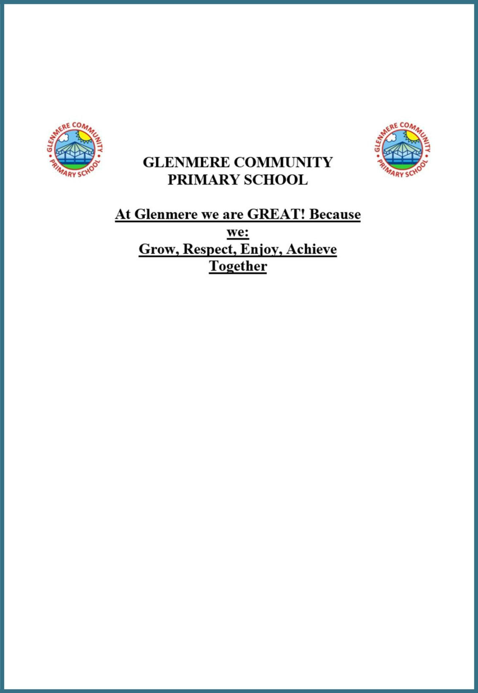

Positive Handling Policy

Last updated: July 2022

Contents:

Statement of intent
- Legal framework
- Roles and responsibilities
- What is positive handling?
- What is reasonable force?
- Use of positive handling and reasonable force
- SEND
- Reporting incidents
- Complaints
- Staff training
- Monitoring and review
Appendices
Appendix 1 – Positive Handling Report Form Appendix 2 – Positive Handling Log

Statement of intent
Glenmere Primary School believes that it is important to establish a safe, secure and stable environment to enable pupils to grow, develop and learn. To achieve this, the school recognises that, in certain circumstances, managing violence through control and restraint may be necessary.
This policy acknowledges that situations may arise in which staff members will be required to use positive handling, and in some cases reasonable force, in order to manage conflict when other measures have failed to do so.
The aim of this policy is to ensure that actions such as positive handling and reasonable force are used in a correct and safe manner, which is in accordance with the relevant legislation and national guidance.

Signed by:
Headteacher Date: Chair of governors Date:

Legal framework

    - This policy has due regard to all relevant legislation including, but not limited to, the following:
      - The Education Act 2011
      - The Children Act 1989
      - The Equality Act 2010

    - This policy has due regard to the following guidance:

      - DfE (2013) ‘Use of reasonable force in schools’
DfE (2018) ‘Working Together to Safeguard Children’
      - DfE (2018) ‘Keeping children safe in education’

    - This policy operates in conjunction with the following school policies:

      - Allegations Against Staff Policy
      - Special Educational Needs and Disabilities (SEND) Policy
      - Behavioural Policy

Roles and responsibilities

  - The governing body is responsible for:

    - Monitoring the overall implementation of this policy.
Evaluating the Positive Handling Log to analyse how and when positive handling is used and identify any trends.
    - Reviewing this policy on an annual basis.
    - Responding to any complaints, in liaison with the headteacher, from pupils or parents regarding the use of reasonable force.

  - The headteacher is responsible for:

    - Ensuring all members of staff receive the appropriate training to use reasonable force.
    - Ensuring all members of staff understand the correct conduct in terms of positive handling.
    - Handling any allegations of abuse in line with the Allegations of Abuse Policy.
Maintaining the Positive Handling Log and sending this to the governing board at the end of each term for it to be evaluated.
Ensuring that any member of staff who uses reasonable force completes the Positive Handling Report Form.

    - Responding to any complaints, in liaison with the governing body, from pupils or parents regarding the use of reasonable force.

  - The SENCO is responsible for:

    - Providing training to members of staff on how to handle pupils with SEND.
    - Ensuring staff understand how pupils with SEND may react differently to reasonable force.
    - Ensuring that staff understand the additional vulnerability of pupils with SEND or medical conditions.
    - Developing individual behaviour plans for more vulnerable pupils and ensuring teaching staff are aware of these.
    - Ensuring that staff understand how reasonable force principles may need to be adapted for pupils with medical conditions.

  - The DSL is responsible for:

    - Providing staff with regular reasonable force training.
    - Ensuring all members of staff use reasonable force in accordance with this policy.
    - Reviewing this policy in liaison with the headteacher and governing board.

What is positive handling?

  - For the purpose of this policy, ‘positive handling’ is the positive application of force with the intention of protecting pupils and limiting damage to property.

  - Legal framework and national guidance often refers to the ‘use of force’ – this policy uses the term ‘positive handling’ whenever possible.

  - Positive handling is used in the school to:

    - Restrain a pupil who has lost emotional self-control until the situation is diffused.
    - Limit the amount of harm that the pupil involved can do to their self or others.
    - Demonstrate to pupils that they are within a safe environment in which adults can contain pupils’ anger and other erratic emotions.
    - Protect all pupils against any form of physical intervention which is unnecessary, inappropriate, excessive or harmful.

  - Positive handling will be limited to emergency situations and used only as a measure of last resort.

  - Where positive handling is required, the school will abide to the following guidance:
    - Initial intervention will always be without force.
    - Any physical intervention will follow other appropriate actions.
    - Staff will take a calm and measured approach in all situations.

  - Failure to positively handle a pupil who subsequently gets injured, or injures another pupil, could lead to an accusation of negligence.

  - Positive handling will never be invasive, humiliating, flirtatious in nature or take a form which could be seen as punishment.

  - Positive handling will be applied as an act of care and control with the intention of re-establishing verbal control as soon as possible and, at the same time, allowing the pupil to regain self-control.

What is reasonable force?

  - There is no statutory definition of reasonable force; it will always depend on the circumstance of the case.

  - The use of reasonable force is only acceptable to control pupils or restrain them.

  - ‘Control’ refers to either passive physical contact, such as blocking a pupil’s path, or active physical contact such as leading a pupil by the arm.

  - ‘Restraint’ refers to physically bringing a pupil under control, such as holding them back. This is typically used in more extreme circumstances, such as to separate two pupils fighting.

  - The degree of force that is used will depend on the pupil’s circumstances,
e.g. age.

  - Staff members will always use actions that are appropriate and in proportion to the circumstances of the incidents.

  - All incidents that involve the use of reasonable force will be reported to the headteacher, recorded in writing and communicated to the pupil’s parents.

  - The school is able to use reasonable force in situations when:

    - Disruptive children must be removed from the classroom and have previously refused to leave.
    - Members of staff need to control disruptive pupils on school trips, or similar.

    - Members of staff must prevent a pupil from leaving a classroom when doing so would lead to a risk to their safety.
    - A pupil is attacking a member of staff or another pupil.
    - A pupil is at serious risk of harming themselves and a member of staff must intervene to prevent this.

  - Physical intervention will never be used as a substitute for good behavioural management in accordance with the school's Behavioural Policy.

Use of positive handling and reasonable force

  - All members of staff will be permitted to use positive handling where they believe it to be appropriate, as long as all necessary precautions are taken.

  - The power to positively handle pupils also applies to any individual whom the headteacher has identified as temporarily in charge, such as volunteers.

  - The decision to physically intervene during a situation is down to the professional judgement of the member of staff and always depends on the circumstances.

  - Staff will always calmly communicate the reasons for their actions to the pupil and explain why it was necessary in a non-threatening manner.

  - Staff will never give the impression that they are acting out of anger or are punishing the child.

  - All staff members will develop strategies and techniques for dealing with difficult pupils and situations, which they will use to diffuse and calm a situation.

  - In non-urgent situations, staff will always try and deal with a situation through other strategies before using force.

  - Staff members will always avoid acting in a way that could cause injury; however, dependent on the circumstances, this may not always be possible.

  - Where a member of staff believes that they are at risk, such as where an injury is likely to occur, they will not intervene in an incident without help and assistance of another staff member.

    - Emergency intervention is necessary when there is a high risk of pupils being injured or property being damaged.
    - If emergency intervention is required, a member of staff will use other methods of defusing the situation, without physically intervening, until assistance arrives.

  - Following the event, the pupil involved may be subject to separate disciplinary procedures, in which strategies should be formed to help avoid reoccurrence of such incidents.

  - Where necessary, external agencies, such as the LA or the police if a crime has been committed, will be informed of the incident.

  - Positive handling techniques which present an unacceptable risk and are therefore in question include:

    - The ‘seated double embrace’ where two staff members force a pupil into a sitting position and lean them forward whilst a third staff member monitors their breathing.
    - The ‘double basket-hold’ in which a pupil’s arms are held across their chest.
    - The ‘nose distraction technique’ which involves a sharp upward jab under the pupil’s nose.

SEND

  - The school will have due consideration to the risks posed by the additional vulnerability of pupils with SEND in terms of positive handling.

  - The SENCO will ensure that the stipulations of the Equality Act 2010 are adhered to in relation to reasonable adjustments, non-discrimination and the Public Sector Equality Duty.

  - The school will adhere to its Special Educational Needs and Disabilities (SEND) Policy at all times.

  - To reduce the occurrence of challenging behaviour that can lead to the use reasonable force, the SENCO will establish individual behaviour plans for pupils with SEND.

  - The SENCO will liaise with the DSL, in terms of using positive handling on pupils with SEND, and establish how training may need to be amended.

Reporting incidents

  - A detailed written report will be kept of any incidents where force is used.

  - Immediately following an incident, the member(s) of staff involved will verbally report the incident to the headteacher and provide a comprehensive written record of the situation as soon as possible, using the Positive Handling Report Form and CPOMS.
  - The written report of the incident must be thorough, including as much detail as possible as to what had happened before, during and after the incident, and describing any injuries incurred due to the event.

  - The headteacher will make the decision as to whether it is appropriate to inform the pupil’s parents of the details of an incident. If it is appropriate, the following will be adhered to:

    - Parents will be informed in writing and a copy of this report will be given to the member(s) of staff involved in the incident.
    - The report will inform parents of their right to complain about the use of positive handling and reasonable force.

  - If a member of staff witnesses or suspects the use of positive handling or reasonable force, where another member of staff is actively involved in physical intervention, they will report this to the headteacher immediately.

  - Any allegations against staff will be dealt with as a matter of urgency, and in accordance with the procedures outlined in the school’s Allegations Against Staff Policy.

  - The headteacher will be responsible for conducting a thorough investigation to find out the correct details of what occurred; this may include talking to other pupils about the incident, for instance those who witnessed the event.

Complaints

  - All members of staff will be made fully aware of the consequences and legal retributions that can occur following the incorrect use of positive handling and force.

  - All complaints regarding the use of positive handling or force will be investigated in a thorough and speedy manner.

  - The person making the complaint is responsible to prove that their allegations are true, and therefore, it is not for the member of staff to prove that their actions were made reasonably.

  - In extreme circumstances, parents may take civil action or pursue a criminal prosecution.

  - In the case where a member of staff has acted within the law, this will provide a defence to any civil or criminal prosecution.

  - Members of staff accused of using excessive force will not be automatically suspended as a response to the allegations. The following procedure will be adhered to:

    - Careful consideration will be given to whether the case warrants a person being suspended until the allegation is resolved.
    - The governing body will always take into account whether a staff member has acted within the law when considering whether or not to take disciplinary action against a staff member involved in an incident.
    - Where a member of staff is suspended, the school will ensure that the staff member has access to a named contact that can provide support and guidance.
    - The school will provide pastoral care to any member of staff who is subject to a formal allegation.

Staff training

  - The DSL will conduct annual safeguarding training for all members of staff, which focusses on the most effective positive handling strategies and use of reasonable force techniques.

  - All staff will be regularly reminded of the positive handling techniques employed by the school, and will communicate these to the pupils they are in contact with.

  - Only techniques and strategies that have been previously discussed with the headteacher and DSL, and have been safely demonstrated, will be used.

  - Staff will be made aware of subsequent risks of their actions and fully understand when it is appropriate and necessary to use such actions.

Monitoring and review

  - This policy will be reviewed on an annual basis by the headteacher, DSL and governing body, who will consider any necessary changes and communicate the findings of the review to all members of staff.

  - The headteacher will review records of the use of positive handling and reasonable force on a termly basis, to analyse the frequency of occurrence and determine what further measures could be taken to prevent these situations from reoccurring.

Positive Handling Report Form
We believe that positive handling and reasonable force should only be used when absolutely necessary. With this in mind, this form has been created to ensure that all incidents of this type are recorded. Incidents must also be documented in the Positive Handling Log.

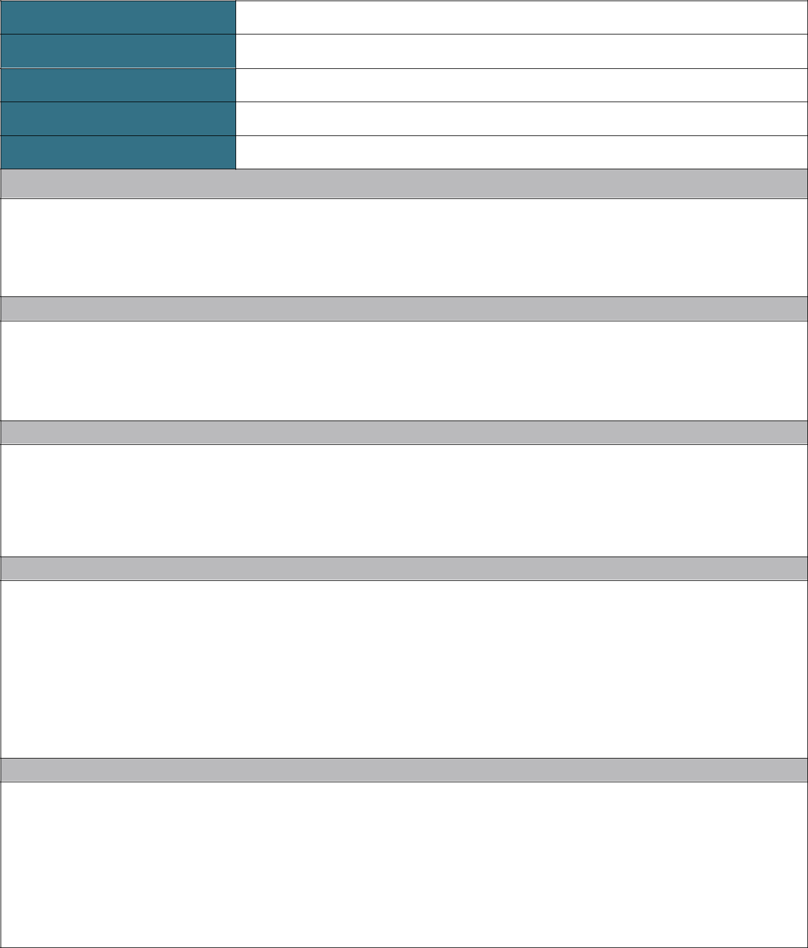
Name of staff member: Name of pupil:
Date: Time: Location:
Name(s) of staff member(s) who witnessed the incident:

Informed parties (parents, social workers, police etc.):

Circumstances prior to the incident:

Details of the incident:

Details of any negative impact on other pupils:

Reason(s) for positive handling (please tick):

Danger to self Danger to others
Significant damage to property

Details of the intervention:

Any disciplinary additional action taken:

Injuries (if any) to staff members, the pupil concerned or other pupils:

Damage (if any) to property:

Recommendation(s) to avoid future incidents:

Headteacher’s signature: | Date:
Signature of staff member concerned: | Date:

Positive Handling Log
We believe that positive handling and force must only be used when absolutely necessary. Positive handling will always to be used in accordance with the Positive Handling Policy. All incidents of this nature must be recorded in this log. Details of the individual incident will be recorded using the Positive Handling Report Form.

Date and | Name of | Name of | Name(s) of | Injuries (if any) to | Damage (if any) to | Nature of intervention | Was the | Signed by staff
 |  | staff |  |  |  |  | headteacher
time | pupil |  | witnesses | pupils or staff | property |  |  | member
 |  | member |  |  |  |  | notified?

