Glenmere Community Primary School

Primary Age-appropriate Child-on-Child Abuse Policy

Date policy last reviewed: | September 2022

Signed by:
 | Headteacher | Date:
 | Chair of governors | Date:

Last updated: 30 June 2022
Contents:
Feeling safe and happy at school
- What is child-on-child abuse?
- Bullying
- Sexting
- Sexual violence and sexual harassment
- Relationships
- How do I know if someone is being abused?
- What do I do if someone else is being abused?
- What do I do if I am being abused?
- Who can I talk to?
- How can I help stop abuse from happening?

Feeling safe and happy at school
At Glenmere Community Primary School we want to make sure that you feel looked after, safe and happy when you are in and out of school.
Sometimes we don’t know if something bad is happening, so you need to tell us.
This policy looks at child-on-child abuse, and what you can do when you feel you are being abused, or when you notice someone else being abused.
We can help you by:
- Teaching you what child-on-child abuse is.
- Teaching you what to do if you feel like you are being abused, or if someone else is being abused.
- Making sure you know who you can speak to if you are worried.

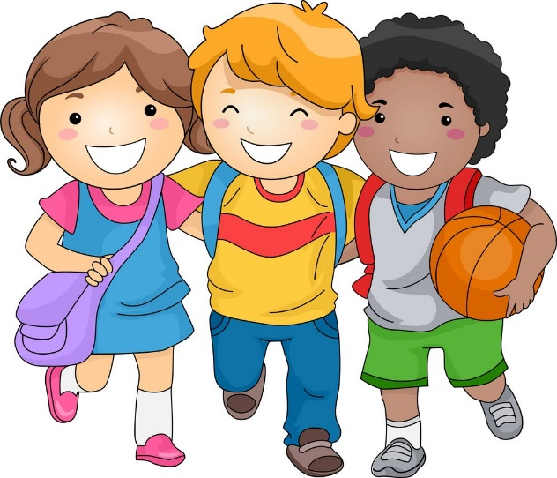

What is child-on-child abuse?
A peer is someone who might be your friend, a child at school with you, or another child you may know. You may sometimes hear child-on-child abuse referred to as ‘peer-on-peer’ abuse.
Abuse is something which usually physically or emotionally hurts another person by using behaviour that is meant to scare, hurt or upset that person.
Child-on-child abuse can happen inside and outside of school – it can happen online or in-person, and it is important to let an adult know if you think you or someone else is being affected by child-on-child abuse.
Remember to ask a teacher if you are unsure about what child-on-child abuse looks like.
It is not always easy to identify abuse when it is coming from a peer, such as a friend or a classmate, but it is really important to look out for the signs of child-on-child abuse and report it so that we can make sure it stops.

Bullying
Bullying is a type of abuse that takes place when someone tries to hurt another person on purpose. People can be bullied in many different ways which may include the following:
Emotional bullying includes hurting someone’s feelings, for example by leaving them out or bossing them about. People can sometimes use emotional bullying to take advantage of you to get their own way by making threats or making you feel like you have to do something for them.
Physical bullying can include hitting, kicking, shaking, biting, hair pulling or purposely hurting someone.
Verbal bullying can include insulting someone because of how they look or because of their personality, and can often go beyond that. People can also use verbal bullying to be racist, sexist or homophobic.
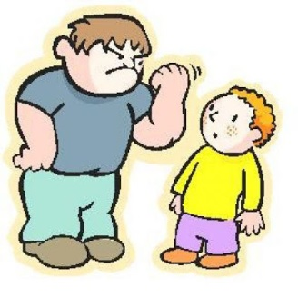
Racist bullying is bullying someone because of their race, skin colour, the country they are from or the religion they believe in.
Homophobic, biphobic and transphobic bullying means bullying someone because of their sexuality or gender; calling someone gay or lesbian to hurt their feelings would be homophobic. Transphobic bullying may include mocking a person’s gender identity, for example pestering someone about whether they are a boy or a girl.
Sexist bullying is bullying someone because of their sex – this is different to transphobic bullying and is typically targeted against girls. Sexist bullying may include thinking that boys are better than girls or stereotyping. Ask your teacher if you are unsure about the difference between sex and gender identity.
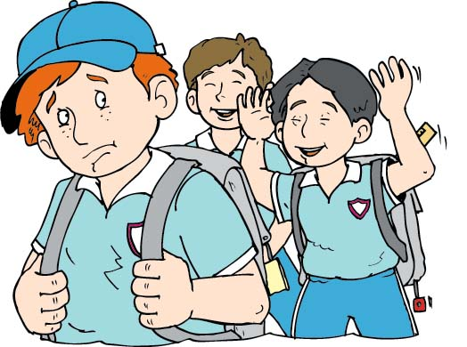
Cyberbullying includes any kind of bullying which takes place online; cyberbullies send insulting messages over the internet and sometimes share secret information online to hurt someone’s feelings.
Bullying is not always done by one person and can often involve a group of people ‘ganging up’ on someone – if you ever see someone being bullied, never join in and always tell a teacher.

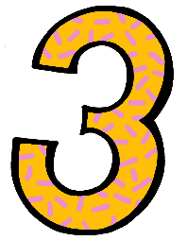
Sexting
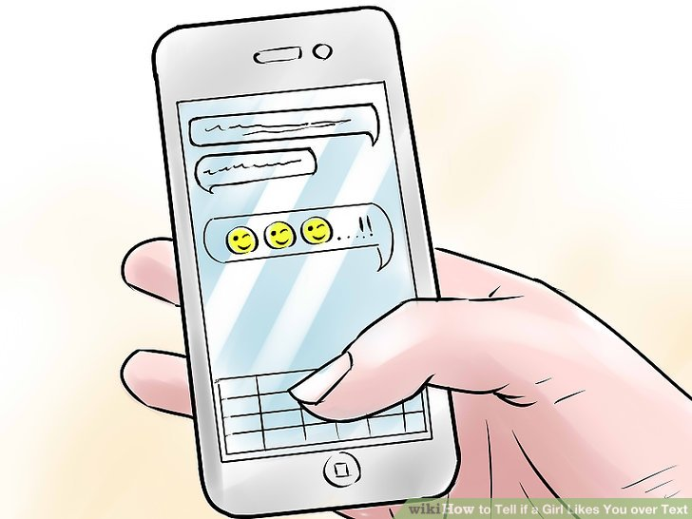
Sexting is sending inappropriate pictures, videos or messages – they can sometimes be called ‘nudes’, ‘nude pics’ or ‘rude pics’, but can also be rude messages.
Pressuring someone into sending these pictures, videos and messages is abuse.
It is important to know that sharing nude images or videos is illegal even if consent is given.
Consent means that someone has given another person permission to do something.
If consent has not been given for someone to share nude images or videos to another person, it is abusive and illegal.
Even if you are not the person who is sending them, it is illegal to have these kind of pictures or videos of a person if they are under 18 years old.

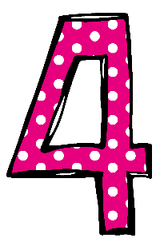
Sexual violence and sexual harassment
Sometimes, people can act sexually towards others, and it might make them feel uncomfortable.
This can happen online and face-to-face (both physically and verbally) and is never acceptable at any age.
It might make someone feel scared, embarrassed, uncomfortable or upset.
It could be:
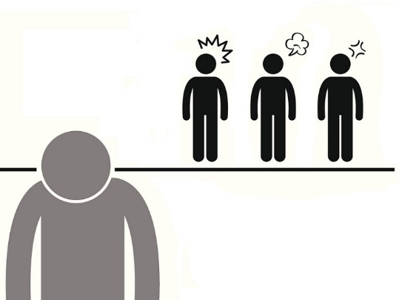
- Someone making sexual comments, like telling sexual stories, saying rude things, or saying sexual things about someone’s appearance or clothes.
- Calling someone sexual names.
- Sexual jokes or teasing.
- Being physical, like touching which makes someone feel uncomfortable or messing with their clothes.
- Showing pictures or drawings which are of a sexual nature.
- Being sexual online, like sharing sexual pictures and videos, or posting sexual comments on social media.
- Sexual threats or pushing someone to do something sexually that they don’t want to or aren’t ready for.
It is important to remember that our school as a zero-tolerance approach to sexual violence and sexual harassment – it will never be acceptable and will never be passed off as “banter” or “just having a laugh”. Everyone at our school must recognise that sexual violence and harassment is not normal.
If you ever feel like you have been affected by sexual harassment, make sure that you tell a responsible adult, and they will listen to what happened and support you with any worries that you will be likely to have.

Relationships
Any relationship you have should be positive and make you feel safe, happy and comfortable.
A negative relationship might make someone feel scared, confused, worried and even unsafe.
It is really important that you know the difference between a positive relationship and a negative relationship.
Positive relationships
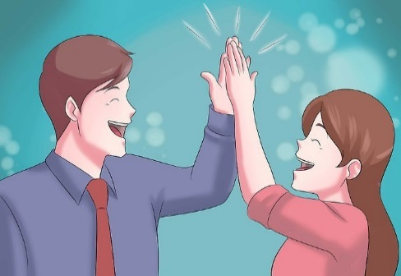
- You are comfortable around that person.
- You can be honest with that person.
- You can say how you feel and what you are thinking, and you listen to each other.
- You support each other and treat each other well.
- You feel safe.
- You trust that person.
- You do helpful things for each other.
- You are never pressured to do anything that makes you feel uncomfortable.
- You feel looked after.
Negative relationships
- The person might push you, hit you or break your things.
- The person might tell you what to do, what to wear or who you can see.
- You might feel scared – they might say they will hurt you if you don’t do something.
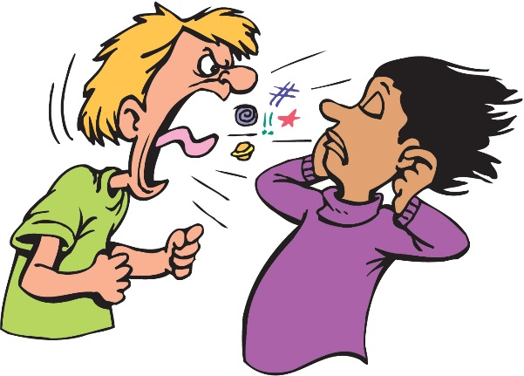
- They might make threats or do harmful things if you do something they did not want you to do.
- The person might call you names, make you feel bad in front of other people and make you feel bad about yourself.
- The person might get angry easily and you may not know what will make them angry – it might make you feel nervous.
- The person might pressure you to do things you don’t want to do or are not ready for.
- The person might not take no for answer when you say you don’t want to do something.

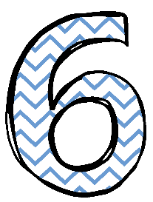
How do I know if someone is being abused?
It might be hard for you to know if you are being abused and you might not really understand it is happening. It is important you can recognise when behaviour isn’t appropriate.
It’s also important that you can notice when someone else might be being abused.
Some signs might be:
- Not going to school.
- Having injuries, like bruises.
- Feeling sad and down.
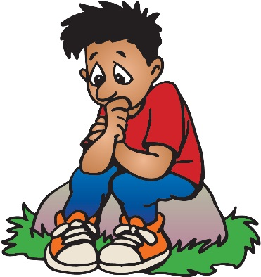
- Feeling like they can’t cope.
- Feeling withdrawn or shy.
- Getting headaches or stomach aches.
- Feeling nervous.
- Not being able to sleep, sleeping too much or getting nightmares.
- Feeling panicked.
- Changing their looks to look much older.
- Being abusive to someone else.
Remember: you can feel all of these things too. Listen to how you feel, and know that these signs can mean you are being abused.

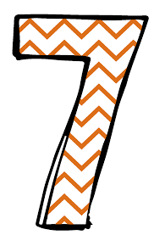
What do I do if someone else is being abused?
If you think that someone is being abused, it is important that you help that person.
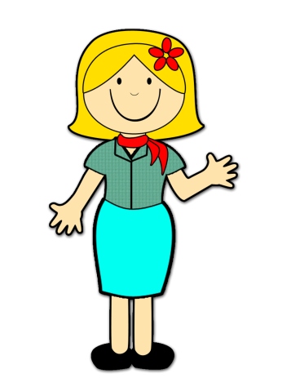
You should never walk away and ignore the problem if you see someone else being abused, because the abuse may keep happening.
If you can, and it is safe to do so, tell the person being abusive to stop, but never get angry or hit them.
Tell a responsible adult, such as a teacher, as soon as you’ve seen someone being abused.
A responsible adult can stop the abuse and give their support to the person who is being abused.
You should never feel scared to tell someone about abuse.
Sometimes, you might not see someone being abused, but you might be worried about them. You might think they are being abused by someone you don’t know, or someone they have told you about. It’s really important you tell someone even if you are worried, but haven’t seen any abuse.

What do I do if I am being abused?
The first thing you should do is tell someone you trust. This could be a family member, a friend or a teacher.
You can also tell the person abusing you to leave you alone. If telling them to leave you alone would make you feel too scared or worried that they might hurt you, make sure you tell someone so they can help.
You should try not to:
- Do what the person says.
- Let what the person says or does upset you.
- Get angry or hit them.
Always remember that if you are being abused, it is not your fault and you are never alone.
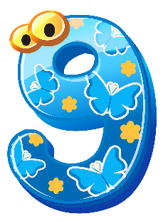

Who can I talk to?
It is important you tell someone as soon as you think that you are being abused, or you think that someone else being abused.
Speaking to someone like your parent, carer or teacher will mean that we can make sure the abuse stops and doesn’t happen again.
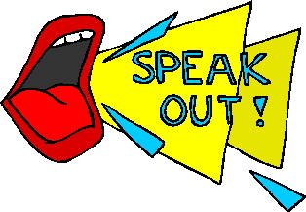
The list below shows the people at our school that you can speak to:
- Mr Harvey
- Miss Murray
- Mrs Tansey (ELSA)
- Mrs Conlon
- Your Class teacher
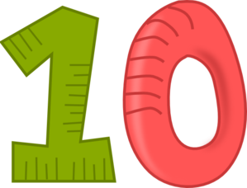

How can I help stop abuse from happening?
We can all help stop abuse at our school by:
- Making sure we understand how we should treat others.
- Helping others when they are in need.
- Being kind, friendly and respectful to others.
- Thinking about people’s feelings before we say or do something.
- Looking back at this booklet and pay attention to school activities such as assemblies, which talk about child-on-child abuse.
- Talking to someone when we are worried.
You should know that abuse is never OK and it is serious. It is not funny, or part of growing up. If you abuse someone, you will get into trouble.

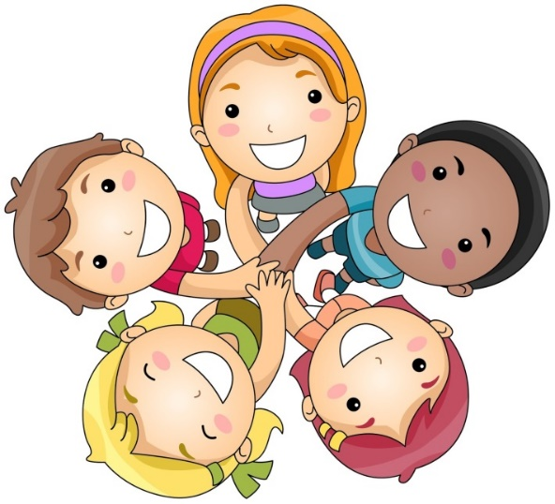
Let’s make Glenmere Community Primary School a happy place!

