Social Media Policy

202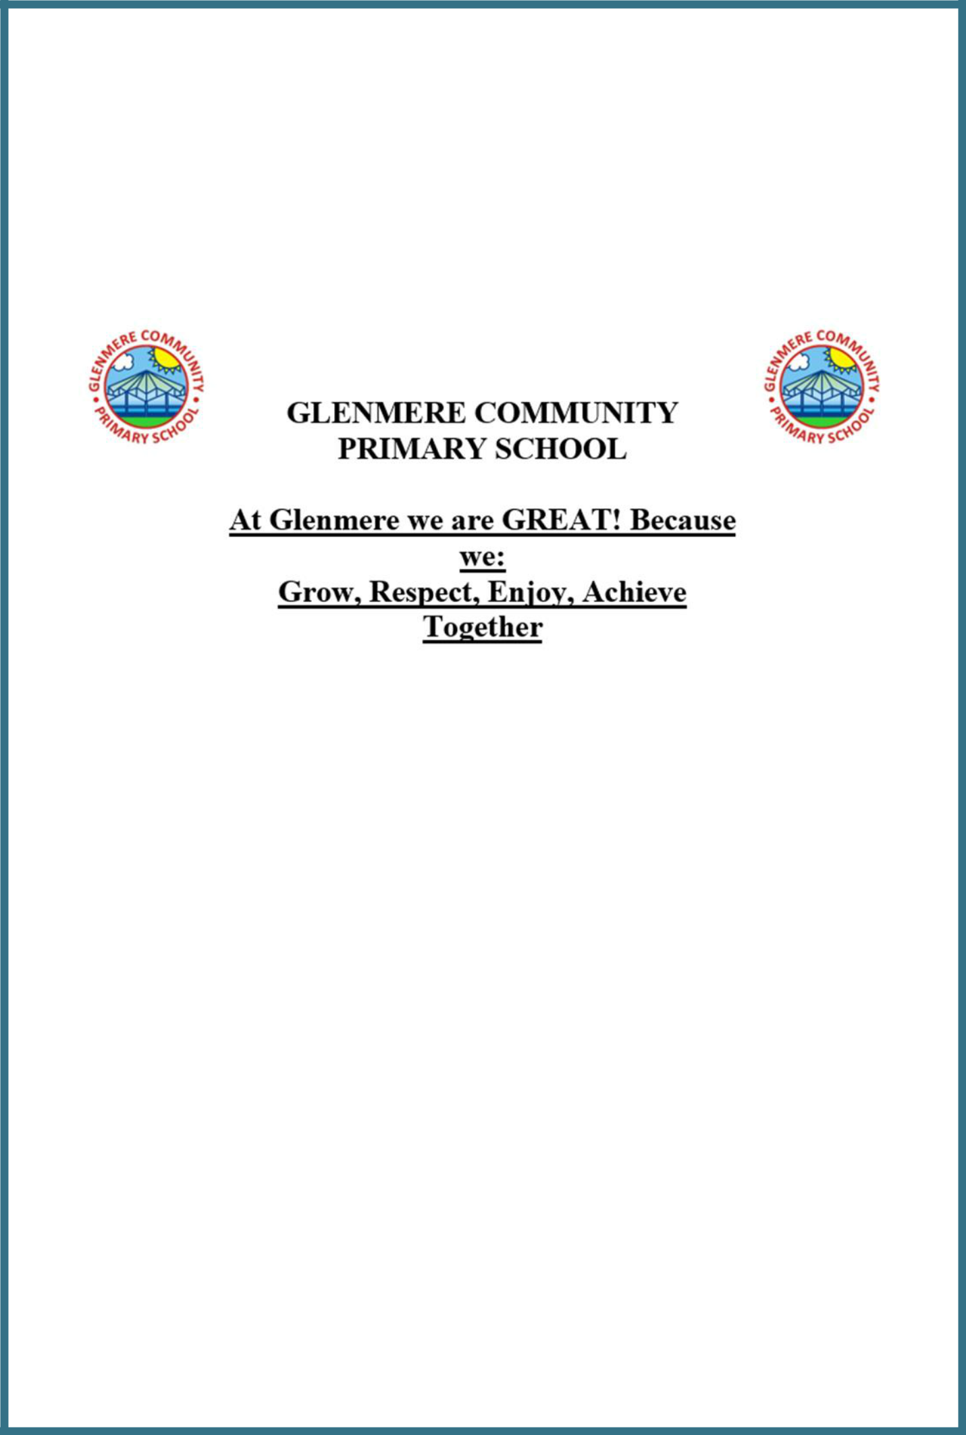4-25

|  |  |
| --- | --- |
| SOCIAL MEDIA POLICY | June 2025 |
| Date of Last Review | June 2025 |
| Next Review Due | June 2026 |

Social Media Policy 2024-2025

This policy has been written to help guide parents with the use of social media. It gives information on how Glenmere Primary School is using social media to communicate with parents and what are ‘good practice’ guidelines and E-Safety advice linked to the use of Social Media.

# What is ‘Social Media’?

Social Media is where you can interact with others online, such as Facebook, Twitter, messaging, blogs and forums/online discussion forums. These bring opportunities to understand, interact and communicate with audiences in new and exciting ways. It is important that people are able to use these appropriately and safely.

# Communication

Glenmere Primary school School use a variety of different ways of communicating with parents. These include daily opportunities for face to face contact, Parent mail updates, school website, parent consultations, informal parent/teacher meetings, phone calls, and emails, parent surveys and via the ClassDojo. In addition to this we use Twitter to share updates, celebrations and information with parents and the wider community.

You can visit us on our website <https://www.glenmere.leics.sch.uk/> or on Twitter @glenmere.

The purpose of using social media as a way of communicating with parents is to provide quick and relevant information about school life.

***Please note that staff are strongly advised not to become ‘friends’ with parents on sites like Facebook, as this can blur professional boundaries.***

# What kind of information do we put on Social Media?

We use Social Media sites to publish information that is of general interest. We do not believe it is an appropriate place to discuss personal matters that are specific to individual members of our community whether that is children, parents or staff. We will aim to update with relevant information, without overloading parents, by giving them an insight to what we are doing in school.

Social media information does not replace information sent out in Newsletters or information given via letters home. It supports these methods of communication and allows the school to post on a regular basis with more general updates e.g. updating a school football score, what happened during a class trip, updates during residentials, etc.

# Guidance for parents using their own personal Social Media sites

We do not want to prevent parents taking photographs in the school. However, we ask that if you take photographs of school events or during school time, that the photographs you publish on any social media pages do not include other people’s children.

Think before you post. Remember that even if you have tight privacy settings, everything that you put on Facebook or Twitter is in public view. Think about this rule – if you don’t want people to see it and if you wouldn’t have the conversation face to face –don’t post it.

If you have a comment, question or concern about anything linked to school, we encourage all parents to come and speak to us.

# Principles

Safeguarding children is a key responsibility of all members of staff and it is essential that everyone at Glenmere considers this and acts responsibly if they are using social networking sites out of school.

Anyone working at Glenmere Primary school either as a paid employee or volunteer ***must not communicate with children outside of their family via social networking.***

We will not tolerate any form of bullying on our social media accounts or any comments or posts which are rude or abusive towards any member of our school community, parent, child or staff.

We will not allow comments that refer to specific matters between the school and individual members of the community.

We will not publish photographs of children without consent from parents.

By “following” us on Twitter you are agreeing to our rules about safe use of Social Media

# Code of Conduct for all members of staff at Glenmere Primary School – Social Networking

Staff need to use social networking in a way that does not conflict with the current National Teacher's Standards.

The following are ***not* considered acceptable**:

* The use of the school’s name, logo, or any other published material without written prior permission from the Headteacher. This applies to any published material including the internet or written documentation
* The posting of any communication or images which link to any form of illegal conduct, which may in turn damage the reputation of the school. This includes defamatory comments
* The disclosure of confidential or business-sensitive information; or the disclosure of information or images that could compromise the security of Glenmere Primary School
* Staff must never add pupils as friends into their personal accounts.

# In addition to the above everyone at our school must ensure that they:

* Do not make any derogatory, defamatory, rude, threatening or inappropriate comments about the school, or anyone at or connected with the school
* Use social networking sites responsibly and ensure that neither their personal/professional reputation, or the school’s reputation is compromised by inappropriate postings
* Do not give their personal contact details to pupils including e-mail, home or mobile telephone numbers, unless the need to do so is agreed with senior management and parents/carers.
* Do review and adjust their privacy settings to give them the appropriate level of privacy and confidentiality.

# Potential and Actual Breaches of the Code of Conduct

In instances where there has been a breach of the above Code of Conduct, the following will apply:

* Any breaches of this policy will be fully investigated.
* Where it is found that there has been a breach of the policy this may result in action being taken under the Disciplinary Procedure.
* A breach of this policy will be considered to be a serious disciplinary offence which is also contrary to the school’s ethos and principles.

*Reference Source - NASUWT Social networking; Guidelines for Members*