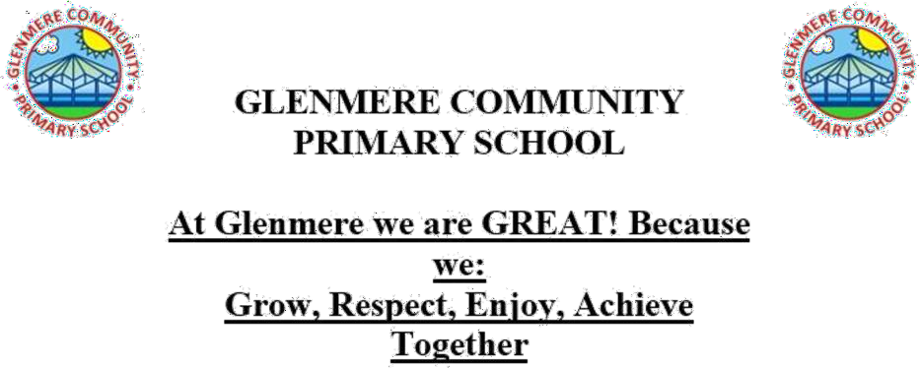

Relationship and Sex Education (RSE) Policy

|  |  |
| --- | --- |
| Date policy last reviewed: | July 2025 |

|  |  |
| --- | --- |
| Signed by: |  |
| Headteacher | Date: |
| Chair of governors | Date: |

# This policy should be read alongside our Child Protection Policy, Behaviour Policy, Online Safety Policy and Keeping Children Safe in Education.

**Introduction**

As part of our school vision, at Glenmere we aim to develop independent children who are equipped for the world they are living in, prepared for the challenges of the future and who strive for excellence in all they do….

We seek to nurture children who appreciate the richness, diversity and potential of the world beyond their own, including their responsibilities within it. We have based our school’s relationship and sex education policy on guidelines set out in the Relationships Education, Relationships and Sex Education (RSE) and Health Education 2021 statutory guidance for governing bodies, proprietors, head teachers, principals, senior leadership teams and teachers.

**Relationships Education** is compulsory in primary schools and parents do not have a right to withdraw their child. Today’s children and young people are growing up in an increasingly complex world, living their lives seamlessly on, and offline. This presents many positive and exciting opportunities but also challenges and risks. In this environment, children and young people need to know how to be safe and healthy, and how to manage their academic, personal and social lives in a positive way.

Relationship Education is taught from Reception to Year 6 and focuses on teaching the fundamental building blocks and characteristics of positive relationships, with reference to friendships, family relationships, and relationships with other children and adults. It also includes teaching the principles of positive relationships online and how to recognise and report abuse. At Glenmere, relationships education is taught by class teachers through the Kapow PSHE scheme and online safety is also taught as part of the ProjectEvolve curriculum.

**Sex Education** is not compulsory in primary schools. At Glenmere, we believe children should understand the facts about human reproduction before they leave primary school so they understand the physical and emotional changes that they will go through during puberty. We have chosen to teach RSE through the Kapow scheme that delivers a sex education programme tailored to the age and physical and emotional maturity of our pupils. It includes teaching about caring for ourselves, staying safe, growing up

and puberty, relationships and reproduction. Parents and carers have the right to request that their child be withdrawn from some or all of sex education (but not Relationships or Health Education) delivered as part of statutory RSE. Parents and carers may choose whether to opt out of the two year 6 lessons which contain sex education on a lesson-by-lesson basis. Applications should be made by completing the form in Appendix 1 and emailing to [office@glenmere.leics.sch.uk](mailto:office@glenmere.leics.sch.uk) Before granting any such request, the class teacher will discuss the request with parents and, as appropriate, with the child to ensure that their wishes are understood and to clarify the nature and purpose of the curriculum.

The Kapow scheme of work builds on learning from previous years and revisits topics to cover them in greater depth and increasing maturity. All teaching is age appropriate in approach and content. Since children of the same age may be developmentally at different stages, if pupils ask questions pertaining to sex or sexuality which go beyond what is set out for Relationships Education, such questions will be handled with sensitivity and children will either be made aware as to why that content is not suitable for their age or there will be the potential for discussion on a one-to-one basis.

The teaching of RSE will be completed by class teachers during the summer term and is taught from Year 1 through to Year 6. Families will receive a curriculum overview document informing them of the content included in the SRE lessons. Year 6 parents and carers will be invited to a Q&A session where you will have the opportunity to see the lesson plan and materials before deciding whether to withdraw from the sex education lessons.

From Year 1, children will learn the difference between appropriate and inappropriate physical contact. From Year 2, children will learn the names of the body parts and what is considered private. From Year 4, pupils begin to learn about the ways in which they will develop and grow and the physical and emotional changes of puberty. In Year 5, pupils continue to learn about puberty, and menstruation is introduced. In Year 6, pupils will learn about conception, pregnancy and birth. The Kapow Primary scheme of work includes two Year 6 lessons which parents can withdraw their children from all/part of the lesson. These are: Lesson 5 Conception and Lesson 6 Pregnancy and birth.

# Please see below the contents of Relationships and Sex Education taught at

**Glenmere in each year group.**

**Safety and the Changing Body**

|  |  |
| --- | --- |
| **Year 1**  Lesson 1 Adults in school Lesson 2 Adults outside school Lesson 3 Getting lost  Lesson 4 Making an emergency call Lesson 5 Appropriate contact Lesson 6 Safety with substances Lesson 7 Safety at home  Lesson 8 People who help to keep us safe | **Year 2**  Lesson 1 Introduction to the internet Lesson 2 Communicating online Lesson 3 Secrets and surprises  Lesson 4 Appropriate contact: My private parts  Lesson 5 Appropriate contact: My private parts are private  Lesson 6 Respecting personal boundaries Lesson 7 Road safety  Lesson 8 Crossing roads safely Lesson 9 Staying safe with medicine |
| **Year 3**  Lesson 1 First aid: Emergencies and calling for help  Lesson 2 First aid: Bites and stings Lesson 3 Be kind online  Lesson 4 Cyberbullying Lesson 5 Fakes emails Lesson 6 Making choices Lesson 7 Influences  Lesson 8 Keeping safe out and about | **Year 4**  Lesson 1 Internet safety: Age restrictions Lesson 2 Share aware  Lesson 3 First aid: Asthma Lesson 4 Privacy and secrecy  Lesson 5 Consuming information online Lesson 6 Growing up  Lesson 7 Introducing puberty Lesson 8 Tobacco |
| **Year 5**  Lesson 1 Online friendships Lesson 2 Staying safe online Lesson 3 Puberty  Lesson 4 Menstruation  Lesson 5 Emotional changes in puberty Lesson 6 First aid: Bleeding and head injuries  Lesson 7 Alcohol, drugs and tobacco: Making decisions | **Year 6**  Lesson 1 Alcohol  Lesson 2 Critical digital consumers Lesson 3 Social media  Lesson 4 Physical and emotional changes of puberty  Lesson 5 Conception (Parents have the right to withdraw their child from **part of** this lesson after the menstruation video)  Lesson 6 Pregnancy and birth (Parents have the right to withdraw their child from this lesson)  Lesson 7 First aid: choking  Lesson 8 First aid: basic life support |

Parents and carers may request to see lesson plans at any time by contacting their child’s class teacher.

At Glenmere, we promote respect for all and value every individual child. We also respect the right of our children, their families and our staff, to hold beliefs, religious or otherwise, and understand that sometimes these may be in

tension with our approach to some aspects of Relationships, Health and Sex Education. The makeup of our student body, including the gender and age range of our pupils will be taken into account and it will be considered whether it is appropriate or necessary to put in place additional support for pupils with protected characteristics. RSE lessons will be delivered through high quality, differentiated and personalised teaching to ensure it is accessible to all pupils, including those with SEND.

The Kapow curriculum for PSHE emphasises acceptance of all children and families. For children in EYFS or KS1, LGBTQ is not mentioned specifically. However, in lessons about families, pictures are used to promote discussions about differences between families. In KS2, whilst LGBTQ is not explicitly discussed, gender stereotypes are. If appropriate for the class, discussions may be held about how gender is different to biological sex and that ideas about gender can and have changed over time and place.

**Health Education** is compulsory in primary schools and parents do not have a right to withdraw their child. It aims to give your child the information they need to make good decisions about their own health and wellbeing, to recognise issues in themselves and others, and to seek support as early as possible when issues arise. Teaching children about puberty is now a statutory requirement which sits within the Health Education part of the DfE guidance. At Glenmere, staff teach this through the Kapow PSHE scheme. Some of the themes include mental wellbeing, physical fitness, healthy eating and basic first aid. These themes are considered each year with age related resources to support their development. Within the national curriculum, certain aspects of body changes, e-safety and physical wellbeing are covered within science, computing and PE.

# Formative and summative assessment

Every lesson begins with the ‘Recap and recall’ section which is intended to allow pupils retrieval practice of key knowledge relevant to the upcoming lesson. This section also provides teachers with an opportunity to make informal judgements about whether pupils have retained prior learning and are ready to move on. Each lesson contains the ‘Assessing progress and understanding’ section which helps teachers to identify those pupils who are secure in their learning or working at a greater depth in each lesson. Each unit has accompanying assessment quizzes to support the teacher in checking the key knowledge and skills from the unit have been retained.

# Parent form: withdrawal from sex education within RSE

|  |  |  |  |
| --- | --- | --- | --- |
| TO BE COMPLETED BY PARENTS | | | |
| Name of child |  | Class |  |
| Name of parent |  | Date |  |
| Reason for withdrawing from sex education within relationships and sex education | | | |
|  | | | |
| Any other information you would like the school to consider | | | |
|  | | | |
| Parent signature |  | | |

|  |  |
| --- | --- |
| TO BE COMPLETED BY THE SCHOOL | |
| Agreed actions from discussion with parents |  |
|  |  |