
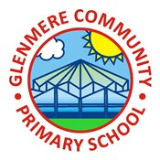
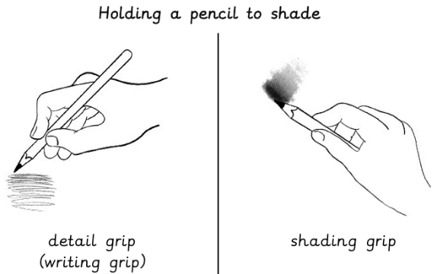
Year 3 Art & Design Knowledge Organiser Autumn 1
Drawing: Developing drawing skills
Focus Artist: Yellena James
Knowledge
 | See like an artist  - Looking for shapes in objects is a good technique to help draw more accurately  - Sketching is quick, rough drawing using basic shapes and light pencil pressure to explore ideas  - Details are added later when refining a drawing
Shading
- Shading is drawing marks to show areas of light and dark
- Using the shading grip and smoothly changing the pressure I can change the tone
Take a closer look
- Creating artwork using careful observation is called observational drawing
- Careful observation can lead to more accurate and detailed artwork
Imagination in bloom
- Unusual shapes and combinations of lines and marks can form effective compositions
- I can make artistic decisions by:
- Using different marks to show texture or tone
- Apply different pressures when controlling my pencil
- Varying my speed to create different marks and lines
- Use geometric and organic shapes
- Be inventive and make things up
Paper to pixels
- Illustrators are artists who create art to go with stories, poems or information in books, magazines and other media
- Digital art is made using electronic devices and computers

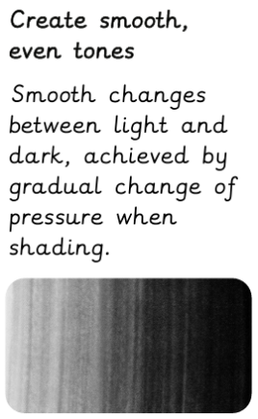
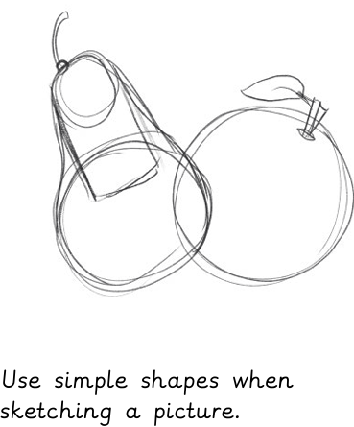
Key Vocabulary
Tone | How light and dark something is
Blend | To mix colours or shades together smoothly
Even tones | Smooth changes between light and dark, achieved by gradual change of pressure when shading
Observation | To look at something carefully and notice all the details
Organic | Irregular natural shapes
Geometric | A regular shape with straight lines and angles


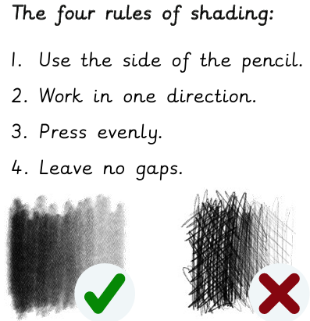
Yellener James, originally from Bosnia, combines complex abstract forms, using colorful arrangements of organic shapes and lines into dazzling imagery.

