
Science Knowledge Organiser
Autumn 1 – Energy: Electricity and Circuits
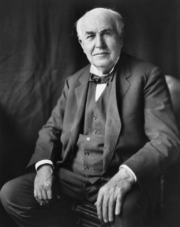 | Thomas Edison was called a “wizard” because of his many important inventions. He created more than 1,000 devices on his own or with others. His best-known inventions include the phonograph (record player), the lightbulb, and the motion-picture projector.

Question for Learning;  How are electrical appliances powered?  - Some devices use batteries and others are mains powered.  - Mains electricity is very powerful and dangerous, batteries are a safe source of electricity but contain harmful chemicals. |   Identifying, grouping and classifying
Question for Learning;  How do you construct an electrical circuit?  - Key words: Cell, battery, battery holder, bulb, bulb holder, wires, crocodile clips, circuit, switches, buzzer.  - Circuits can be complete or incomplete.  - It doesn’t matter how big the circuit is, the bulb will still light as long as it is a closed circuit.  - simple series circuit by connecting a battery, bulb and wires in one continuous loop.  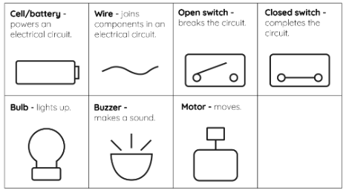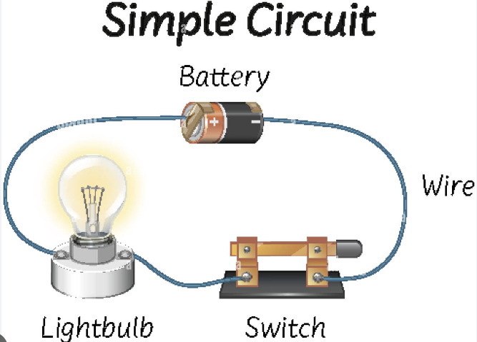 | 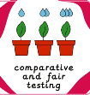  Comparative and fair testing
Question for Learning;  How does a switch work in a circuit?  - A switch works by breaking or forming a complete loop in the circuit.  - Some of the uses of switches are controlling when appliances are on, keeping us safe around electricity and playing buzzer games.  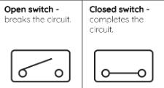 | 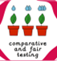  Comparative and fair testing
Question for Learning;  Which materials are conductors and insulators?  - A material is a good electrical conductor if it is added to a series circuit and the bulb lights. If the material lets electricity flow through it the bulb will light.  - A material is a good electrical insulator if it is added to a series circuit and the bulb does not light.  - Metals are good electrical conductors and plastics are good electrical insulators. | Comparative and fair testing
Question for Learning;  What effects bulb brightness?  - The more bulbs added to a series circuit, the dimmer the bulbs will be.  - When more bulbs are added to a circuit, less energy is transferred to each bulb, causing them to be dimmer. | Comparative and fair testing
Question for Learning;  How can we be safe around electricity?  - Precautions for working safely with electricity, such as not inserting metal items into electrical appliances and not using water next to them.  - Inventing new materials or appliances may change safety advice, such as the invention of the plastic coating used around telephone wires.  - If plastic layers around wires break apart, the electrical wire is no longer insulated and may stop working or cause an electric shock. |   Research
Key Words
Battery | A battery stores chemical energy in a form that can be converted into electrical energy on demand.
Light bulb | A light bulb is the round glass part of an electric light or lamp which light shines from.
Battery cell | A cell is a single-unit device which converts chemical energy into electric energy.
circuit | A circuit is a device made of other, smaller electrical devices that can move the flow of electricity through itself to power larger devices.
hazard | If something is a hazard, it is a potential source of danger.
electrical conductor | Materials that allow electricity to pass through them easily are called electrical conductors. Examples of these materials include many metals, such as iron, steel, copper, and aluminum.

