
Year 4 Personal Development Curriculum
Other experiences that will take place throughout the year to support and promote our Personal Development
Fundraising: Children in Need, Red nose Day, Jeans for Genes, Christmas Jumper Day(save the children), Harvest Festival.
Experiences: Cooking, baking, trips, competitions, visitors, workshops, theatre companies, escape rooms, gardening, life skills
Assemblies: Everyone Welcome, Picture News, Protected characteristics, Values, Awareness Days. Visitors assemblies
British Values Key Vocabulary
British value  of democracy | democracy, vote, voting, secret ballot, government, one person one vote, laws, rules, parliament, council, representative,  campaign, democratic change, society
British Value  of rule of  law | law, rules, everyone, rights and responsibilities, police, courts, proper order, safety, wellbeing.
British value  of mutual  respect and  tolerance for  diversity | respect, mutual (two way), diversity (gender, disability, faith, belief, ethnicity), care, friendship, everyone has beliefs  and some people have religious beliefs.
British Value  of individual  liberty | choice, own beliefs, freedoms, liberty, individual, each person, protect.
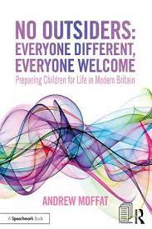

No Outsiders, Everyone Different, Everyone Welcome
Book | Learning intention
Along Came A Different by Tom McLaughlin | To help someone accept difference
Dogs Don’t Do Ballet by Anna Kemp and Sarah Oglivie | To choose when to be assertive
Red: A Crayon’s Story by Michael Hall | To be proud of who I am
Aalfred and Aalbert by Morag Hood | To find common ground
When Sadness comes to Call by Eva Eland | To look after my mental health
King and King by Linda de Haan and Stern Nijland | To show acceptance

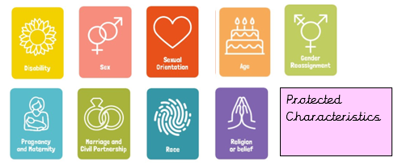


School Values
  grow | Self-Belief and Independence
  respect | Honesty and Politeness
  enjoy | Creativity and Enthusiasm
  achieve | Patience and Determination
  together | Friendship and Kindness

