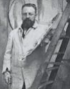
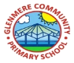
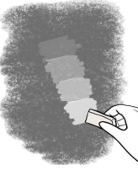
A French artist, known for his revolutionary developments in the visual arts and expressive use of colour.
Henri Matisse
1896-1954
Year 4 Art & Design Knowledge Organiser Autumn
Drawing: Power Prints
Knowledge
 | 3D Drawing  - Shading can create different tones. Different shading techniques can create pattern and contrast.  - Contrasting tones can make a picture look 3D.  - Different grades of pencil can change the shade and tone.  - Changing the way the pencil is held creates different effects.
Proportion
- Charcoal can be used as a different medium to create tone.
- Lines can be lighter or darker, or thicker or thinner and that this can add expression or movement to a drawing.
Collage
- Combining basic shapes can form more complex shapes and patterns.
- Combining different shapes, sizes and textures creates contrast.
Pattern and Contrast
- Hatching is used to create tone.
- A wax-resist technique stops another material from stick.
- Different tools can be used to scratch a painted surface.
Printing
- You can print in different ways e.g. monoprint, block print
- Printing can create contrast and pattern
- Patterns can be irregular and change in ways you wouldn’t expect
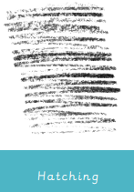

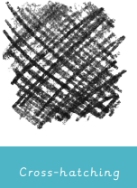
- Use the tip for sharp lines
- Blend light and dark areas to create tone
- Use a rubber to create light tones
Key Vocabulary
Collaborate | Work in a group to create a shared artwork
Collage | Cutting, arranging and sticking materials to a background
Composition | Putting different elements together
Engraving | Lines cut into a hard surface, covered in ink and printed
Proportion | How big an element of an artwork appears
Shading | Marks that illustrate degrees of light and dark
Tone | How light or dark something is

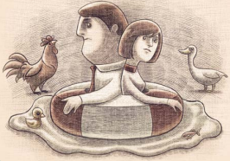

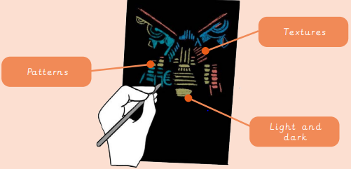
- Think of the size and shape of objects
- Proportion makes drawings more realistic
- Exaggerate proportion to draw attention to one aspect of the artwork

