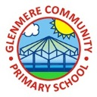
Supporting Your Child in Year 1

Autumn Term 2021
Dear Parents,
I hope you have had a fabulous summer and the children are excited about starting year 1! After last year being a very different to one that we are used to I am very much looking forward to working with the children. This letter highlights areas that we will be covering over the autumn term and how you can support your child’s progress at home. We will be starting the term with some work all based around the children’s wellbeing to ensure they have a positive transition from the Reception class into Year 1.

English Your child will have a daily English lesson which will follow the new National Framework for year 1, and will be differentiated to meet the needs of all children in the class. We will be following the talk for writing structure where the children learn a text by using different actions to help them when they write their own version of a story or text.
This term the children will be looking at simple sentence writing using basic grammar skills. They will be looking at familiar stories that contain predictable phrasing and repeated language. They will have the chance to look at free verse poems and be able to read, write and perform their own free verse poems. They will also be writing using a non-fiction concept through labels, lists and captions. Children will have the opportunity to write traditional tales and recounts based on personal experiences.
Phonics This term during phonics the children will be looking at high frequency words, tricky words, common exception words to aid the children in their reading and spelling. We will be revisiting the sounds on Mat 1 and 2 and introducing the sounds on Mat 3 and 4 throughout this year. In order to support your child’s learning, it would be helpful if you could encourage your child to read daily and also listen to them read. I would be grateful if you could write a brief comment in their reading journal. There is a list of recommended books below if you are wondering what sort of books would be suitable for your child to read at home in addition to their reading books.
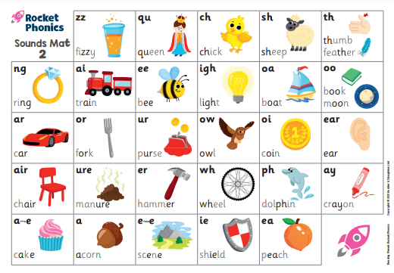
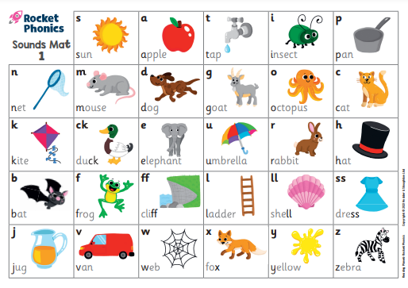

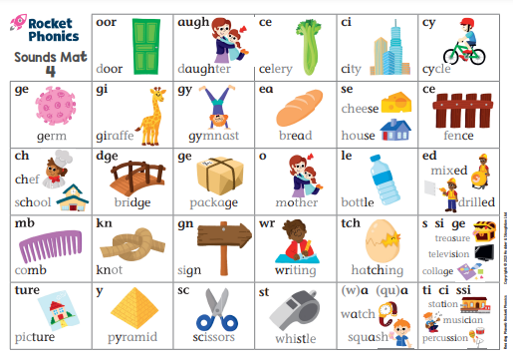
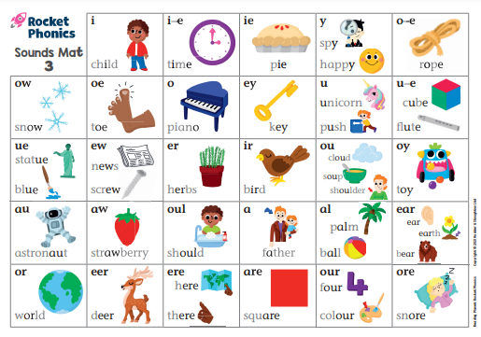

Maths
Your child will have a daily maths lesson which will follow the new National framework. All children will be set level appropriate work, and will be encouraged to challenge themselves by attempting the higher level of work. Please let your child show you the calculation methods that they have learnt at school, and encourage them to use and apply their mathematical skills.
This term, we will be looking at the following units and objectives:
Place value – within 10
Count to ten, forwards and backwards, beginning with 0 or 1, or from any given number.
Count, read and write numbers to 10 in numerals and words.
Given a number, identify one more or one less.
Identify and represent numbers using objects and pictorial representations including the number line, and use the language of: equal to, more than, less than (fewer), most, least.
Number – Place Value (within 20)
- Count to twenty, forwards and backwards, beginning with 0 or 1, from any given number.
- Count, read and write numbers to 20 in numerals and words.
- Given a number, identify one more or one less.
- Identify and represent numbers using objects and pictorial representations including the number line, and use the language of: equal to, more than, less than (fewer), most, least.
Number – Addition and subtraction
- Represent and use number bonds and related subtraction facts within 10
- Read, write and interpret mathematical statements involving addition (+), subtraction (-) and equals (=) signs.
- Add and subtract one digit numbers to 10, including zero.
- Solve one step problems that involve addition and subtraction, using concrete objects and pictorial representations and missing number problems.
Geometry: Properties of shapes:
- Recognise and name common 2-D and 3-D shapes, including rectangles, squares, circles and triangles, cuboids, pyramids and spheres.
- Describe position, direction and movement, including whole, half, quarter and three quarter turns
KEY VOCABULARY: rectangle, square, circle, triangle, cube, cuboid, pyramid and sphere.

Foundation Subjects
There will be four main ‘Topics’ this term which will be covered through all curriculum subjects. The first term will be a Geography based topic- ‘Under the Sea’. In the first half term children will learn about continents and oceans, use maps and atlases to locate different places, find out about the seaside and look at sea creatures and their habitats. In the second half term children will learn about Christmas through the years which is a History based topic. They will discuss how people celebrate Christmas now and make comparisons with Victorian times and war time. They will have the opportunity to look at old traditions and ones that are still relevant to them now.

Science
The science based topic in the first half term is ‘Seasonal Changes’. Children will learn about the four seasons, Autumn, Winter, Spring and Summer. We will look at different types of weather and how it affects us, what happens in each season, they will observe changes across the seasons by exploring the signs of autumn, winter, spring and summer through nature and wildlife. A range of learning activities will include learning walks, investigations and observations. After half term we will look at plants and find out what makes them grow and all their different parts.

P.E
Your child will have a 30-minute active lesson every day. One of these lessons with be active maths and one active English. For both of these lessons the children will only need to put on their indoor plimsolls or outdoor trainers. They will need a Glenmere sports t-shirt and black shorts, and an outdoor PE kit, including tracksuit bottoms and a warm top. A change of footwear is needed (plimsolls for indoor sessions, trainers for outdoors, and these should not be the same shoes as their school shoes). This term we will be outdoors for some of the sessions, so it is VERY important that your child has an outdoor kit, hat, scarf and gloves for days when it is particularly cold. It would be useful if children could have their PE kits in school on Monday and take it home on Fridays, as occasionally other opportunities for sessions can arise during the school week, and afterschool activities may require they change. Can you please NAME your child’s kit as it it will be easier to retrieve. Please also note that for ALL PE activities, NO jewellery whatsoever must be worn, including earrings, watches and necklaces.

ICT
Children will be learning about online safety and exploring Purple Mash to begin with. They will learn how to group and sort various different objects in different ways, use pictograms and become lego builders.

Homework
Children will have reading books daily and I will put a list of high frequency words, tricky words and common exception words that they can practise reading and writing onto google classroom. When spellings are given we will learn and revise these during the week in school as well. There will also be maths and reading comprehension books sent home with tasks set for the children to complete weekly.

More able/children who require more support
Within the class there is a range of needs which is catered for through differentiated lessons and activities. For the more able children they will be writing in detail using extended sentences. They will be developing their comprehension skills where they are discuss what they are reading. They will be given problem solving and reasoning activities to explain their mathematical understanding. http://www.primaryresources.co.uk/english/englishB12.htm
https://www.theschoolrun.com/teachers-tricks-reading-comprehension
https://nrich.maths.org/9016
https://nrich.maths.org/9798
Children who require more support will have provisions put into place to allow progression. They will have adult support most of the time, have their progress monitored and have the activities adapted to meet their learning needs.
http://www.sentenceplay.co.uk/
https://www.topmarks.co.uk/maths-games/5-7-years/counting

Supporting your child at home
If you have the internet at home, below is a list of websites which will help your child in each of the areas outlined above:
- http://www.phonicsplay.co.uk/ParentsMenu.htm
- http://www.letters-and-sounds.com/
- https://www.topmarks.co.uk/english-games/5-7-years/letters-and-sounds
- http://www.ictgames.com/literacy.html These websites have some great phonics games to help your child with their phonics.
- http://www.ictgames.com/resources.html
- http://www.topmarks.co.uk/maths-games/5-7-years/counting These websites provide a range of numeracy games.
- https://www.topmarks.co.uk/interactive.aspx?cat=63
- http://www.bbc.co.uk/bitesize/ks1/ These websites provide information about materials.
- www.weatherwizkids.com/
- www.metoffice.gov.uk/learning/weather-for-kids
- www.weatherforkids.org/
- https://www.theschoolrun.com/homework-help/dinosaurs
- https://www.kids-dinosaurs.com/dinosaur-facts.html These websites provide information about dinosaurs.

Thank you for your support.
Miss Hartley

Recommended books for Year 1
Going on a Bear Hunt | Michael Rosen
Dear Zoo | Rod Campbell
The Jolly Postman | Allan Ahlberg
The Day the Crayons Quit, Came Home | Drew Daywalt
The Day the Tiger Came to Tea | Judith Kerr
The Hungry Caterpillar | Eric Carle
A Squash and a Squeeze | Julia Donaldson
The Tear Thief | Carol Ann Duffy
The Train Ride | June Crebbin
On the Way Home | Jill Murphy
The Smartest Giant in Town | Julia Donaldson
Jim and the Beanstalk | Raymond Briggs
Gingerbread Man | Jim Aylesworth
Light house Keeper’s Lunch | Ronda Armitage
The Snail and the Whale | Julia Donaldson
The Adventures of Captain Underpants | Dav Pilkey
Dear Dinosaur | Chae Strathie
The Perfect Guest | Paula Metcalf
Monster in the Mood | Maggie Meils
Can I Join Your Club? | John Kelly
Collins Primary Dictionary
Children’s First Encyclopaedia
Children’s Atlas
Traditional Nursery Rhymes
Traditional Fairy Stories

