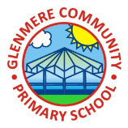 **Year 1 CLASS NEWSLETTER**

**Autumn 2021**

**We would like to share with you about some of the things we have been doing in the autumn term.**

In **Science,** we have looked at and discussed the different seasons. We went out on an autumn walk and found lot of signs that winter was on its way. We learnt about lots of different weather and found out who and why certain animals hibernate. We also found out about plants and what they need to survive. We talked about evergreen and deciduous trees and made comparisons of tree and plant roots.

[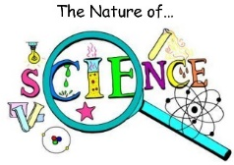](https://www.google.co.uk/url?sa=i&rct=j&q=&esrc=s&source=images&cd=&cad=rja&uact=8&ved=0ahUKEwiNwYLXoobTAhWIB8AKHaMWCpsQjRwIBw&url=https://www.youtube.com/watch?v=Y4a-NyYvwEA&bvm=bv.151325232,d.cGc&psig=AFQjCNHaGDhENPivJtto2zMhaNKya8HGzA&ust=1491239624389791)

In Science we were planting seeds to grow a broad bean. We then had to write our instructions in Literacy of how we planted our bean in the correct order.

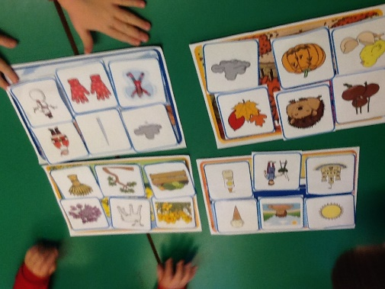

In **English,** we have been learning how to write sentences using capital letters, full stops and finger spaces. We have read lots of stories and even had a go at acting some of these out in our Talk for Writing sessions. We learnt We’re all going on a bear hunt off by heart and had a go at writing instructions on how to make a sandwich. We found out what verbs are and have even tried to use some adjectives in our writing.

[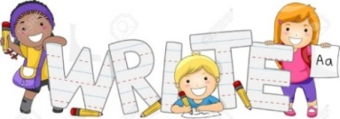](https://www.google.co.uk/url?sa=i&rct=j&q=&esrc=s&source=images&cd=&cad=rja&uact=8&ved=0ahUKEwiMk6PL5oDTAhUJvBoKHQXzDWMQjRwIBw&url=https://www.123rf.com/photo_10327122_illustration-of-kids-learning-how-to-write.html&psig=AFQjCNHV3a2uEjgBviuoYDgSICM22a-ZKQ&ust=1491051666855846)

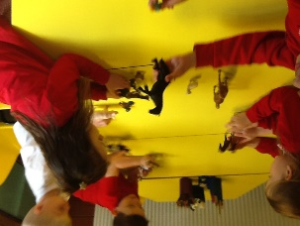

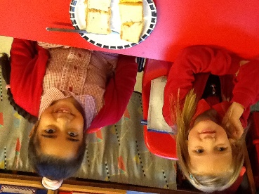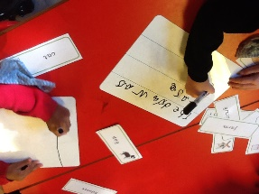

[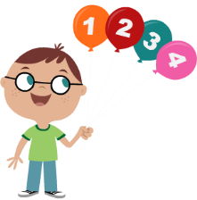](http://www.google.co.uk/url?sa=i&rct=j&q=&esrc=s&source=images&cd=&cad=rja&uact=8&ved=0ahUKEwjaprub54DTAhWEvRoKHZA_BlsQjRwIBw&url=http://clipart-library.com/maths-pictures-cartoon.html&psig=AFQjCNFpLPDIW2-X3w5kM3PoiHOpmu2oaQ&ust=1491051850693795)

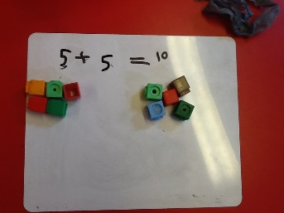

In **Maths,** we have been exploring different shapes and properties, 2D and 3D. We have investigated numbers by looking at sequences, one more, one less, had go at addition and subtraction. We also enjoyed finding out about number bonds to 10 and 20! We have used the part, part whole model and used dienes to understand tens ones. We have been trying really hard to deepen our understanding working on our reasoning skills.

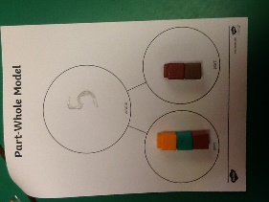

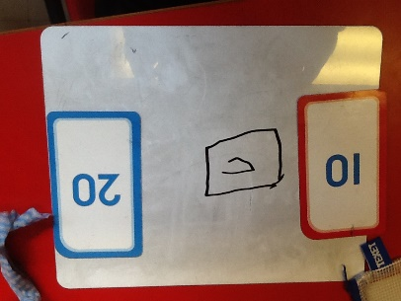

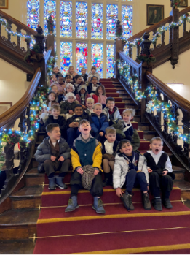

**Victorian Christmas at Beaumanor**

We were lucky enough to go to Beaumanor Hall to experience what it would have been like in Victorian times. We are definitely glad we are at school now and not then. Getting to meet Santa was a real highlight.

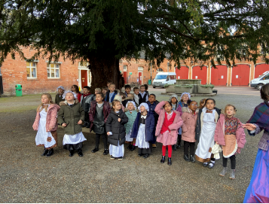

**PE:**

Gymnastics has been so much fun! We have continued to develop our stamina and core strength through a variety of different activities.

Active Maths and English has really helped us to understand some of the concepts we have been learning in class like question marks and different ways to represent numbers.

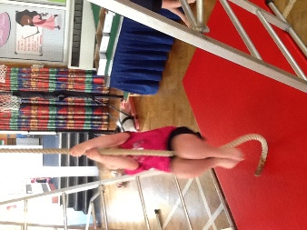

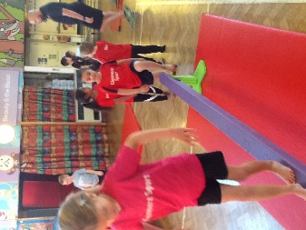

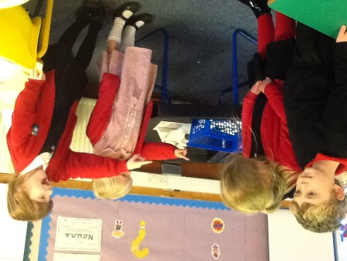

In our Personal Growth curriculum, we have discussed from garden to plate. We found out where our food comes from originally and what happens to it.

Perhaps the most important part this term was talking about conflict and what that means. We created beautiful stone poppies to remember all those people who have fought during wartime and battle. The children were extremely respectful and you should be very proud of their attitude towards all these activities and discussions.

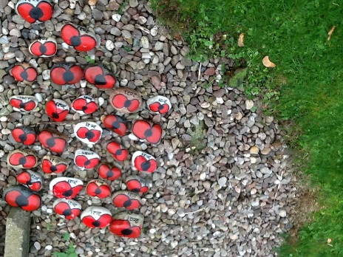

What a way to end our first term in Year 1. A Christmas party! It was so much fun, games, dancing and eating! What more could you ask for!

Certainly well-deserved after a long term where you have all worked so hard. You should all be very proud of yourselves with what you have achieved so far.

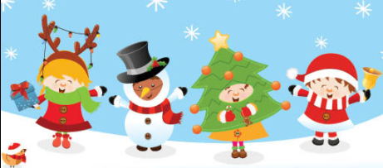



I would like to thank you all for your continued support this term and wish you all a restful and relaxing Christmas.

Miss Hartley and Mrs Bown