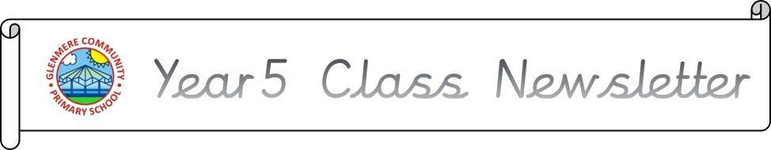

There have been many exciting learning opportunities this term in year 5, so please keep reading to find out more!

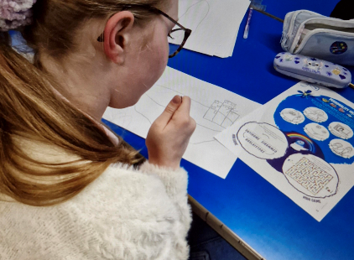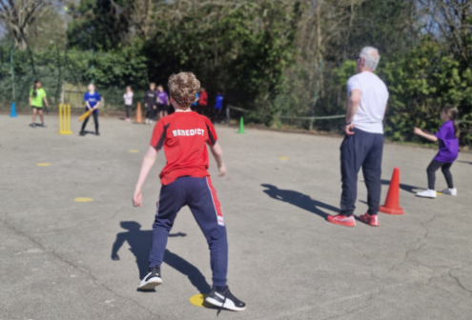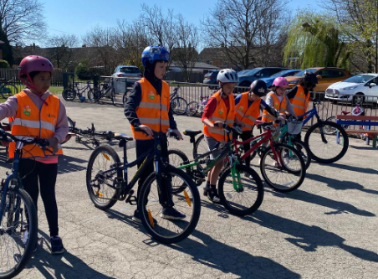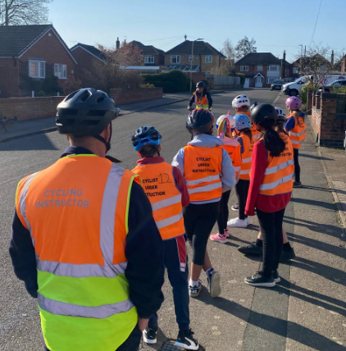

Also this term, Year 5 have been studying crime and punishment in the UK from the Romans through to modern day. We have learnt all about the UK justice systems’ origins, comparing specific eras with todays.

We cannot believe how unfair punishments were in the past for such small crimes! We thoroughly enjoyed our crime and punishment workshop

This term in art, we are focused on our drawing and painting skills, which have accumulated in us producing our own self-portraits. We have been experimenting using different methods and materials to create the desired effect, be it evoking an emotion or a memory.

In DT, we have been making stuffed toys for children in Reception and their reading corner. Year 5 have relished in the challenges that being a designer face and have had a go at everything thrown at them.

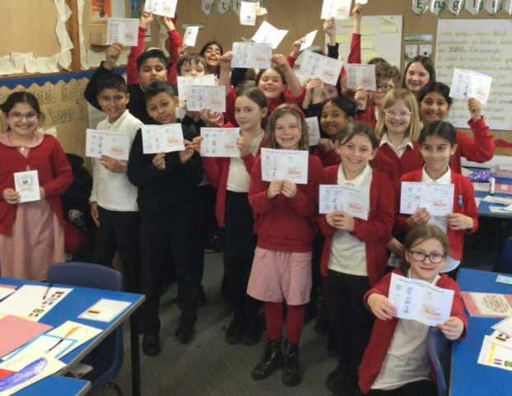

As part of children’s mental health week, we also looked at the importance of knowing our own personalities as well as celebrating what is good about us on the outside. We also looked at how social media doesn’t always reflect reality

On top of this, the children have thoroughly embraced bikeability with the instructors commenting on how incredibly well behaved the children have been and how well they have taken on board the really important learning.

As well as all our usual work, we have had so many enrichment opportunities including inflatables, family day, our international languages day – where children gained stamps of their passports – and our ICT afternoon to name a few. We can’t wait to see what next term holds – including the class production!

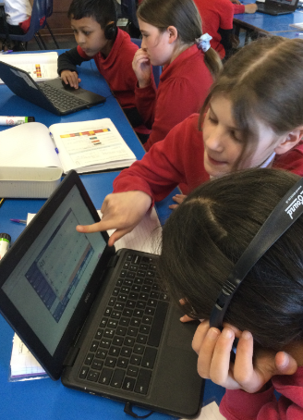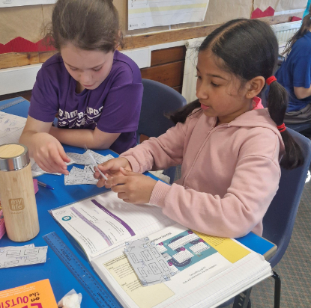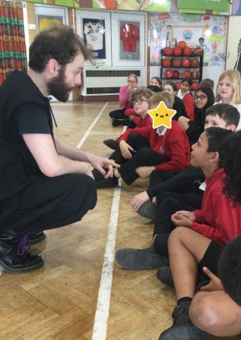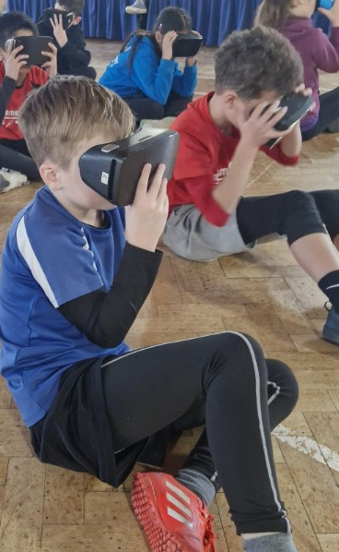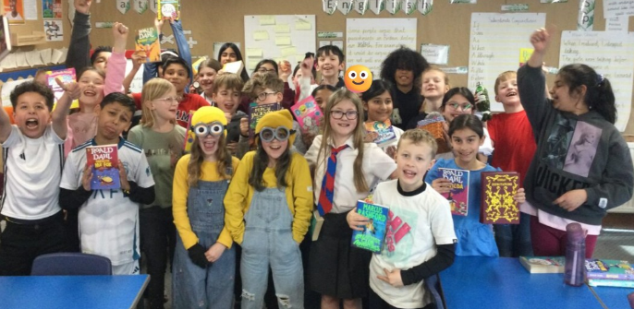



In computing, year 5 have been learning about programming systems. We had the opportunity to work with a new bit of kit called ‘crumbles’ which we could program using algorithms we created! We also learnt all about databases and what makes a good database, including a comparison between paper and computer-based styles.

In Science, year 5 has been investigating materials and their states of matter. We have been studying why different materials display different properties and what this means for their use. Following this, we have been learning how we have altered states of matter using reversible and irreversible changes.

Our RE lessons this term have involved us learning about Jesus as a ‘King’ and why Christians believe he was a good king. We thought about characteristics of a ‘good’ king and whether Jesus showed any of these characteristics, using evidence from parables. We have also studied Judaism this term, and what the Torah means to Jewish people. We have learnt the great respect Jewish people give to the Torah and what the Torah is. We learnt the impact the Torah has on Jewish people’s daily lives. We have noticed some crossover between Christianity and Judaism.

In PSHE, we have been learning all about citizenship and what it means to be a good citizen in the United Kingdom. This included learning about the positive impacts of individuals like Marcus Rashford and Greta Thunberg, as well as the UK justice system and the UK parliament.

We have also done lots of work on economic wellbeing, learning about the risks associated with money.

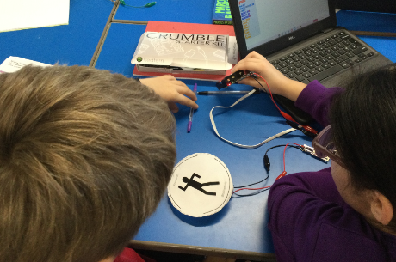

In music this term, we took it slow and learnt all about ballad music. We focused on the song ‘Make You Feel My Love’ by Adele. We loved singing our hearts out to this but were not too keen on the pace of it. We followed this unit with a more upbeat style: Old-school hip-hop. Our focus song has been ‘The Fresh Prince of Bel-Air’. We have loved bopping along and rapping to this song!

In PE, we been learning many of the skills needed within a game of cricket, including the skill of fielding and how to bowl someone out.

We have also had lots of fun in our tag rugby lessons, learning about skills and strategies to help be great players.