Glenmere Primary School

Core
Mathematics
Policy


Mathematics Policy
Last Reviewed: July 2023

This policy outlines the teaching, organisation and management of mathematics taught at Glenmere primary school.

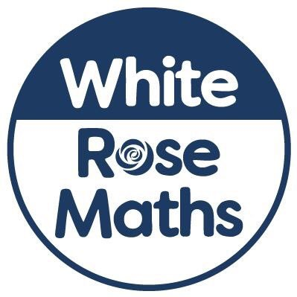
At Glenmere primary school we use the new National Curriculum for Mathematics (2014) as the basis of our mathematics programme. Staff use the White Rose Mathematics Scheme to help plan their lessons and EYFS and KS1 also use Number Sense to support their delivery.

Developing Mastery
We are committed to ensuring that all pupils achieve mastery in the key concepts of mathematics, appropriate for their age group, in order that they make genuine progress and avoid gaps in their understanding that provide barriers to learning as they move through education. Our Mathematics curriculum reflects a greater emphasis on mastery of the key skills of mathematics to ensure children have adequate time to develop their fluency and understanding before moving onto a new concept. Assessment for Learning, an emphasis on investigation, problem solving and the development of mathematical thinking and a rigorous approach to the development of teacher subject knowledge are considered to be essential. As children master new concepts they will be moved on.

Maths Endpoints

By the End of Key stage 2 and start of secondary, Children should:

- Skills of being able to mentally use the four operations
- Develop efficient techniques (to make maths quicker and easier)
- Problem solving skills
- Mathematical vocabulary to be able to apply them accurately and appropriately
- To reason decisions
- To read and interpret data
- Apply skills to real-life situations in word problems
- To have a bank of methods to be able to use written formats
- To develop a sense of spatial awareness
- To estimate and make informed judgements
- To be able to use and know the times tables efficiently
- To know numbers can be represented in different ways e.g. algebra

For the future:

- Apply mathematical skills to everyday situations – time (catching the bus), money (buying things) and weight (cooking)
- To build on those concepts to apply them to more complex situations e.g. mortgages, shopping, budgeting
- Statistics – reading the news and being able to interpret the data
- Time management

Maths Statement of Intent

The national curriculum for mathematics intends to ensure that all pupils:

1. Become fluent in the fundamentals of mathematics, including through varied and frequent practice with increasingly complex problems over time, so that pupils develop conceptual understanding and the ability to recall and apply knowledge rapidly and accurately.

2. Reason mathematically by following a line of enquiry, conjecturing relationships and generalisations, and developing an argument, justification or proof using mathematical language.

3. Can solve problems by applying their mathematics to a variety of routine and non-routine problems with increasing sophistication, including breaking down problems into a series of simpler steps and persevering in seeking solutions.

Mathematics is an interconnected subject in which pupils need to be able to move fluently between representations of mathematical ideas. The programmes of study are, by necessity, organised into apparently distinct domains, but pupils should make rich connections across mathematical ideas to develop fluency, mathematical reasoning and competence in solving increasingly sophisticated problems. Our curriculum ensure children apply mastery skills. We follow the White Rose maths scheme, with Deepening Understanding used to extend fluency, reasoning and problem-solving. They should also apply their mathematical knowledge to science and other subjects.

Implementation

The Foundation Stage

Maths is taught as part of the Area of Learning designated as ‘Mathematics’ in the statutory framework for EYFS September 2021.The children will receive some whole class and adult led maths teaching and they have access to independent child initiated maths activities daily. Children are given opportunities to work on maths activities both indoors and outdoors. These activities are planned based on the main areas as outlined in the EYFS framework. As in the rest of the school, the Maths planned builds on previous learning and allows time for children to develop ‘mastery’ in the key areas of Mathematics without moving onto a new concept too quickly.

Planning is updated daily taking into account previous learning. This ensures the maths activities are appropriate and relevant to the children’s learning needs and their interests. Maths activities in Continuous Provision are planned taking into account both the children’s interests and curriculum coverage.

Key Stage 1 and 2

Planning
The New National Curriculum has several strands
- Number: number and place value, addition and subtraction, multiplication and division, fractions, percentages (Yr 5 & 6 only)
- Measure
- Geometry: properties of shape, position and direction
- Statistics (Year 2 onwards)
- Algebra (Yr 6 only)
- Ratio and Proportion (Yr 6 only)

Short term plans are produced weekly by individual class teachers. These plans include opportunities to review, teach, practise and apply skills in all strands. Planning now also includes purposeful misconceptions for children to solve and teachers to address.

Teaching
In Key Stage 1 and 2 children have a daily mathematics session of approximately 45- 60 minutes. Teachers in Key Stage 1 and 2 also plan and provide opportunities for children to use and apply maths knowledge and skills in other areas of the curriculum (e.g. science and investigation).
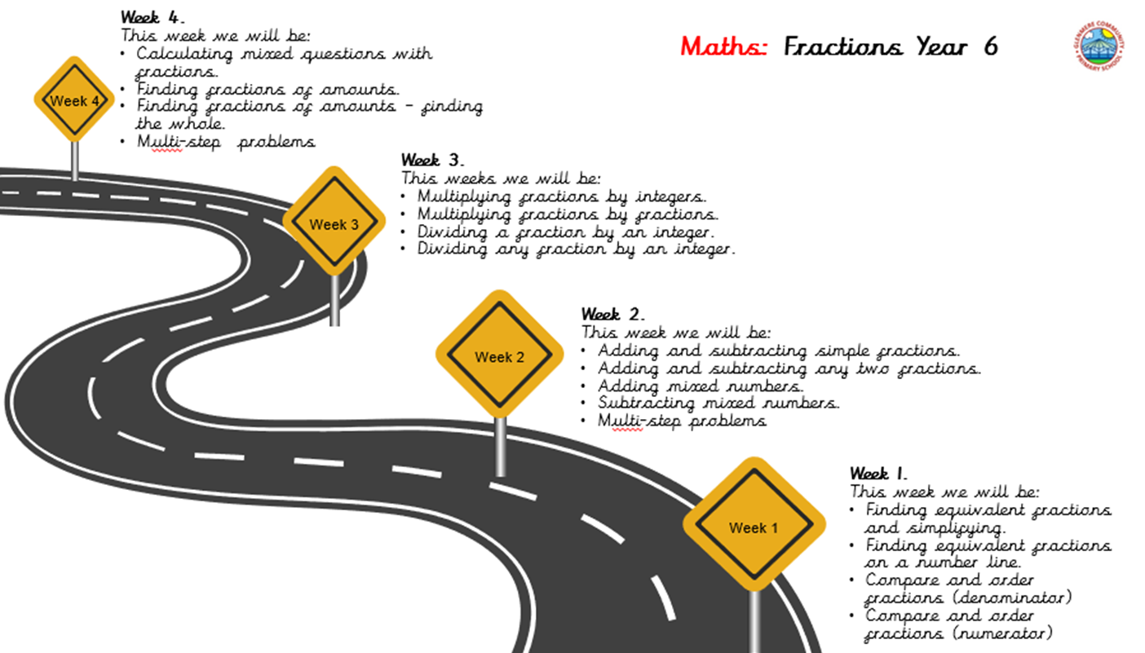

Children have the opportunity to see where their learning is going next by all books having a Road Map in like the other subjects. This shows a breakdown of the lessons taught in that particular unit.

Every day the maths lessons starts with a quick recall grid, with a question from last year, last term, last week and last lesson, to help them keep recalling information and ensuring these skills are moved to long term memory. Year 5 and year 6 also have an extra 4 grid of the four operations.

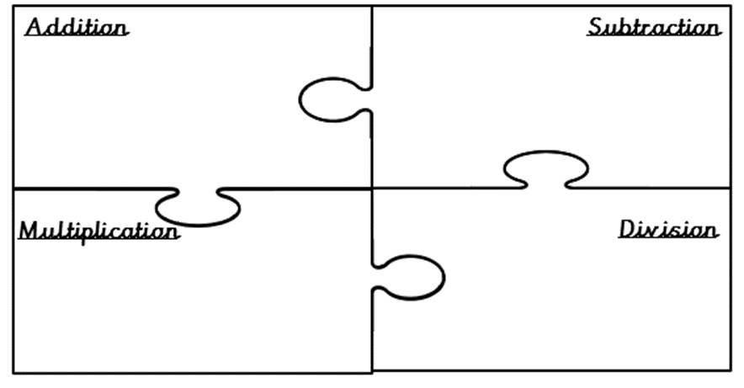
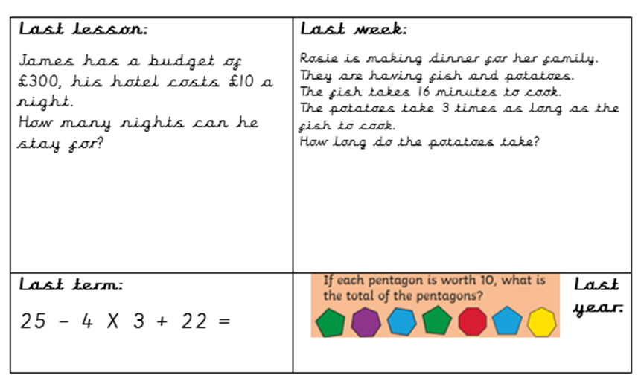

At the end of each week, children will also complete the ‘Frayer Model’ linked to mathematical vocabulary – in key stage 1 this is with support of the class teacher. Teachers have had a list of mathematical key vocabulary linked to our White Rose Scheme and the national curriculum; that need to be explicitly taught.
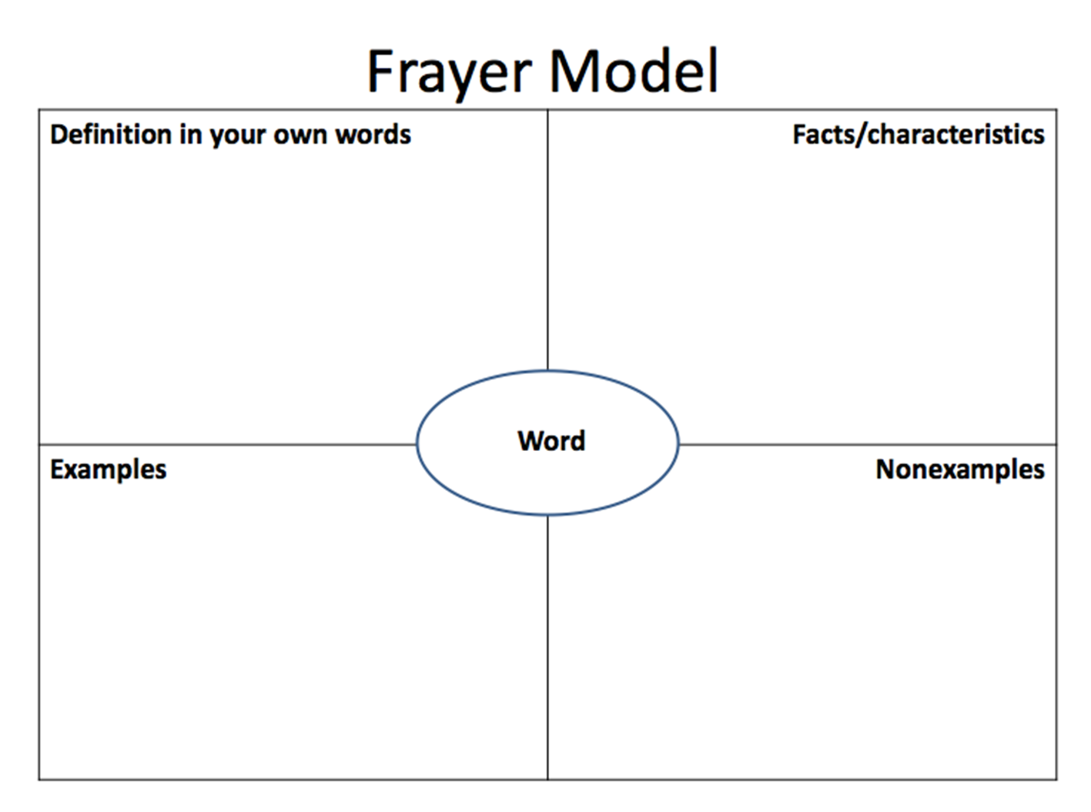

ASSESSMENT

Class teachers are responsible for assessing individual children’s attainment in maths. Teacher assessments are completed termly along with pupil progress meetings.

Maths assessment happens in 2 forms:

- Formative – the day to day assessment that takes place continually and informs teacher’s short term planning e.g. work samples, observation notes.

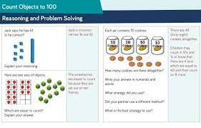
- Summative – formal assessment that takes place at the end of a strand of learning or a whole year taking into account all evidence gathered through formative assessments e.g. work in books, end of unit reviews, SATS tests (Year 2 and 6).

Pupils complete a blue test assessment at the end of each unit of work to test the children’s knowledge and for the teacher to see whether the class is ready to move on to a new unit or not.

The data from formative assessments is used to judge children’s attainment at the end of each unit, term or year.

Assessment records
Assessment folders are kept by all class teachers and will contain termly pupil progress sheets which identify children by name that are not attaining or making progress and the next steps that will be taken. A summary assessment sheet will be completed at the end of the year that will show a break down of the attainment of different groups such as boys, girls, EAL, PP, SEN and more able.

AfL in maths
Children are also expected to assess their own learning in maths. This can take different forms depending on the age and ability of the children. In the early stages of AfL, children will be expected to talk about their learning by identifying what they are good at and what they find hard and what they need to get better at. As children move through the school they will begin to talk in more detail about their learning and areas for improvement.

More Able pupils and those with Special Educational Needs(SEN)
Our school provides a fully inclusive maths curriculum where teaching and learning is differentiated appropriately to meet the needs of all learners with challenge for all.

SEN Provision
If a child has a specific difficulty relating to maths that is listed on their IEP, they may be given extra time or additional support with a teacher, LSA or TA to address their specific needs and to support and develop their maths knowledge and skills accordingly.

More Able Provision
Where children are excelling in an area of maths, they will be given further opportunities to deepen their understanding and apply higher order thinking skills through carefully planned problem solving and reasoning tasks.

EAL Provision
Care is taken to diagnose when an error is caused by language proficiency or a mathematical difficulty. When language is the barrier to learning, mathematics is made ‘clearer’ and opportunities are provided to enable EAL pupils to engage with the learning and convey and develop their mathematical ability.

MONITORING AND EVALUATION

The policy will be monitored and reviewed in line with the school’s monitoring and review practices.
The work undertaken will be monitored and evaluated by the curriculum leader with responsibility for Maths. This will be in line with the school’s monitoring and evaluation practice e.g. sampling teacher’s planning, samples of work (recorded using audio tape, video tape and written), discussion with children and observations.

PARENTAL SUPPORT
At the start of each term parents will be given a letter informing them on how they can support their child during that term and will be given activities they can do to support and websites they may find to be useful.

At the maths afternoon parents are also given the calculation policy and the non-negotiables for each year group.

Homework
All children have been given a log in number for My Maths and are set weekly tasks on this.
Children also receive weekly maths homework in the CPG books:
Year 3 , 4 & 5 – 1 piece of maths a week.
Year 6 – 2 pieces of maths a week.

Children in years 3, 4 & 5 also receive weekly times table challenges from their ‘famous 5’ times table scheme.

