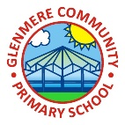 |  | Glenmere Primary School/March 2022 Edition
 | GLENMERE COMMUNITY NEWS
Mrs S Conlon: Headteacher |  |  |  |  |  | Published by Year 5
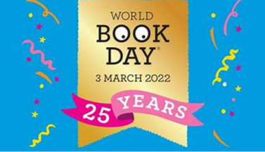  World Book Day  On Thursday 3rd March, as part of World Book Day, we dressed up as a character from any book. We had to then bring the book that our character was from. Children dressed up as all different characters from Harry Potter, Luna Loveheart, The Hungry Caterpillar and Mary Poppins. The classes took part in different activities. We loved dressing up in all our different outfits! Even the teachers dressed up – they were the Little Miss and Mr Men Characters. We had Little Miss Sunshine, Little Miss Princess and Mr Silly!  Article written by: M, D, K  Fundraising  At Glenmere in the last term, classes have been carrying out lots of different fundraising activities in order to raise money for resources in school! Each class was tasked with the challenge to come up with different ways of making money. Activities included basketball shootouts, dances, cake sales and fun runs! Altogether we raised a total of £2753 – how incredible!  Article written by: K, L, E, A |  |  |  |  | Rocking it out  Rock Steady is a fun way to make some noise. Bands will learn songs and play in front of the entire school! It takes place every Friday.  On Friday 1st of April, the Rock Steady concert took place in the morning where parents and carers with classes could see the different bands play: Radioactive Rockstars, Project Dream, Seven Rockstars, Golden Fire Birds and Nightwolves are the names of the different bands. |  |  |  | They performed songs such as ‘Counting Stars’, ‘Happy’ and ‘Seven Nations Army’. The children worked really hard to perform the best concert for our school. Unfortunately, the concert was the last for year 6 but they made sure it was also the best!  Article written by: Z, G
 |  |  |  |  | All the Drama  On Tuesday 29th March, children across the school took part in drama workshops. A lady named Jo from West End Theatre carried out Matilda workshops with KS2 and Stickman with Reception and Key Stage 1. She got children in year 3, 4, 5 and 6 to act out characters from Matilda, answer agree or disagree questions and make freeze frames. We made a circle which someone in the middle shouted different insults such as ‘maggots’ and ‘warts’ whilst acting as Mrs Trunchbull. Jo summarised the story to us in an incredible version. The younger children acted out the different characters from Stickman making different noises and becoming the characters. It was such a good workshop.  Article written by: M, H, C |  |  |  | 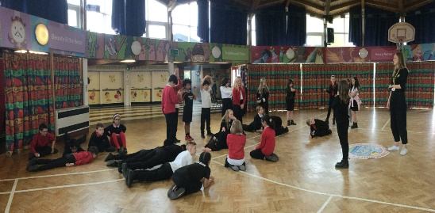  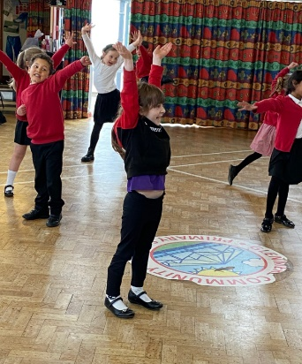

 | GLENMERE COMMUNITY NEWS
Children at Glenmere Primary School have been on many trips and had many visitors since Christmas.  All the children from Year 1 to 6 visited different churches (Bethel and the Kings Centre). During the visits children learned about different religious clothing, stories from the Bible and even tasting different foods. Those who visited the Kings Centre discovered about the Jewish book the Torah and how Jesus was indeed Jewish. |  |  |  | This term, we were very fortunate to welcome Matt Windle into our school. Matt (who had a secret identify of Matt Man) is a box/poet who came to teach us poetry. He started the day with an assembly where he told us all about one of his poems and then included all of us in a key stage poem. He told us how he wanted to be a superhero when he grew up and in actual fact he kind of is because he has a superhero cape. When in the different classes we were able to create our own class poems based on our different topics. He taught us that to be able to write our poems, we need a tune (like a rap). |  |  | On Monday 21st February children went down to the hall to greet an unexpected guest but little did they know who they were going to meet. The children were busy working when they were interrupted by a man from the future who alarmed us all about the state of which the world will be in in the future if we continue to pollute it. He told us all about pollution on earth. The Ecos were the Flingatrons enemy so they decided to pollute the planet. It was so bad that they had to wear oxygen masks and clean air tubes. We were taught that we need to use the 3 Rs: Reduce, Reuse, Recycle to save the planet, oceans and seas  Article written by: D, E, S, J, T, Z, G, A, P

Visits and Visitors
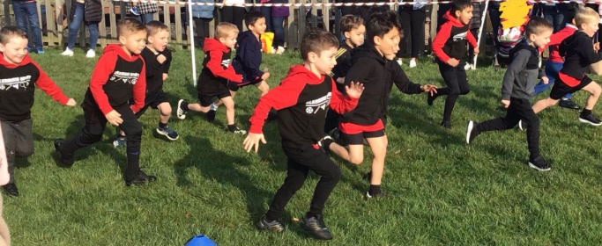
Running, Running, Running  It was great to be able to have the whole cross country back this year! During Monday 28th March, children from Reception to Year 6 took part in a cross-country race. Year 6 kicked it all off by racing first, followed by Reception through to year 5. Parents were invited to watch and the whole school cheered each other on! There were winners but no losers – everyone is a winner in our eyes as everyone tried their hardest. There were medals for those who came 1st, 2nd, 3rd and 4th. The atmosphere was great (and it didn’t snow!)  Article written by: M, E, J |  |  |  | Chick Update  Exciting news at Glenmere; this March – we got chicks! At the start of March a special delivery was made to the year 2 class. This delivery was in the form of eggs in an incubator. Mrs Siddons (the class 2 teacher) set up the chicks on ‘Egg Cam’ which meant that classes and parents could watch the chicks beginning to hatch. Day by day, they were beginning to hatch. Sadly, one of the chicks needed a little help getting out of the egg as it was born with a poorly leg but luckily it survived and is now walking and jumping again. After much deliberation, we decided to home 4 of the chicks in school. The chicks – which were named by children in the school – are now known as Heidi Lilly, Pepper and Eliza. Soon they will make their way into the hutch outside.  Article written by: Z, M, S, C, A |  |  |  | 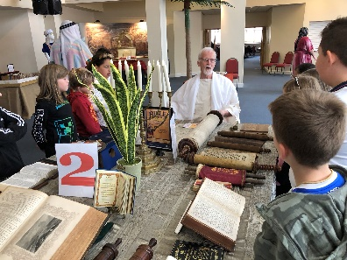  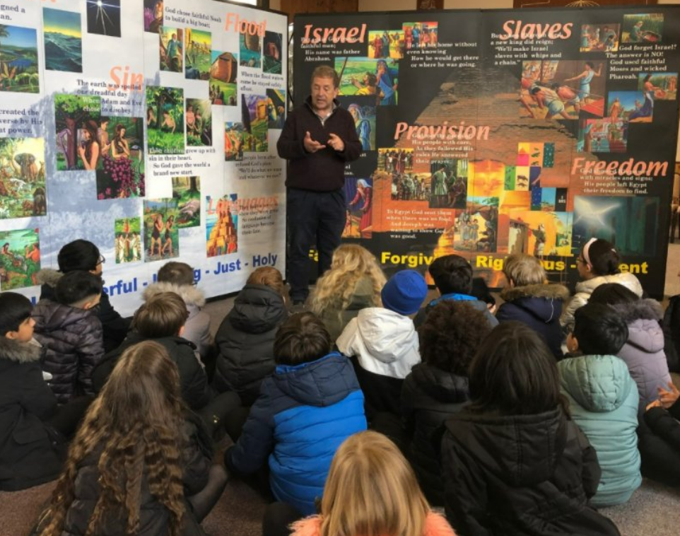
Interested in becoming a community governor at Glenmere then please do ring the school office on 0116 288 2228 or email office@glenmere.net

