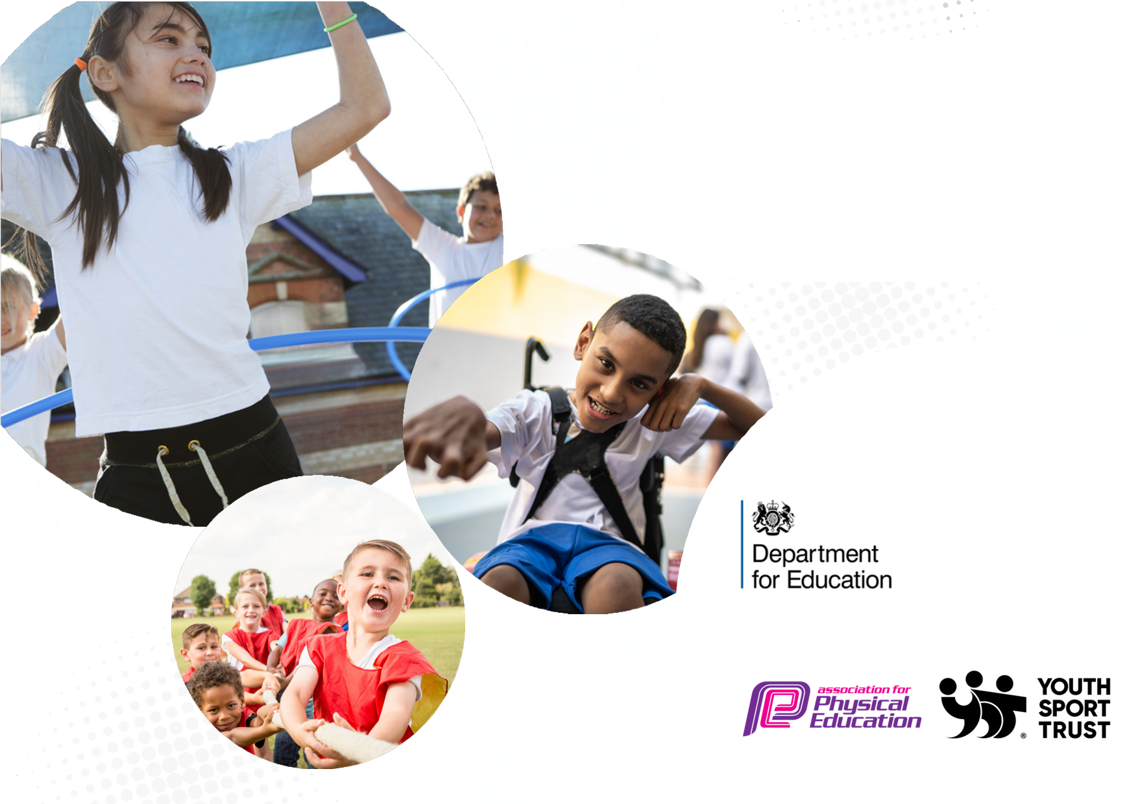

PE intentions and implementations

25/26

|  |  |
| --- | --- |
| INTENT 25/26 | implementation |
| **Key indicator 1: Engagement of All Pupils in Regular Physical Activity (30 minutes in school)**   * + Continue developing three focused sports (basketball, quad kids, and tennis) with specialist coaching and extra squad sessions to increase participation and skill development.   + Provide a variety of clubs for both Key Stage 1 and Key Stage 2 pupils to encourage regular physical activity.   + Organise internal competitions such as Sports Day and Cross Country to motivate pupils to participate actively.   + Run a Healthy Lifestyles Day for all children to promote physical activity alongside healthy living awareness. | **Key Indicator 1: Engagement of All Pupils in Regular Physical Activity**   * **Move It March Programme & Active Travel Initiatives**    + Engage all pupils in the Move It March programme, providing physical activity trackers and milestone rewards (Bronze to Platinum) to motivate consistent physical activity.   + Promote Active Travel programmes throughout the year to encourage walking, cycling, or scooting to school, increasing daily physical activity. * **Timetabled PE and Active Learning**    + Ensure 2 hours of PE weekly, incorporating active maths and English sessions to embed movement across the curriculum.   + Provide equipment at playtimes and a wide variety of extra-curricular clubs for Key Stage 1 and 2 to maximise daily movement opportunities. * **Sports Ambassador and Playground Leader Roles**    + Train Year 6 pupils as Sports Ambassadors and Playground Leaders to organise and lead active games during lunchtimes, increasing activity levels especially for younger pupils. * **Healthy Lifestyles Day**    + Run a whole-school event focused on physical activity and well-being, reinforcing the importance of regular exercise and healthy habits. |
| **Key indicator 1: Engagement of All Pupils in Regular Physical Activity (30 minutes in school)**  **Intended Impact:**   * 60% of pupils (approximately 126 children) will actively travel to school, improving physical health and reducing environmental impact. * 75% of pupils (approximately 158 children) will participate in the Move It March programme, aligning with the Chief Medical Officer’s Physical Activity Guidelines.   **Impact:**   * Increased active travel will contribute to better pupil fitness, concentration, and readiness to learn. * Participation in Move It March will raise awareness of the importance of daily physical activity and foster lifelong healthy habits.   **Sustainability:**   * Continued partnership with SLSSP to deliver and expand universal physical activity projects that engage the whole school community. * Promotion of active travel and physical activity initiatives will be maintained through regular communication and school campaigns. | |
| **Key indicator 2: Raising the Profile of PE and Sport Across the School**   * + Engage Year 6 pupils in Sports Ambassador Leader training to develop leadership skills and promote sport within the school community.   + Invite a disabled athlete to speak in assembly as an inspirational role model, raising awareness and enthusiasm for sports and inclusivity.   + Celebrate participation and achievements in PE and sports events through assemblies and school communications. | **Key Indicator 2: Raising the Profile of PE and Sport Across the School**   * **Sports Ambassador and Well-being Ambassador Training**    + Train Year 6 pupils as Sports Ambassadors to lead the School Sport Organising Crew, promoting sports participation and leadership.   + Train Well-being Ambassadors to promote the 5 ways to well-being and develop peer support initiatives, linking physical health to mental well-being. * **Inspirational Role Models and Assemblies**    + Invite disabled athletes and other role models to speak in assemblies, inspiring pupils and raising awareness of inclusivity and resilience in sport. * **Celebration and Cross-Curricular Links**    + Celebrate participation, progress, and achievements in PE through assemblies and displays.   + Integrate PE with subjects such as English (writing match reports), Maths (data handling), and Computing (creating competition highlights) to raise the subject’s profile. |
| Intended Impact:  * **80% of Year 6 pupils** will complete Sports Ambassador Leader training, developing leadership skills and taking active roles in promoting sport within the school community. * **100% of pupils** will be inspired by at least one assembly featuring a disabled athlete or other role model, increasing awareness of inclusivity and resilience in sport. * **All year groups** will have opportunities to celebrate participation and achievements in PE and sports events through assemblies and school communications.  Impact:  * Trained Sports Ambassadors will demonstrate increased confidence, responsibility, and leadership by organising and leading sports activities and events. * Pupils will show improved attitudes towards inclusivity and diversity in sport, reflected in increased participation from SEND and disadvantaged groups. * Increased pupil motivation and engagement with PE, seen in higher attendance at extra-curricular clubs and improved enthusiasm during PE lessons.  Sustainability:  * Sports Ambassador and Well-being Ambassador training will be embedded into the annual school calendar, ensuring ongoing leadership development for future cohorts. * Long-term relationships with local athletes and sports organisations will be maintained to provide regular inspirational visits and assemblies. * Celebration of PE achievements will become a regular feature in school life, supported by displays, assemblies, and communications. * Cross-curricular links with PE will be maintained through collaborative planning with subject leaders, ensuring sustained integration and development across the curriculum. | |
| **Key indicator 3: Increased Confidence, Knowledge and Skills of All Staff in Teaching PE and Sport**   * + Upskill teachers by providing high-quality demonstration lessons led by specialist coaches to improve the quality of first teaching in PE.   + Support staff development to ensure effective delivery of PE curriculum and improve pupil outcomes in physical education. | **Key Indicator 3: Increased Confidence, Knowledge and Skills of All Staff**   * **Staff CPD Based on Needs Analysis**    + Conduct a staff-wide PE survey to identify gaps in knowledge and confidence.   + Deliver targeted CPD sessions, including observation of high-quality lessons by specialist coaches, followed by reflective discussions. * **Professional Development and Networking**    + The PE lead will engage in local network meetings and conferences to stay updated on best practice, sharing insights during INSET and staff meetings. * **Staff Well-being Ambassador**    + Train a staff member as Well-being Ambassador to promote physical activity and health within the school workforce, creating a supportive culture. |
| **Key indicator 3: Increased Confidence, Knowledge and Skills of All Staff in Teaching PE and Sport**  **Intended Impact:**   * By July 2026, 100% of PE lessons will meet high-quality teaching standards as evidenced through lesson observations. * Staff will demonstrate increased confidence and competence in delivering a broad and inclusive PE curriculum. * 80% of teachers will actively model healthy lifestyles through participation in the Staff Well-being Ambassador programme.   **Impact:**   * Staff survey results will identify specific areas for targeted CPD and support, leading to measurable improvements in teaching quality. * Lesson observations will confirm consistent application of high-quality PE teaching strategies across all year groups. * Teachers will become role models for healthy living, positively influencing pupil attitudes towards physical activity.   **Sustainability:**   * Ongoing CPD will be embedded through collaboration with local PE networks and South Leicestershire School Sports Partnership (SLSSP). * The Staff Well-being Ambassador programme will continue to encourage staff engagement in health and well-being initiatives, promoting a culture of active role modelling. | |
| **Key indicator 4: Broader Experience of a Range of Sports and Activities Offered to All Pupils**   * + Continue to develop and provide specialist coaching in basketball, quad kids, and tennis, offering pupils a wider range of sports.   + Maintain a varied extra-curricular club offer for both Key Stage 1 and Key Stage 2 pupils, ensuring access to diverse physical activities. | **Key Indicator 4: Broader Experience of a Range of Sports and Activities**   * **Focused Development of Basketball, Quad Kids, and Tennis**    + Deliver specialist coaching in these sports, ensuring a sequenced curriculum that builds skills progressively from Reception through Year 6.   + Provide extra squad sessions to deepen pupils’ skills and prepare them for competitive opportunities. * **Inclusive Extra-Curricular Offer**    + Maintain a diverse range of clubs accessible to all pupils, including those with SEND and EAL, to broaden their physical activity experiences. * **Fundamental Movement Skills (FMS) Development**    + Ensure that pupils regularly revise and refine FMS such as running, jumping, throwing, and ball skills through purposeful play and structured lessons, especially in Early Years and Key Stage 1. |
| **Key indicator 4: Broader Experience of Physical Activity and Leadership Opportunities**  **Intended Impact:**   * Daily Lunchtime Physical Activities will increase KS1 pupil activity by 40%, improve social interaction, and boost confidence among student leaders. * Sports Ambassadors will enhance the visibility and organisation of PE and sports events, fostering a positive school culture around physical activity. * Well-being Ambassadors will lead initiatives supporting emotional well-being, increasing pupil confidence in sharing concerns and promoting mental health awareness.   **Impact:**   * Playground Leaders and rotating activity zones will create an inclusive environment encouraging physical activity and social skills development. * Leadership roles will empower pupils, develop responsibility, and promote peer support in physical and emotional well-being activities. * The National Koboca Survey will provide actionable feedback to continually improve sports and well-being programmes.   **Sustainability:**   * Annual training of new student leaders ensures continuity and fresh leadership in PE and well-being initiatives. * Embedding well-being activities within the school calendar, such as Mental Health Week and daily check-ins, will maintain focus on pupil emotional health. * Regular use of feedback mechanisms like the Koboca Survey will guide ongoing programme refinement. | |
| **Key indicator 5: Increased Participation in Competitive Sport**   * + Organise and run internal competitions such as Sports Day and Cross Country to foster competitive opportunities within the school.   + Provide extra squad sessions for focused sports to prepare pupils for competitive events and build their skills and confidence.   + Ensure Year 5 and 6 pupils attend weekly swimming lessons to achieve the national expectation of swimming 25m by the end of Year 6, including essential life skills. | **Key Indicator 5: Increased Participation in Competitive Sport**   * **Internal Competitions**    + Organise Sports Day and Cross-Country events that link directly to curriculum learning and offer all pupils competitive experience in a supportive environment. * **Swimming Provision**    + Provide weekly swimming lessons for Year 5 and 6 pupils to ensure they meet the national expectation of swimming 25m and acquire essential water safety skills. * **Pupil Leadership in Competitions**    + Empower Sports Ambassadors and Playground Leaders to support the organisation and officiating of competitions, developing pupils’ subject thinking and leadership skills. |
| Intended Impact:  * **All pupils** will have access to a broad and balanced PE curriculum, supported by a varied extra-curricular programme that complements and extends learning. * **High attendance and participation rates** in extra-curricular clubs, including pupils from disadvantaged backgrounds, SEND, and EAL groups, ensuring equity of opportunity. * **Pupils will develop strong foundational movement skills (FMS)**, enabling them to progress confidently in more complex physical activities. * **Year 5 and 6 pupils** will meet or exceed national expectations in swimming proficiency and water safety. * **Pupils with SEND** will receive tailored support to access the PE curriculum fully and achieve ambitious outcomes. * **Pupils will demonstrate secure knowledge** of rules, strategies, and tactics across a broad range of activities beyond just invasion games. * **Pupils will understand and articulate the social and mental health benefits** of physical activity, fostering positive attitudes to lifelong fitness.  Impact:  * Pupils regularly participate in PE and extra-curricular activities, showing improved physical fitness, skills, and confidence. * Increased inclusivity and engagement among disadvantaged and SEND pupils, supported by effective adaptations and targeted interventions. * Pupils demonstrate improved recall and understanding of PE knowledge, including rules and tactics across diverse sports. * Swimming outcomes improve, with a higher percentage of Year 6 pupils achieving the 25m proficiency and safe self-rescue skills. * Pupils exhibit positive attitudes towards physical activity, recognising its benefits for mental and social well-being. * Staff demonstrate increased confidence and subject knowledge in delivering inclusive, high-quality PE lessons.  Sustainability:  * The extra-curricular offer will be maintained and regularly reviewed to ensure accessibility and relevance for all pupils, with barriers to participation actively addressed. * Staff will receive ongoing training and support to enhance their pedagogical content knowledge, particularly for supporting SEND pupils in PE. * Swimming provision will be sustained with regular monitoring of pupil progress and targeted support for weaker swimmers. * Cross-curricular links and celebration of PE achievements will continue to reinforce the importance of physical activity. * Pupil leadership roles (e.g., Sports Ambassadors) will support ongoing engagement and peer-led promotion of physical activity. * The school will maintain partnerships with local sports clubs and community organisations to enrich PE opportunities and competitive sport pathways. | |
| How Will You Know the Impact? What Evidence Will There Be?1. Engagement of All Pupils in Regular Physical Activity (30 minutes in school) **How to know impact:**   * Monitor participation rates in Move It March and Active Travel initiatives (e.g., number of pupils actively travelling to school, physical activity tracker data). * Observe and record attendance at extra-curricular clubs and lunchtime activities. * Collect pupil and staff feedback on physical activity enjoyment and engagement. * Measure pupils’ fitness and readiness to learn through observations and wellbeing surveys.   **Evidence:**   * Physical activity tracker reports and milestone achievement records. * Club registers and attendance logs. * Pupil and staff surveys/questionnaires. * Observational notes from Sports Ambassadors and staff.  2. Raising the Profile of PE and Sport Across the School **How to know impact:**   * Track the number of Year 6 pupils completing Sports Ambassador training and their active involvement in events. * Record attendance and pupil feedback from assemblies featuring role models. * Monitor participation rates in PE and sports events before and after celebrations and communications. * Review cross-curricular work samples linked to PE (e.g., match reports, data handling).   **Evidence:**   * Training completion certificates and leadership activity logs. * Assembly attendance records and pupil reflections. * Newsletters, displays, and social media showcasing PE achievements. * Samples of cross-curricular work and teacher feedback.  3. Increased Confidence, Knowledge and Skills of All Staff in Teaching PE and Sport **How to know impact:**   * Conduct pre- and post-CPD staff surveys to measure confidence and knowledge gains. * Use lesson observation and learning walks to assess teaching quality improvements. * Monitor participation in Staff Well-being Ambassador activities and related initiatives.   **Evidence:**   * Staff survey results and CPD attendance records. * Lesson observation reports and feedback forms. * Records of staff-led well-being activities and participation rates.  4. Broader Experience of a Range of Sports and Activities Offered to All Pupils **How to know impact:**   * Track participation rates in specialist coaching sessions and extra-curricular clubs. * Monitor progression in Fundamental Movement Skills (FMS) through assessments. * Gather pupil feedback on variety and enjoyment of sports offered.   **Evidence:**   * Club and coaching attendance registers. * FMS assessment data and progress reports. * Pupil focus group feedback and surveys.  5. Increased Participation in Competitive Sport **How to know impact:**   * Record pupil participation in internal competitions (Sports Day, Cross Country) and extra squad sessions. * Track swimming lesson attendance and achievement of 25m proficiency and water safety skills. * Monitor involvement of Sports Ambassadors and Playground Leaders in event organisation.   **Evidence:**   * Competition participation logs and results. * Swimming lesson registers and assessment records. * Leadership role activity logs and pupil reflections.  General Monitoring & Evaluation  * Regular review meetings with PE leads, senior leaders, and staff to evaluate progress against key indicators. * Use of pupil voice sessions to gather qualitative evidence of engagement and attitudes. * Analysis of PE and Sport Premium funding reports to ensure alignment with impact goals. | |