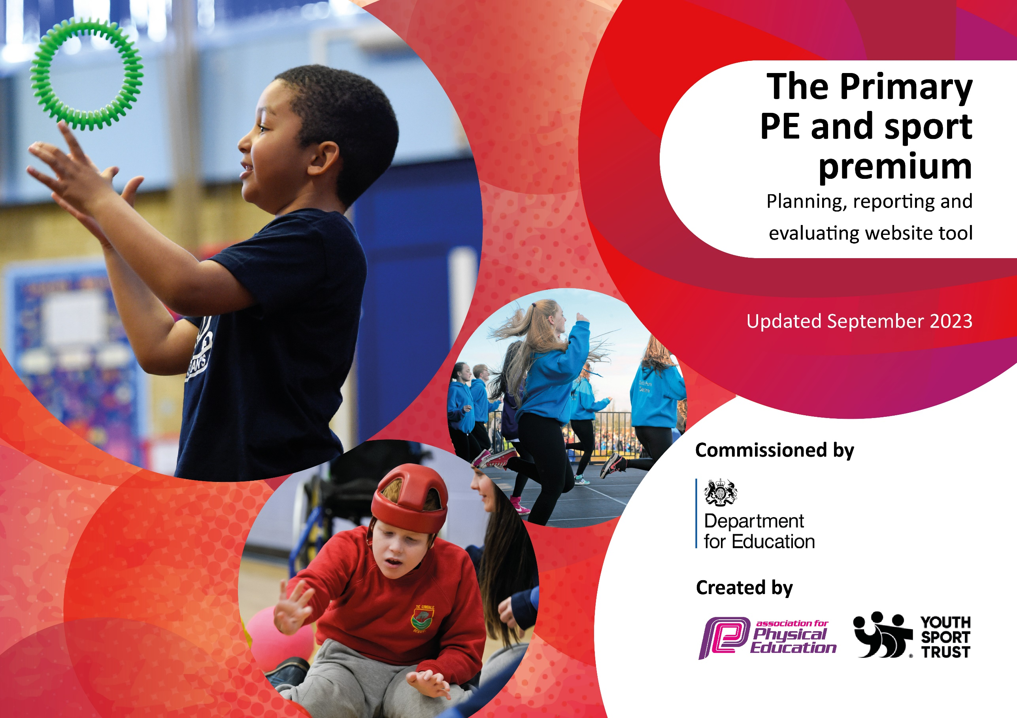

Updated July 2024

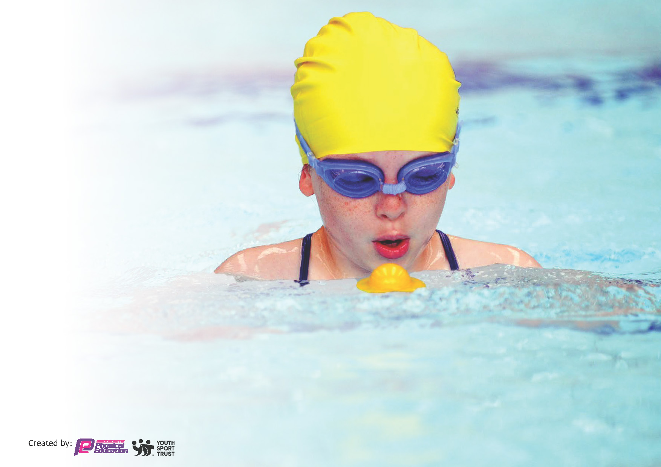
This template can be used for multiple purposes:
by:
- It enables schools to effectively plan their use of the Primary PE and sport premium
- It helps schools to meet the requirements (as set out in guidance) to publish information on their Primary PE and sport premium
- It will be an effective document to support Ofsted inspections enabling schools to evidence progress in Physical Education (PE) and evidence swimming attainment, which forms part of the PE National Curriculum. We would recommend schools consider
the Intent, Implementation and Impact of any spend, as examined within the Education Inspection Framework.

It is important that your grant is used effectively and based on school need.

Schools must use the funding to make additional and sustainable
improvements to the quality of the PE, School Sport and Physical Activity (PESSPA)
they offer. This means that you should use the Primary PE and sport premium to:

- Build capacity and capability within the school to ensure that improvements made now will benefit pupils joining the school in future years
- Develop or add to the PESSPA activities that your school already offers.

The Primary PE and sport premium should not be used to fund capital spend projects; the school’s core budget should fund these. Further detail on capital expenditure can be found in the updated Primary PE and sport premium guidance.

The Primary PE and sport premium guidance, outlines 5 key priorities that funding should be used towards. It is not

necessary that spending has to meet all the key priorities, you should select the priorities that you aim to use any funding towards.

Although completing this template is not a requirement for schools, schools are required to publish details of how they spend this funding. Schools must also outline what the impact this funding has had on pupils’ PE and sport participation and attainment and how any spending will be sustainable in the future. All funding must be spent by 31st July 2024.

The Department for Education has worked closely with the Association for Physical Education (afPE) and the Youth Sport Trust (YST) to develop this template and encourages schools to use it. This template is an effective way of meeting the reporting requirements of the Primary PE and sport premium.
Review of last year’s spend and key achievements (2022/2023)

We recommend you start by reflecting on the impact of current provision and reviewing your previous spend.

Activity/Action | Impact | Comments
There have been many key achievements during the year 2022/23.  Achievements of the children was celebrated weekly.  All keystage 2 children had the opportunity to take part in a competition or festival – 100%  Staff were given training throughout the year.  New scheme introduced in the last part of the summer term. (Primary PE passport)  Competition sports competed at a high standard in the competitions provided by school’s sports partnership.  Sports and well-being ambassadors used effectively across the school. | Self esteem boost and value given to achievements made in or out of school.  All children were included and given the same opportunities whatever ability.  Confidence in staff risen so high-quality PE lessons taught.  Easy to follow lesson plans and progression made throughout all year groups.  Due to coaches providing high quality training allowed our children to compete in competitions with confidence and clear knowledge of how to play the sports. This allowed us to win some of our competitions.  Children were able to speak to other children if they needed support at any time. Sports ambassadors helped to run school events giving them the opportunity to take responsibility for particular roles. | As a school we have provided the children with a broad and balanced PE curriculum.  They have had many opportunities both in and out of school. They show real enthusiasm to represent Glenmere positively when attending competitions or festivals and have shown they can be great overall sports people.  Level 3 – Delivery of dance – 1 member of staff.  Athletics, tennis and basketball training – all staff.  Level 2 swimming training – 4 members of staff.  Staff training given in how to use Primary PE passport – support given where needed.  Lesson observations showed progression  100% of KS2 children were given lessons in basketball, tennis and athletics.  Extra lunchtime sessions given to teams ready for competitions.  Children gained valuable skills on the training that allowed them to support others.  The sports ambassadors ran playtime games for the KS1 children in which they planned and timetabled themselves. This gave the children a variety of activities to take part in.

Key priorities and Planning
This planning template will allow schools to accurately plan their spending.

Action – what are you planning to do | Who does this action impact? | Key indicator to meet | Impacts and how sustainability will be achieved? | Cost linked to the action
Promote a whole school approach to PE and School Sport -providing all staff with professional development, mentoring, appropriate training and resources to help them teach PE and sport more effectively to all pupils, and embed physical activity across your school  Training  Staff watching professional coaches in lesson time.  For children to have daily focused physical activity in addition to break and lunch.  To offer a wide variety of extra-curricular sports activities to help ensure the pupils are active.  To develop focused activities at lunch and break time.  Providing targeted activities or support to involve and encourage the least active.  Inspire ALL students to get involved in 30 minutes of physical activity during school time and take part in physical activity outside of school.  For children to be safe on the road and therefore be able to cycle to school and keep active rather than coming in a car.  To give parents knowledge and information on how to be active during the summer. | PE co-ordinator has taken part in local PE Subject Leader meetings. The PE Co-ordinator has then shared the learnings with all colleagues during staff meetings  Staff meetings – staff have been kept up to date with all new initiatives and ofsted findings when necessary.  The PE co-ordinator has taken part in the Leicestershire and Rutland PE Conference, taking part in a variety of workshops. The PE Co-ordinator shared the learning points with all staff.  Staff have accompanied professional coaches throughout the year to sessions given to pupils. Staff watched the delivery of these lessons.  Staff to attend whole day swimming course. 4 staff were trained this year  Most classes have had daily 30 minute daily physical activity. This was achieved through 3 Pe lessons and 2 active maths and English lessons. Active maths and English are a scheme that we follow to ensure it is good quality and progresses.  We offered clubs to all year groups from EYFS to year 6, before school, at lunch and after school. New resources were purchased new for these clubs.  As part of SLSSP, children were trained as sports ambassadors and ran activities with the younger children at lunchtime.  The school took part in the SLSSP Big Moves project designed for KS1 pupils who lack fundamental movement skills/physical literacy. A coach from SLSSP delivered 6 sessions to 15 targeted pupils, the pupils had a fundamental movement assessment on week 1 and 6 to evaluate the impact of the intervention. A member of staff supervised the sessions and continued to focus on the 15 children.  The whole school took part in the Move It March project. Each child was given a physical activity tracker to fill out during March 2024. Certificates and prizes were awarded to children who achieve physical activity milestones (250 active minutes=Bronze, 500 active minutes=Silver, 750 active minutes=Gold and 1000 active minutes=Platinum). Pupils were given points for achieving milestones and the most active class won a trophy.  Children in year 5 took part in cycling proficiency so that they are now able to travel to school themselves. Rewards and incentives were given.  We promoted SLSSP holiday resources to all parents and students. SLSSP produced resources to inspire children to be active and healthy over the Christmas, Easter and Summer holidays | Key indicator 3: Increased confidence, knowledge and skills of all staff in teaching PE and sport 23/24  Key indicator 1: The engagement of all pupils in regular physical activity – Chief Medical Officers guidelines recommend that primary school pupils undertake at least 30 minutes of physical activity a day in school | Staff are up to date with training and feel more confident delivering PE lessons. They are aware of how important physical education is not just fitness but also mental well-being. Ofsted updates were given.  Staff training day gave all staff the knowledge to step in to support these lessons or run sessions on their own. Active maths/English training given.  Training was given to the PE coordinator enabled PE lead to feedback to staff to make them aware of what is expected within the PE timetable. Angela Kirk deep dive provided monitoring and feedback was given to staff.  Staff watched 50% of lessons provided by coaches for CPD reasons. They have been made aware of skills progression throughout these sessions.  4 staff members completed the swim England course. These staff are more confident on how to teach swimming and this has enabled more children to complete the swimming expectations and the year 6 target of 25m has been reached by most children – 97%  Staff have been able to use the knowledge gained in these sessions to use within their own PE lessons and staff have also run after school sessions.  Glenmere children have a positive attitude to exercise and will go out in all weathers.  Our children show good stamina and resilience in all lessons.  Active maths and English has supported the children’s subject knowledge, while also keeping them active.  We have external coaches as well as staff offering clubs and the money comes from parental payment.  KS1 – 67% took part in a club.  KS2 – 89% took part in a club.  Children had opportunities to go to yoga, football, gymnastics, trampolining, basketball, netball, tag rugby, running, table tennis, dance, multisports, tennis.  The sports ambassadors, have learnt leadership skills and then made an impact on the younger children by giving more focused play times by keeping them active while having fun at the same time.  A variety of children took part with these activities which changed on a weekly basis for example parachute games and obstacle courses.  Focused children chosen for these sessions have been the children that needed to believe in themselves and their abilities more. By taking part in these fun sessions the children have come back to class motivated and enthusiastic about what they had been doing.  The reception children who took part in the big moves project have shown better core stability which has had an impact on their ability to concentrate harder within class and is beginning to impact on their ability to sit correctly at a table to complete work set. 87% of the children who took part showed greater concentration after completing the course.  Pupil interviews were done to measure the enjoyment of Move It March and also participation was recorded.  The majority of the children were involved with the move it March project and received certificates. Year 3 won the trophy for the most participation.  After completing a week’s training children are more aware of what to look out for especially when riding on the roads.  83% passed their cycling proficiency. (25 out of 30)  All details were sent to parents via email to make them aware of what activities are available to them.  Termly newsletters gave activities and links to ways they could be active and look after their wellbeing. | £1198  (coaching – £8,380)  £396  (coaching – £9,100)  SLSSP membership - £2700  £975

To continue to give sport and physical education and activity a high profile, by it being done daily, having focused time tabled slots.  Parents to know the high profile all sport and physical activity is given, by being given details each week in all year groups of what is being covered in school.  Sports notice board, sports awards, annual sports newsletter and the regular use of TWITTER will ensure PESSPA is given a high profile.  To engage student voice and use students’ leaders to raise the profile of PE and School Sport.  Embedding Physical Activity and Well-being into the school day through different leadership roles in year 6.  For lunch time supervisors to be trained on how to make lunch times active.  Encourage active travel to school.  To increase the number of staff who are active to raise the profile of sport and exercise in school.  To understand how to be physically and mentally healthy.  Additional achievements:  Provide all pupils with a broad and balanced PE curriculum and school sport offer, which includes alternatives to traditional sport.  To offer different sports and activities for the children through enrichment in school and in after school clubs.  Increasing and actively encouraging pupils’ participation in the school competition. Ensuring competition is for all and not just ‘sporty’ children.  To provide links to take part in further competitions outside of school. | All classes had 3 timetabled slots a week for Pe, plus 2 active maths and English slots. Regular monitoring was done of this.  All classes sent out a weekly outline of what is being covered in all subjects and this ensured PE was given the same profile as other subjects and parents can talk to their children about this.  There is a dedicated sports board, we have a very large cabinet in the entrance of school to show our achievements. We also have a talent board for talents outside of school. We celebrated success in assemblies with our half termly sports award per class, regular TWEETS about activities and we sent out a termly sports newsletter celebrating all that has gone on through each term.  The school sent 4 students to become Sports Ambassadors to promote physical activity. The ambassadors formed a school sport organising crew and devised an action plan to promote PE and physical activity in school.  The ambassadors took control of the PE and school sport noticeboard. The notice board included the physical activity guidelines infographics.  Younger students were encouraged to submit pictures of themselves taking part in physical activity and pupils’ sporting achievements were included on the noticeboard.  Sporting achievements was also celebrated in assemblies. The school newsletter contained information about physical activity, sports clubs and fixtures.  4 students were trained to become Well-being Ambassadors to support mental health and internet safety in school. The Well-being Ambassadors supported the Sports Ambassadors. They had their own budget and hoodies to identify their important roles.  The school took part in an Active Travel Month. During October 2023, students and families were encouraged to walk to school. A wallchart was given to each class to record children actively travelling to school. A trophy was given to the class that actively travelled the most.  Year 5 also did cycling proficiency which enabled them to ride to school safely.  Student playground leaders and lunch time supervisors were trained to make lunch times more active. A member of staff from SLSSP delivered a Playground Leader workshop to 20 Year 5/6 students and lunchtime supervisors.  SLSSP’s Staff Well-being Challenges were promoted to all staff. This included Steptober. The South Leicestershire School Sports Partnership challenged staff to compete as a school to complete as many steps as they could over the month of October!  The SLSSP will delivered Staff Well-being Ambassador training for 2 members of staff in school again this year. An action plan for staff wellbeing was put together.  An active lifestyles day – a variety of activities for the whole school to take part in.  A range of activities has been offered to targeted groups through SLSSP membership (as outlined in Key Indicator 1).  Year 6 went on a residential and took part in rock climbing, canoeing and many other different outside activities.  3 enrichment days – 1 each term - giving the children the opportunity to try different sports – zorbing, laser tag, archery etc – the activities are our choice. Every year group benefitted from this.  First session was given free.  Different clubs offered – tap, dance etc.  Subscription to SLSSP provided opportunities for high ability, lower ability, SEND, less active and Pupil Premium pupils. We participated in sports festivals to aid transition to secondary schools.  Pupils took part in INSPIRE festivals which are designed to engage targeted pupil and inspire them to be involved in physical activity.  For example, active aspiration project.  Pupils also took part in DEVELOP festivals and competitions, which are designed to develop physical literacy and sport specific skills  For example, dodgeball, rounders, golf, tennis, dance  Pupils took part in EXCEL competitions which are designed for our most able pupils and are based on performance.  For example, basketball, gymnastics, hockey, cricket.  Pupils took part in the virtual competitions. The personal/team challenges are designed to give all students the opportunities to take part in a competition and learn sport specific skill/develop physical literacy.  The SLSSP put on a series of virtual Key Stage 1 competitions. The pupils took part in activities designed to improve agility, balance and co-ordinator (physical literacy).  Ks1 bespoke virtual challenges.  We provided links to running, tennis and basketball, these are our focused competition teams. | Key indicator 2: The profile of PESSPA (physical Education, school sport and Physical activity) being raised across the school as a tool for whole school improvement.  Key indicator 4: Broader experience of a range of sports and activities offered to all pupils  Key indicator 5: Increased participation in competitive sport | We hope for some of the livelier classes the daily exercise in the school time table, in addition to physical activity at break and lunch will really help the children stay focused.  All classes were given slots to allow the children to be active daily. At times extra physical activity was given if needed.  The weekly outline and daily lessons will show children and parents how much we value PESSPA.  Weekly outlines were given via class dojo.  Roadmaps used to inform children of what skills they were learning and why.  Children are very proud of their achievements and children are becoming more resilient in what they do. This is why it is important to celebrate. The children have learnt how to win and loose and they have also learnt how to be proud of their individual achievements. The sports awards have gone to different ability children and the children show such pride in this.  Sports ambassadors will be able to help run some of the lunch time clubs and support the playground leaders at lunchtime. The children will all given hoodies with their sport’s ambassadors role on. Sports board highlighted children’s achievements celebrated. Termly trophy given to children showing great perseverance, improved skills, great sportsmanship.  Termly newsletter celebrating children’s achievements during competitions and festivals.  The ambassadors will encourage children to share their achievements to display on the noticeboard.  Sports ambassadors created simple games for KS 1 to take part in during lunchtimes.  A timetable was created for them and termly catchup with PE coordinator took place.  Different year groups were interviewed termly to ensure that they had a good understanding of skills being taught, the links between them all, what they have enjoyed, what they would like to have the opportunity to do.  The assemblies are enjoyed by the children and staff ensure a variety of children win the awards. These will be shared in newsletters and on TWITTER.  This leads to improved self-esteem and confidence.  Children understand the importance of being active and healthy living and the benefit to how it makes them feel.  Well being buddies have ensured playtimes and lunchtimes are happy for the majority of the children.  Playground leaders will set up and run activities during lunch time to encourage children to be active by having fun. Sports ambassadors will also run activities and clubs.  Dinner staff will be actively engaged with children and groups of children.  All staff were given the resources to utilise as needed.  All staff were given opportunities to take part in the challenges set termly.  8 activities completed by the whole school - benefits of PE, drinks and how much sugar is in them,  Mindfulness/breathing/colouring , Mental Health – yoga session,  benefits to having the right amount of sleep,  Food and diet – reasons for being healthy, Physical activity and heart rate – what are the benefits of physical activity, Hygiene – importance of washing, cleaning teeth.  All activities offered to us were taken up to give the children as many different opportunities as possible.  Primary PE passport allows a broad and balanced PE curriculum to be delivered.  Tap dancing, yoga and trampolining was offered to the children as alternative clubs to encourage different children to take part – uptake of these clubs was good especially trampolining.  These activities gave the children a chance to explore different things that were not part of the school curriculum and they used equipment and costumes that wouldn’t normally do.  Enrichment days  - Laser tag/nerf wars  - Ultimate frisbee  - Street dance  - Zorbing  All opportunities given from the SLSSP was taken up. Competitive and festivals.  Participation in competitions  Key stage 2  Yr. 3 – 80%  Yr. 4 – 81%  Yr. 5 – 100%  Yr. 6 – 90%  Key stage 2  88% of pupils took part in competitions or festivals.  100% took part in whole school cross country and sports days.  Key stage 1  100% took part in school cross country and sports day.  Whole school  67% of the school took part in competitions.  We provided links to OWLS running club.  We provided links to Knighton Tennis club.  These links in the past have led to two children to reach county level tennis, we have had a child go onto play National league basketball and be part of the Aspire England development programme, we have also had children represent Leicestershire in the national cross-country finals. | £799.30  (resources used for sporting activities)  £9274  Resources - £1056.07  .  £1776.03  Triathlon - £375  Total spend = £18,670.40

Key achievements 2023-2024
This template will be completed at the end of the academic year and will showcase the key achievements schools have made with their Primary PE and sport premium spending.

Activity/Action | Impact | Comments
Achievements of the children was celebrated weekly.  Termly newsletter created to celebrate what the children’s achievements were in all areas of sport and wellbeing.  All keystage 2 children had the opportunity to take part in a competition or festival.  Staff were given training throughout the year – active maths/English.  New scheme introduced in the last part of the summer term has now had the chance to be used for a year. (Primary PE passport)  Competition sports competed at a high standard in the competitions provided by school’s sports partnership.  All children were given tennis, basketball and running/athletics training through the year.  Sports and well-being ambassadors used effectively across the school. | Self-esteem boost and value given to achievements made in or out of school.  Children able to feel proud about their achievements.  All children were included and given the same opportunities whatever ability.  Confidence in staff risen so high-quality PE lessons taught.  Easy to follow lesson plans and progression made throughout all year groups. Roadmaps and assessment books introduced.  Due to coaches providing high quality training allowed our children to compete in competitions with confidence and clear knowledge of how to play the sports. This allowed us to win some of our competitions.  From year 1 to year 6 all children had the opportunity to be given training from the coaches. This has given them progression in skills which can be built on year on year.  Children were able to speak to other children if they needed support at any time. Sports ambassadors helped to run school events giving them the opportunity to take responsibility for particular roles. They also ran games and activities during playtimes for the children in keystage 1. | As a school we have provided the children with a broad and balanced PE curriculum.  The scheme has provided the children with a variety of sports and shows real progression with skills. It has provided staff with the support needed to provide high quality lessons. Talking with the children has given me a great insight into how they feel about PE. The feedback was very positive.  They have had many opportunities both in and out of school. They show real enthusiasm to represent Glenmere positively when attending competitions or festivals and have shown they can be great overall sports people.  Sports board was updated termly to showcase the children’s achievements.  Each term the newsletter celebrated competitions and sports activities that have taken place. It highlighted successes and ensured the children were aware of how they had represented Glenmere showing great sportsmanship.  88% of KS2 children took part in out of school competitions or festivals.  100% of KS2 children took part in school competitions and tournaments. (cross country, sports day)  Lesson observations showed that staff were more confident in delivering PE lessons and it also showed good progression through year groups.  Children represented Glenmere in a variety of competitions. They showed great sportsmanship and a high level of skills was demonstrated when competing.  Basketball tournament, cross country, year 3/4 and year 5/6 tennis competitions.  Lesson observations and talking to the children showed that all children enjoyed the sessions and were able to talk through skills. This also indicated progression that can be built on year on year.  The training received for the children has given them the confidence to plan, run and enjoy a leadership role. They put into action the action plan they had created and KS1 were given a better lunchtime experience due to this.  The children obviously enjoyed the opportunity to use their own initiative when planning activities and lunchtimes were made more purposeful for the children particularly involving the less active children.

Swimming Data
Meeting National Curriculum requirements for swimming and water safety.
Priority should always be given to ensuring that pupils can perform safe self-rescue even if they do not fully meet the first two requirements of the National Curriculum programme of study

Question | Stats: | Further context  Relative to local challenges
What percentage of your current Year 6 cohort can swim competently, confidently and proficiently over a distance of at least 25 metres? | 97%
What percentage of your current Year 6 cohort can use a range of strokes effectively [for example, front crawl, backstroke, and breaststroke]? | 97% | The 1 child who has not successfully reached this level does not attend swimming lessons out of school.

What percentage of your current Year 6 cohort are able to perform safe self-rescue in different water-based situations? | 97% | The children who can swim 25 metres are all fairly confident swimmers so ae able to perform safe self-rescue in different situations.
If your schools swimming data is below national expectation, you can choose to use the Primary PE and sport premium to provide additional top-up sessions for those pupils that did not meet National Curriculum  requirements after the completion of core lessons. Have you done this? | Yes/No | Our data shows we are above the national expectations.
Have you provided CPD to improve the knowledge and confidence of staff to be able to teach swimming and water safety? | Yes/No | All staff who participate in swimming lessons have completed swim England training. We have also signed up to this as our scheme to follow.

Signed off by:

Head Teacher: | 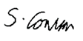
Subject Leader or the individual responsible for the Primary PE and sport premium: | Tash Hartley
Governor: | Janine O’Brien
Date: | 10/7/24

