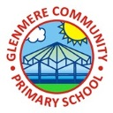

Supporting Your Child in Year 2

Autumn Term 2020 - 2021
Dear Parents,
Welcome back! I sincerely hope that you have all had a wonderful summer and that you managed to enjoy some sunshine!
So, following a very difficult time for all of us, a new academic year has started, and we have an exciting and eventful autumn term ahead of us; full of fun and purposeful learning experiences. I’m sure all the children are ready and raring to go, as we work through our next term in year 2! I know I’m looking forward to it very much!
There are so many useful resources available on our brand new website, so why not take a look at all of the wonderful learning opportunities that Glenmere has to offer.
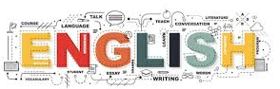
English
English will be very creative again this term, using pictures, drama and outdoor activities, to stimulate and support your children’s learning. There is a whole school focus on spelling, so we will be doing fun games and activities every English lesson, to help embed these skills.
We will be following the objectives set in the new national curriculum framework for year 2 and we will be focusing this term on both non-fiction and fiction; specifically writing using descriptive language, to create exciting pieces of work, by using adjectives, adverbs and interesting openings to describe characters and for setting the scene. We will also be doing specific writing linked with our topics.
We will be looking at adventure stories, poetry, instructions and recounts this term.
To support their learning, it would be helpful if you could encourage your child to read daily, and if you listen to your child read, I would be grateful if you could write a brief comment in their reading journal detailing how well they read and any word they struggled to read or had extra help with (reading or understanding). Reading comprehension skills are a particular focus this term and so it is essential to ensure that the children understand what they are reading. Therefore, it would be helpful if you could ask your child questions about ‘what’ they have read. Details about the types of questions that will benefit them can be found later in the letter.
Children are encouraged to read from a variety of sources and authors including fiction and non-fiction. We will work on presentation and cursive handwriting throughout the term and would appreciate it if you could ensure that any homework is completed to a neat standard.
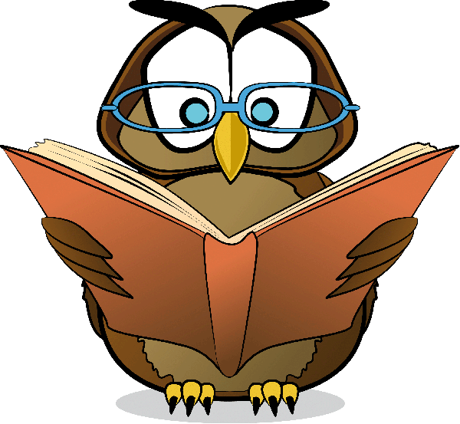
Ways that you may help with reading:
These are the types of questions your child might be asked at school. You can include some of these questions when you talk about reading at home too:
The following questions require your child to get clues from the text to answer:
How do you think the character was feeling?
How would you change the ending?
How would you describe the changes in the character/setting?
These questions require your child to refer back to the text:
What were the characters’ names?
What was the setting?
What did each character do?
What happened at the beginning, middle and end of the text?
The following questions require your child to think about the main messages:
What do you think is the main message in the story or text?
Can you relate it to another event or issue?
Do you agree with the views of the author?
What is your opinion about the message in the story?
How could other people see it differently?
Before telling your child the word when he or she is reading, try these prompts:
Look for clues for the word’s meaning in the sentence.
Look at the word closely. Does it look like another word you know?
Can you break the word down into smaller parts?
Do the words before and after this word help you to understand its meaning?
Ways you may help with writing:
You may also like to work with your child on their writing. The following are a few practical ideas that you may like to try:
-Create characters together and write a story with them.
-Read and write recipes.
-Choose a topic and write as many words as possible and then use these to write a poem.
-Verbally tell stories to each other.
-Make a book with illustrations to match their story.
Booklist for the Autumn Term:
Children in KS1 are encouraged to read a range of books, and I have included examples of the types of books which cover each genre the children need to be reading.
Title | Author | Genre
Mister Magnolia | Quentin Blake | Picture book
Gorilla | Anthony Browne | Picture book
Hey, Little Bug! | James Carter | Poetry
Strike! | Rob Childs | Football / Realistic fiction
Pumpkin Soup | Helen Cooper | Picture book
The Day The Crayons Quit | Drew Daywalt | Picture Book, Humour
Croc and Bird | Alexis Deacon | Picture Book
Aliens Love Underpants (series) | Clare Freedman | Picture book, Humour
The Ant and the Big Bad Bully Goat | Andrew Fusek Peters | Picture book
Toys in Space | Mini Grey | Picture book
Dear Greenpeace | Simon James | Picture book
The Chocolate Monster | Jan Page | Fantasy
Quick, Let’s Get Out of Here | Michael Rosen and Quentin Blake | Poetry
The Cat in the Hat | Dr Seuss | Picture book, Humour
It’s a book | Lane Smith | Picture book, Humour
 | Non-Fiction
Title | Author | Genre
The Solar System | Emily Bone | Space (Science & Nature)
Cheetah | Suzi Eszterhas | Animals
Exploring Mountains | Anita Ganeri | Geography
Eddie’s Garden and How to Make Things Grow | Sarah Garland | Plants (Science & Nature)

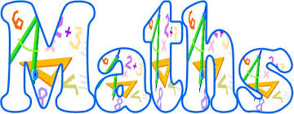
Maths
Your child will have a daily maths lesson which will follow the National framework. All children will be set level appropriate work and will be encouraged, when appropriate, to attempt the higher level of work for the children working at greater depth. Please let your child show you the calculation methods that they have learnt at school and encourage them to use and apply their mathematical skills in everyday life situations. Practising times tables, working with money and teaching your child to tell the time are all ways that you can help at home and I have outlined some practical ideas for this later in the letter.
Ways you may help with maths:
It is important that children see the ‘real life’ practical uses of the maths which they have been learning at school. There are lots of ways in which you can practise maths with your child in real life contexts. For example:
RECIPES
-Collect and read recipes and discuss and encourage your child to make accurate measurements using measuring cups and spoons.
-Discuss how you would double a recipe. Encourage your child to record the new measurements for the recipe.
-Identify the temperature and cooking time on the recipe.
-Find the cost to buy all the ingredients to make the recipe.
-Make a list of the abbreviations used in the recipe and then write them in full, for example, L for litre, mL for millilitre, tsp for teaspoon, tbs for tablespoon.
MONEY
-Encouraging children to think about money, saving money and considering how they spend money are important skills for all children to develop.
-Encourage your child to work out how much change you will get after buying something.
-Investigate costs for family trips together. For example, a visit to a theme park may include transport costs, entry ticket costs and food costs.
Challenging your child:
In order to teach children greater depth in maths it is important that they are encountering and solving problems which offer a range of different contexts in order to deepen their knowledge. Websites such as Nrich (nrich.maths.org), NCETM (www.ncetm.org.uk) and NACE (http://www.nace.co.uk) offer a large range of problems, puzzles and questioning support which can help children to deepen their understanding.
The children will also use ‘mathematical reasoning’ during all lessons. This is the critical skill that enables children to make use of all other mathematical skills. With the development of mathematical reasoning, students recognise that mathematics makes sense and can be understood. It would also be helpful to your child if you can ask them to ‘explain’ how they have solved the problem. This will reinforce their own understanding and verbalise their thinking.
Broader Curriculum

We are very excited about our new and exciting revised curriculum!
Our topics this term are ‘On your Doorstep’ where we will be comparing where we live with another part of the world. The second half of the Autumn is ‘History Makers’ where the children will learn about famous people and the impact that they have had. One of the key aspects of our curriculum design is deciding what we want our children to learn. After a great deal of research, we now use “Knowledge Organisers” (KO) to demonstrate, for class projects and key subjects, what we want children to learn. They will contain:
- Key questions – that children should be able to answer when the project is complete.
- Important vocabulary.
- Relevant images such as maps, portraits, photographs, timelines
- Skills needed to apply the knowledge learnt.
- How the learning fits into the overall scheme of our curriculum.
All of our Knowledge organiser are available on our website. A copy of your child’s homework KO will be sent home in black and white but a colour pdf can be viewed on our website.
There will be 2 science topics this term; Animals including Humans, where the children will learn about life cycles, hygiene and how to keep healthy. Plants is our science topic for the second half of the Autumn term, where we will investigate what plants need to survive and how they reproduce.

P.E.
Your child will have daily P.E. lessons each week including fitness with maths and English sessions.
They will need a Glenmere sport t-shirt (for indoors, and outdoor), black shorts and an outdoor PE kit, including tracksuit bottoms and a Glenmere sports jumper if the weather is cold. (Why not look on our website at the details for the exclusive Glenmere Sports wear.) A change of footwear is needed. The children need plimsolls or indoor trainers for indoor sessions, trainers for outdoors, and these should not be the same shoes as their school shoes.
As we will be outdoors for some of the sessions, it is VERY important that your child has an outdoor kit, which will need to reflect the weather. A lightweight waterproof can also be worn, as we will still be outside if it is drizzly rain, and sun cream needs to be put on before coming to school if it’s hot! I would like all children to bring a water bottle to school to be taken out for PE please. Please ensure the water bottles are clearly named, and the children will be encouraged to bring them home daily to wash them, and bring back for the following day. PE kits in school on Monday and take it home on Fridays. Please also note that for ALL PE activities, NO jewellery whatsoever must be worn, including earrings, watches and necklaces.
SEND
For some children learning can be a challenge and at Glenmere we work hard to ensure that all children’s needs are met when delivering the curriculum in order for them to access the learning. In year 2 children have access to physical resources to support them in their maths work, such as counting apparatus, number lines, dienes, place value counters, number grids and have opportunities to learn in a practical way. During out English lessons we provide scaffolding resources to support understanding and work in fun, active ways that engage all learners. Interventions for reading takes place in the form of our reading coaching programme where children are taught to read using activities that deepen their understanding of the text and by using visual resources and games for word recognition. We want all children to become independent learners but are also aware that some children need support at different times so we work hard to provide a balance between supporting them in one to one situations, small group work (both in and out of the classroom) and working in a larger group with support. We model activities for children using the ‘I do it, we do it, you do it’ approach which helps to embed their understanding and allow the children to become successful learners. Here are some resources to support these children:
- http://www.ictgames.com/numberFacts.htm
- http://www.ictgames.com/placeValue.htm

Homework
Homework will look very different moving forward and you will be receiving a letter about this next week.
Remember to follow the school on Twitter as year 2 will regularly post examples of our learning and it’s so useful to learn about any school news!

(@GlenmereSchool) | Twitter

Thank you in advance for your support in your child’s learning.
I’m really looking forward to teaching them and making their learning experiences as purposeful and memorable as possible.

Mrs. R Siddons.

