Year 4 Christmas Class Newsletter!!
The Christmas holidays are upon us, it is time for some relaxation, fun and quality family time. The children have worked incredibly hard all term and have shown how excited they are about their learning and how committed they are to develop their knowledge and skills across the curriculum. Not only have they had fun, but the progress they have made is absolutely amazing. I am incredibly proud of all of them!
One of the children’s favourite subjects this term has been geography. They have been so inspired by the new knowledge they have gained about the Rainforests, that they have even continued this learning at home, without having to be asked! In the Amazon, the children learnt all about the layers of the Rainforest and which animals, insects and plants reside in each layer. They have also discovered the biomes for particular animals, and that some species are endangered, so they discussed what they could do to help them, which they were really passionate about. They loved acting out the layers of the rainforest and researching the animals in ICT.
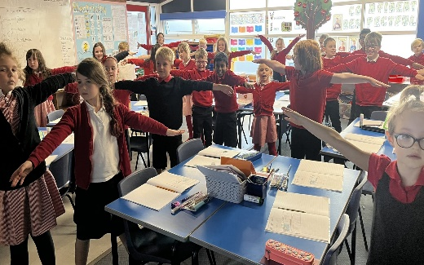

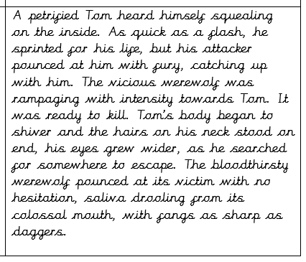
English has proven to be a real hit with the children in year 4. We are following the Talk for Writing scheme, which the children have responded to amazingly. They have written some amazing setting descriptions, wonderful narrative stories and excellent explanation texts. The level of vocabulary, punctuation and grammar the children are applying is great and they have learnt exactly what makes a good piece of writing for that particular genre, by identifying which key features need to be included in their writing. They have done this by highlighting the features in a model text, then applying them into their own piece of work.

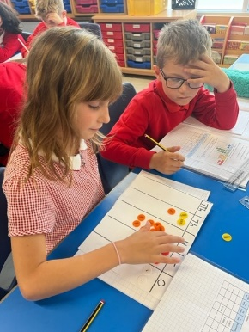
We have covered place value, addition and subtraction, measures (perimeter and length) and multiplication and division for the 3, 6, 7 and 9 times tables in maths. The children have shown that they are superstars at following the methods and using the key vocabulary as well as the sentence starters to help them explain and reason their answers. They have begun to show this in their books too, which demonstrates wonderful understanding. They all self-assess their work, which lets me know just how to help and support them if they ever need it.

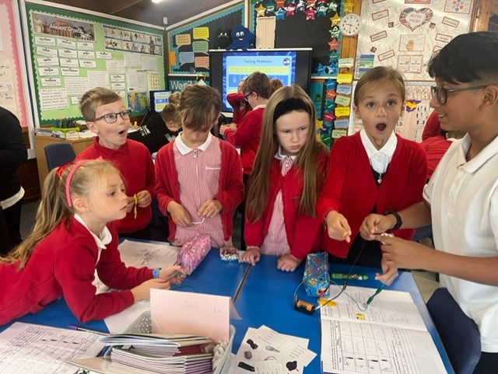
Science has proven to be a favourite amongst the children this year. They have had many opportunities to investigate, enquire, test and report on their findings and have always used the technical vocabulary when doing so. In our Electricity topic, the children learnt what components are used to make a circuit and how to ensure that it is complete, as well as how to be safe when using electricity, it was great to see their eyes light up when the bulb lit up! In Sound, the children (which is so impressive) can tell you how sound travels to the ear and enables you to hear the different sounds, naming the relevant parts using scientific vocabulary, such as the stirrup, anvil, hammer and ear-drum.

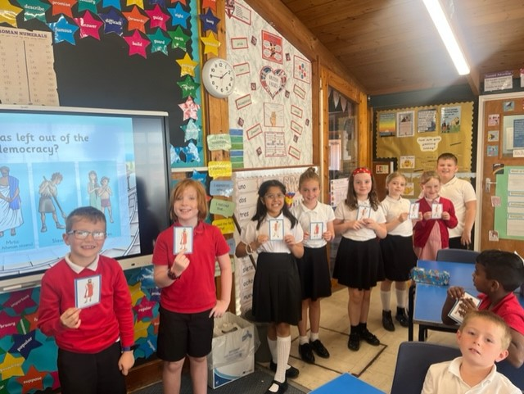
The children thoroughly enjoyed their history topic on the Ancient Greeks this term. They learnt about how we use artefacts from that period in time to understand how the Ancient Greeks lived, fought and worshipped their Gods. One of their favourite lessons was linked to British Values and ‘Democracy,’ where some children played characters who were allowed to vote and others weren’t. They enjoyed learning about the Gods and Goddesses too!

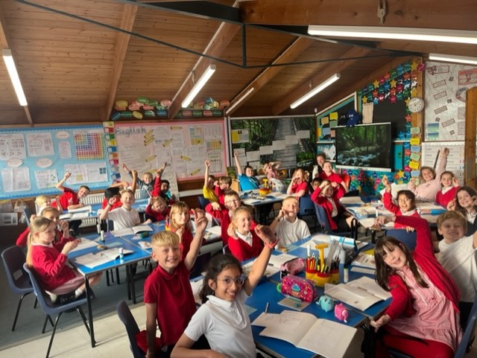
Year 4 have been so creative this term and have thoroughly enjoyed both the art and design technology units of work. They have developed their artistic skills when making various tools from everyday objects to create printed patterns, but I think the most exciting lessons were in DT, when they had to taste, make and evaluate biscuits and they loved the challenge of designing and making their own too!

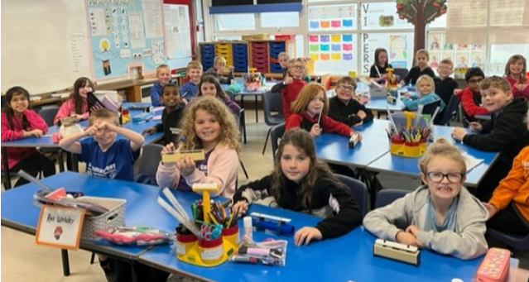
I am so pleased that the class are learning to have musical bones! They have thoroughly enjoyed the music in year 4 and have learnt about how to listen and appraise songs by ABBA, as well as sing along to Mama Mia and have also learnt how to play C, D, E, F and G on the glockenspiel and even compose their own part of a song!
Finally, at the end of a fantastic and incredibly busy term, the children will celebrate by dancing the afternoon away to some Christmas tunes and have fun playing games at their Christmas Party! Well done to all of you. Have a very Happy Christmas and to all of your parents, thank you for all your support, it is a pleasure teaching your children and I look forward to seeing them bright-eyed and bushy-tailed in the New Year!

