

Supporting Your Child in Year 4

**Autumn Term 2021**



Dear Parents,

Welcome back! It has been so wonderful to see your children back in school, I hope you have all had a wonderful summer break. It has been a wonderful start to the new school year and I have been so impressed by how confident and excited the children have been coming into school. They have happily fallen straight back into loving their learning with smiles on their faces. They are adapting brilliantly to the new routines and are still following all the safety procedures that have been in place for them since last year. I know this year is going to be a fabulous one, and I am very excited to be their teacher. It will be wonderful to watch them grow in confidence and develop an even greater love for learning!

Please remember that if you should need any support from me throughout the year, if you need to ask any questions regarding your child’s education or welfare, just get in touch via Class Dojo and I will do my best to help in any way I can.

**The Curriculum**

Our curriculum has been developed and includes lots of wonderful opportunities for children to learn their topics in a fun and interesting way. Below outlines some of the areas that we will be covering over the Autumn Term, and some ideas on how you might support your child’s learning at home. Literacy and Maths will follow the new National framework for Yr. 4. See details on: <https://www.gov.uk/government/collections/national-curriculum>

**SEND and More Able**

Interventions will be put into place to support those children who need it. Children will be challenged in class with greater depth learning activities and work is differentiated so that children are able to become more independent, while still feeling supported. More able children will be given opportunities to further their knowledge and skills and will be asked more in-depth questions in class. Our new curriculum knowledge organisers have a ‘greater depth thinking’ section, to ensure that children demonstrate the ability to delve deeper into a subject area and justify their answers.

Below are some websites and ideas to support the more able children with work they can do at home to develop and deepen their skills and knowledge.

**MATHS – MORE ABLE**

<https://nrich.maths.org/7741>

<https://komodomath.com/d/12?gclid=EAIaIQobChMItpiXhKG76wIVjd_tCh1SuQyUEAAYASAAEgLDF_D_BwE>

<https://thirdspacelearning.com/blog/maths-challenges-ks2/>

The last website gives you a huge array of website links for maths for the more able.

Describe a mathematical concept, procedure or idea in his or her own words;

• Represent a mathematical concept, procedure or idea in a variety of ways e.g.

using concrete materials, pictures and symbols

• Explain it to someone else;

• Make up his or her own examples (and non-examples) of it;

• See connections between it and other facts or ideas;

• Recognise it in new situations and contexts;

• Make use of it in various ways, including in new situations

• Solve problems of greater complexity (i.e. where the approach is not immediately

obvious), demonstrating creativity and imagination;

• Independently explore and investigate mathematical contexts and structures,

communicate results clearly and systematically explain and generalise the

mathematics.

**Questions like; Can you convince me?**

This is another question that can help develop generalisation. Asking individuals or small

groups to work together to convince you of something develops their depth of

understanding and ability to reason. Here are some examples:

'Convince me that subtraction is the opposite of addition’

'Convince me that all multiples of 8 are multiples of 2’

**ENGLISH – MORE ABLE**

<http://www.grammar-monster.com/>

<https://wherereadingrocks.files.wordpress.com/2017/04/class-novel-books1.pdf>

The above website provides a list of books which can be used by more able children.

**WRITING**

Feedback in writing for the Most Able children will encourage the children to think

deeper about the choices they have made in their written work. This may be through a

question such as ‘Can you explain why you have chosen the verb clambered instead of

climbed in this sentence?’ This allows the children to analyse their choices and also think

about the effect of their choices on the reader.

**READING**

more able children will be given a text that is suitable to their ability and will then be asked a variety of evaluative questions, such as:

• Identify a passage in the text where the author successfully created an atmosphere.

Explain how the author achieved this.

• Think about a character and why they behaved as they did. Do you agree with the actions of this character? Explain your answer.

• Do you think the author uses words in an interesting way? Find four examples and

explain why you like them.

They may also be asked to show appreciation of the text by answering:

• How did the text make you feel and why?

• Think about a character in the book. Which one would you choose to socialise with?

Why?

• Finish this idea: ‘I love the way the author…’ Give examples to support your opinion.

**Mental Health and Well-being**

Children have access to a variety of support in school to help them with any challenges they face regarding mental health and wellbeing. Through discussions with the children, it was wonderful to hear that they know who they can talk to in school if they need to and that they are enjoying the activities we are doing with them to support their mental health and wellbeing.

**Extend their learning!**

Playing games/doing activities with your child can help to enrich their learning. Here are a few ideas for literacy, numeracy and science you could play/do with your child.

**Literacy and maths** – Crack the code! Ask your child to solve the literacy problem by answering questions, (mathematical) to find the number that corresponds to the right letter e.g. 19,3,9,5,14,3,5…….can you figure it out? The answer is SCIENCE. Each letter corresponds to its numerical position in the alphabet e.g. A=1, B=2 and so on.

**Literacy** – Deepen the children’s story writing skills by reading higher level books to them to enrich their choice of vocabulary.

**Literacy** – Give them a story starter and a theme and ask them to write you a story based on the theme you give them. Can they create a mood?

**Literacy** – pictures – Give them an interesting picture. Ask them to brainstorm about it, then create a story starter of their own that’s good enough to hook a reader and reel them in.

**Maths** – Magic squares – Can they fill in a grid of numbers e.g. 4x4 grid where each line adds up to the same amount?

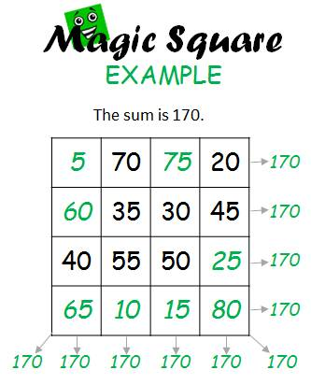

**Maths** – Sudoku!

**Maths** – bbc bitesize is an excellent website to use to reinforce and extend leraning.

**Science** – bbc bitesize give interactive games for the children to play to consolidate and further their learning.

**Science** – Experiment with; cornflower, oil and water, dissect plants, look for bird and animal habitats when out walking. Ask them questions like, because I have longer legs than you, does it mean I can jump further? What is the scientific name for the skull?

**Memory games** – A good memory is vital to extending a child’s capabilities. Memory matching cars, a tray of goodies covered with a tea towel – can they remember what was on the tray to tell you which is missing if one is removed as the tea towel is removed?

Have fun learning and experimenting with your children!



**English**

In English we follow the ‘Talk for Writing’ scheme, so it will be very creative this term, using pictures, drama and outdoor activities, to stimulate and support your children’s learning. There is a whole school focus on spelling and grammar, so we will be doing fun games and activities every English lesson, to help embed these skills.

We will be following the objectives set in the new national curriculum framework for year four and we will be focusing predominantly this term on fiction; specifically writing using descriptive language, to create exciting pieces of work, by using adjectives, adverbs and interesting openings to describe characters and for setting the scene. We will also be doing specific writing linked with our topic of the Romans.

The children will begin to develop their independent skills of planning, drafting, revising, editing and presenting, to ensure there are producing the highest standard of work they are capable of.

Reading comprehension skills are incredibly important. It is essential to ensure that the children understand what they are reading. These skills will be tested during assessments, so we are practising them on a daily basis. To support their learning and comprehension skills therefore, it would be helpful if you could listen to your read daily (a range of both fiction and non-fiction texts) and ask your child questions about ‘what’ they have read. Please comment briefly in their reading journal, on their comprehension, reading and vocabulary skills.

We will be using VIPERS to support the children’s comprehension skills. These are broken down below.

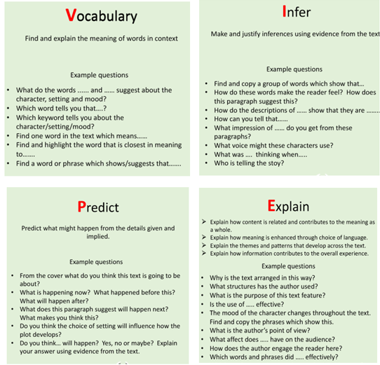

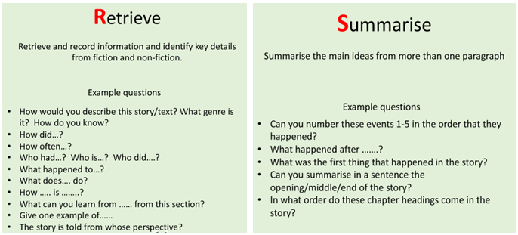

Presentation is important, so cursive, joined handwriting is essential now they are in year 4. We have introduced a new handwriting scheme to help support this in school. Any practise they can do at home would be greatly appreciated too.

**Numeracy**

Numeracy lessons will also follow the new National framework. Our areas to focus on this term are:

* **Recognise place value**
* **Find 100 more and less than a number**
* **Ordering 4 digit numbers**
* **Rounding numbers to nearest 10,100 and 1,000**
* **Roman numerals**
* **Count backwards through zero**
* **Addition and subtraction with 4 digit numbers- written method**
* **Inverse operations- *checking work***
* **Word problems**

We will be practising mental calculations regularly, every day during our Numeracy lessons and on a weekly basis, as mental recall is a valuable resource when doing any calculation, but particularly in light of the new introduction of a multiplication tables assessment in year 4. Therefore, multiplication tables will be rehearsed more often, as the more confident the children are, the happier they’ll be and easier they’ll find it.

Children find problem solving tricky, so applying it to real life situations is invaluable. Therefore, any opportunities you have to give them a problem to solve for example taking them to the shops and asking them to count up how much you are spending and what your change would be if handing over a value note (e.g.£10) would really help their skills and to make learning fun and ‘mean something!’

It would also be helpful to your child if you can ask them to ‘explain’ how they have solved the problem. This will reinforce their own understanding and verbalise their thinking.

I have included some examples of how addition, subtraction, multiplication and division questions might be answered. These have been taken from our maths calculation policy.

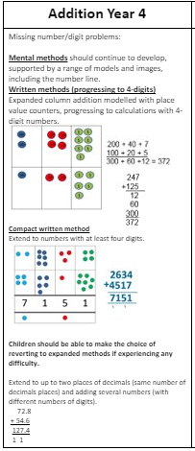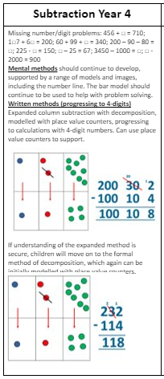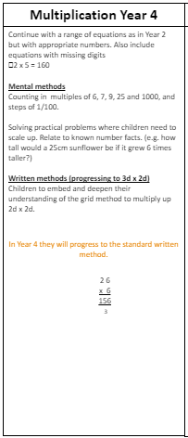

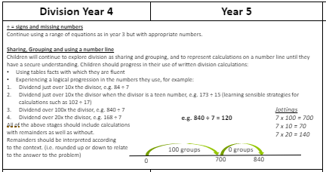

**Foundation Subjects**



Our History topic for the first half of the Autumn Term is The Ancient Greeks. We will be travelling back to the time of the Greeks and learning amazing facts about this incredibly interesting period of time. We will be linking our learning with art, geography, maths, ICT and literacy.

The children will study the history of Ancient Greece – link with sport and the Olympics – look at traditional food, clothing, housing, people.

An exciting topic I’m sure you’ll agree!

The second half of the Autumn term will be great fun as it is all about Rainforests!

The children will be finding information about the rainforests of the world, their locations, climates and main features and use maps, atlases, globes and digital/computer mapping to locate countries and describe features studied.

**Science**

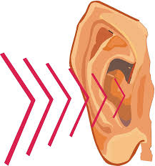

**Electricity and Sound**

In this unit the children will find out all they can about electricity: investigating how circuits work and how we use them to send electricity to bulbs and buzzers and sound: how it travels, pitch and volume. They will then investigate materials to see which will provide the best insulation against sound. We will be having lots of fun making muffle boxes, string telephones and a tuning fork experiment.

Here are the National Curriculum objectives:

**Pupils should be taught to:**

* identify how sounds are made, associating some of them with something vibrating
* recognise that vibrations from sounds travel through a medium to the ear
* find patterns between the pitch of a sound and features of the object that produced it
* find patterns between the volume of a sound and the strength of the vibrations that produced it
* recognise that sounds get fainter as the distance from the sound source increases

**P.E.** 

Physical activity supports our mental health, fitness and wellbeing, so your child will have a PE lesson every day for 30 minutes. However, two of those lessons will be a PE based English and maths session.

They will need a **Glenmere t-shirt and jumper (which can come in any colour) black shorts and an outdoor PE kit, including tracksuit bottoms and a warm top if the weather is cold. A change of footwear is essential. The children need plimsolls or indoor trainers for indoor sessions, trainers for outdoors, and these should not be the same shoes as their school shoes. Football boots are needed, especially if the children are involved in any extra-curricular football activities as they will not be able to participate if they do not have the correct footwear, it is a health and safety recommendation. Therefore, both boots and shin pads are essential**.

As we will be outdoors for some of the sessions, it is **VERY important that your child has an outdoor kit, which will need to reflect the weather. A lightweight waterproof can also be worn, as we will still be outside if it is drizzly rain, and sun cream needs to be put on before coming to school if it’s hot! I would like all children to bring a water bottle to school to be taken out for PE please. They will need to keep rehydrating themselves and this is the most efficient way of ensuring they do so, without eating into valuable PE time by needing to go inside for a drink at the water fountain. Please ensure the water bottles are clearly named, and the children will be encouraged to bring them home daily to wash them, and bring back for the following day.** Although PE is timetabled, children need to have their PE kits in school on Monday and take it home on Fridays. **Please also note that for ALL PE activities, NO jewellery whatsoever must be worn, including earrings, watches and necklaces.**

**ICT**

Children will continue to develop their ICT skills by using Purple Mash. They will be using the programme 2Code and studying online safety.

Research using ICT is invaluable to enrich children’s learning of all areas of the curriculum, so I have provided a list of websites that may be useful during this term.

We will also be using Google Classroom for the children’s homework, so they will be learning how to use this effectively too. The children will be expected to do their homework on line unless otherwise agreed, they will be given the skills to help support themselves and their families at home, so homework can be completed and given in successfully.

**Literacy**

<http://www.bbc.co.uk/bitesize/ks2/english/spelling_grammar/>  
<http://www.bbc.co.uk/bitesize/ks2/english/reading/>

**Maths**

<http://nrich.maths.org/teacher-primary>  
bbc bitesize – (type in any area of maths)

**History - The Romans**

<http://www.bbc.co.uk/education/topics/zwmpfg8>  
<http://www.primaryhomeworkhelp.co.uk/Romans.html>  
http://resourcesforhistory.com/historywebsites.htm

**Science - Sound**

<https://www.bbc.co.uk/bitesize/topics/zj44jxs>

<https://www.theschoolrun.com/what-is-electricity>

<https://www.stem.org.uk/resources/community/collection/12388/year-4-electricity>

Any other sites you or your children find useful, please let me know so I can add them to the list! Thank you.

**BOOKLIST**

Children in year KS2 are encouraged to read a range of books, from poetry e.g. Roald Dahl’s Revolting Rhymes, to The Hobbit!

Reading is amazing and, as it is a real passion of mine, I would love the children to develop a real love for reading as it develops a higher vocabulary and extends their imagination. A list of the recommended books for lower key stage 2 is on the website to support you and your child with their book choices.

**Homework – Blended learning**

Homework will now be delivered via Google Classroom. Children will be given training into how to access the learning and upload their work. This will be set by the class teacher and marked accordingly.

Children will be given spellings via our new scheme called ‘Spelling Shed.’ This is a wonderful interactive site, which will engage your child using games and activities for them to complete. There will be a lesson on a Monday to introduce the new spellings and children will be tested at the end of the week. Practising spellings daily will help your child to understand different spelling patterns and apply them when writing unfamiliar words.

There will be a multiplication test in the Spring/Summer term, so it will be important for the children to practise their tables every day. They will be able to use our Famous 5 tables test, as well as online activities such as timestables.co.uk to practise in a fun and interactive way.

**Working Together**

I am looking forward to working with you all to provide a wonderful and exciting year of learning for your children. Thank you for your support and here’s to a wonderful year 4!

Thank you.

Mrs Dorrington