Music Knowledge Organiser -Year 6 – Classical Jazz 2
Song for the lesson;  Bacharach Anorak  Key learning;  - This piece uses the trademark chord progressions (the order in which chords are played) and syncopated rhythmic patterns (emphasizes weak upbeats instead of strong downbeats) | 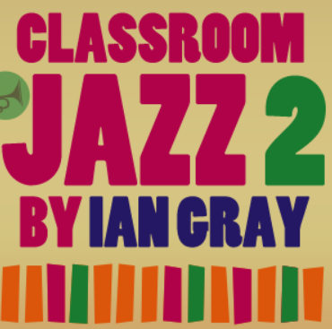
Song for the lesson;  Speaking my peace performed by Jespar Lundfaard  Key learning;  - The original musician who wrote and performed this song was Horace Parlanborn who was an American Jazz piano player  - The main instrument in this piece is a saxophone. | 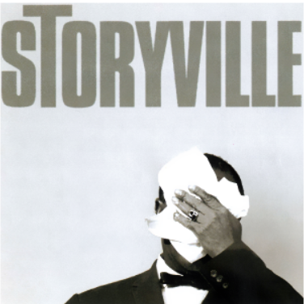
Song for the lesson;  Take the ‘A’ Train by Duke Ellington  Key learning:  - Take the ‘A’ Train is a jazz standard by Billy Strayhorn that was a tune by which the Duke of Ellington orchestra was known by  - Musical instruments in this composition include saxophones, trumpets and trombones | 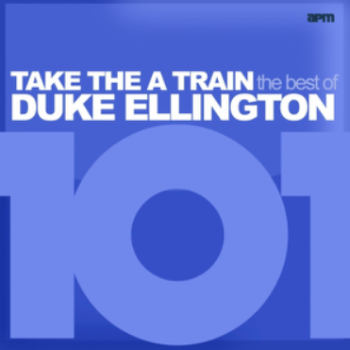
Song for the lesson;
Meet the Blues by Ian Gray
Key learning:
- This piece is made up of different sequences of notes/chords which change very slightly every 12 bars (12 X 4 beats) creating a different texture.
- The key jazz instruments heard are a piano and a double bass.
Song for the lesson;
Back O’Town Blues by Earl Hines
Key learning:
- Earl Hines was an American jazz pianist and developed modern jazz piano
- This Blues song, like many others, tells us a story about lost love and how the singer regrets his actions. The loss is often signified by the sound of a trumpet and its droll sound. There is the classic 3 chord run down which is often heard in blues songs.
Song for the lesson;  One O’clock Jump by Count Basie  Key learning:  - One O’clock jump is a 12-bar blues instrumental.  - The music incorporates riffs (repeated sequence of notes or chords | 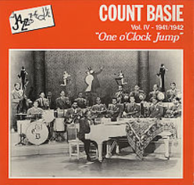
Blues | A musical form that came from America that became popular in the early 1900s. Guitar, piano and harmonica are typical blues instruments
Jazz | Jazz combines African American music with European music
Composition | This considers how the music is structured or put together
Melody | The melody is the music of the song
Key Words

