Year 6 Design and Technology Knowledge Organiser Autumn 2
Cooking: Come Dine with Me
Knowledge
Exploring complimentary flavours
- There are five basic tastes: bitter, sweet, salt, umami (savoury) and sour
Evaluating against nutritional value
- Nutritional value tells us how much fats (including saturated fats), sugar, salt and energy is in the food. This is on packaging, including that of ready meals.
- It is important to consider meals with low sugar, salts and fats
Improving and adapting recipes
- Recipes can be adapted to improve their nutritional value and healthier alternatives can be used.
- They can be adapted to meet different dietary requirements
Food preparation
- Different coloured boards and knives are used to avoid cross contamination between
- When chopping food, different safe techniques can be used
- It is important to wash hands between cutting different ingredients
- Foods can be chopped in different ways
Cooking
- It is important to consider the different steps when cooking a full meal, including foods that will accompany it.
- Timings are important also.
Evaluating
- We can evaluate food through its taste, texture, smell and look.
- This is usually the job of food tasters or critics.

 | Key Vocabulary
Accompaniment | A side dish that complements the main dish and enhances its taste flavour
Collaboration | Working together to achieve a finished product
Preparation | The process of handling, cleaning, cooking an preserving food to make it edible and safe
Processed | Food that is changed from its natural state
Flavour | The distinctive taste of a food or drink

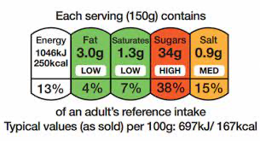
Food labels following the traffic light system.

