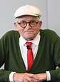
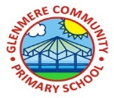
One of the most important artists of the 20th century, known for using a multitude of mediums to create his pieces.
David Hockney
1937

Year 6 Art & Design Knowledge Organiser Spring
Panting and mixed media: Artist study
Knowledge
- Hockney works with paint for most of his art, however, he also uses photography and printing techniques
- He was involved in the pop art movement in the 1960s
- Pop art was a style of art that was bright and full of colour.
- He created a revolutionary style of art called a ‘Joiner’, where he takes lots of photographs of the same scene and combines them
- Fiona Rae is a British contemporary artist known for her colourful abstract work
- She uses formal elements such as line, shape and colour to create paintings that can be interpreted in different ways
- Abstract art aims to provide viewers with an emotional experience, one that is completely different for each person, depending on their personality and mood
- Artists use art to tell about things that are important to them; looking at artworks from the past can reveal thoughts, opinions, memories and experiences
- Art can be analysed and interpreted in lots of ways and can be different for everyone
Artistic techniques

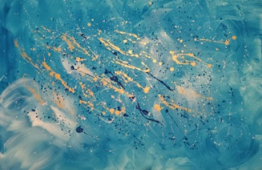

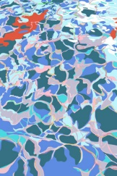

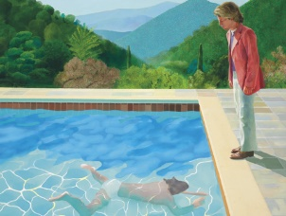

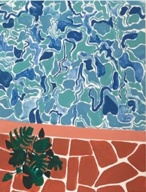

Key Vocabulary
abstract | Art that doesn’t necessarily look like real life – uses shapes, colours and gestural marks
analyse | To investigate something in detail to understand it
evaluate | To form an opinion of how good or useful something is
interpret | To understand or explain the meaning of something
medium | The materials used to make a piece of art
mixed-media | Art made from a combination of different materials
respond | To create ideas from experiencing art of others
