Skills I will require and apply:
- Be able to identify primary and secondary sources and used evidence to build up a picture of past events
- We will sequence several events
- Make comparisons between different times and in the past, comparing the Anglo-Saxons and Vikings
- Use different sources to retrieve key information, including topic books in the classroom.
- Use maps to locate key settlements linked to the periods in time

To hook me into this project I will:
Hook Box – artefacts linked to the different periods in time

Experiences that will help me remember:
Visit to Compton Verney for Viking Villagers experience
Class 5 Subject: History Unit: Viking Invaders Theme: Social Class
Project: a historical study on British settlements by Anglo-Saxons and Vikings
Big Question: How much change did the Anglo Saxons and Vikings bring to Britain?
The British Values I will be demonstrating and deepening my understanding of will be: individual liberty and rules of law
 | By the end of this project, I will know the answers to these questions
 | What was the timeline of events during the different periods of time? | AD 43 Romans invaded parts of Britain where they made lots of changes to Britain. The empire collapsed in AD 407. The Anglo Saxons, after the fall of the Roman Empire, started from 410 to 1066 soon after the death of Edward the Confessors. In AD 793 the Vikings first invaded England
cause | Why did the Anglo-Saxons invade? | Some say to fight, to farm, to make new homes or that in fact they were invited to help the Britons from other people attacking them
cause | Why did the Vikings invade? | It is suggested that they came for better land and more land as well as raiding places for treasures
Sim + Diff | How was Britain ruled during this time? How was this different from before? | Anglo Saxon Britain wasn’t rules by one person. Britain was split into Kingdoms which were led by a king who led a small army. Punishments were still in place however they did not have prisons. This was different to Roman Britain which was ruled by an emperor.
Significance | Why was Alfred the Great so important to England? | He unified the England. He agreed a treaty with Vikings to divide England The Saxons retained the west, while the east (between the Thames and Tees rivers) was to be Viking territory - later known as the 'Danelaw' - where English and (Danish) Vikings were equal in law.
Cause | How did the Vikings and Saxon rule come to an end? What caused the Battle of Hastings? | In 1066, King Harold defeated Harald Hardrada (who was a Viking warleader) in the last Viking invasion. They then went on to battle William the Conqueror of Normandy when they invaded Kent. The exhausted English army fought the Normans at the Battle of Hastings. After a long day’s fighting the Normans had won and William was the new king of England as both the Vikings and Saxons had been defeated. King Harold was reported shot in the eye with an arrow.
Change | How did they both change Britain? | They changed Britain in a range of ways including bringing their own religious beliefs but Saint Augustine converted most of the country to Christianity
Sources | Why was the Anglo –Saxons known as the dark ages? | It was known as the dark ages because there is little written record about this period of time.
Cause | What could have happened if Alfred the Great hadn’t been so successful? | The English and Danish may not have signed the treaty, therefore not making them equal in law, which could have resulted in further invasions and battles.
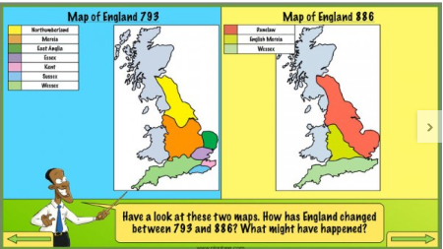

Whole School Vocabulary Threads, | Tier 2 and Tier 3
Empire, Law, Tax, Parliament, Society, Democracy, Power, Invasion, Settlements, Kingdoms | Conquer | Overcome and take control of
 | Defeat | Win a victory over someone in battle
 | Legacy | Something left or handed down
 | Unified | To unite – make whole
 | Danelaw | Part of northern and eastern England occupied or administered by Danes
 | Monastery | A building occupied by a community of monks living under religious vows
 | Peace treaty | A formal agreement which ends a conflict
 | Jurisdiction | An official power to make legal decisions

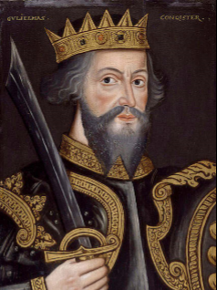
Metacognition
What am I being asked to do? Which strategies will I use? Are there any strategies that I have used before that might be useful?
Life Skills
Resolving conflict and working in teams

Texts/books I will be using in this project:
Beawulf – Michael Morpurgo
Viking Boy – Tony Bradman

