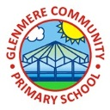
Supporting Your Child in Year 5

Autumn Term 2020
Welcome back. we hope you’ve had an enjoyable summer holiday and are ready for the year ahead. We are extremely excited about working with Year 5. It is going to be a very busy and hard-working year but we have full confidence that it is going to be a good one.

English
In English this term we will be focusing on Beowulf, particularly linked to our ‘Invaders’ history unit. The story is about a quest to destroy a murderous monster, set in fifth century Denmark. We will continue to develop our use of ‘Talk for Writing’ which they became so strong at in Year 4. Along with this we will develop our non-fiction writing skills within news reports and explanation texts which will link to Geography – Extreme Earth.

The QR codes provide links to some of the books we will be reading this term:

Beowulf Boy in the Tower Room 13
I Survived the Destruction of Pompeii Brightstorm

Support in writing
- Write parts of sentences onto different cards then discuss the different word types e.g. verbs, adjectives etc.
- Rainbow sentences are great. Write each sentence in a different colour. This allows children to see where and when punctuation is needed
- Cross words and hangman are a good way to practice spelling the year 3 and 4 spelling words, or the 5 and 6 spelling words.

Confident writers
- Work on editing skills by unpicking parts of a story and finding synonyms for different words then re-read the section with changes
- Play with sentences, adding clauses to different places within the sentence
- Begin experimenting with different types of punctuation including colons, dashes and brackets

In addition to this, there will also be a big push on reading and reading comprehension. We will be carrying out whole class comprehension skills using something called VIPERS. This focuses on Vocabulary, Infer, Predict, Explain, Retrieve and Summarise.

We ask that you support us by listening to your child read whenever possible as this will help support the comprehension work in class. This includes questioning the children as they read to you. There are a variety of different question types you can ask: -
- Open ended questions – encourage children to give a range of responses and shows their deeper level of understanding.
- Literal questions – encourage children to recall facts or make simple comprehension where the answer is clearly stated in the text.
- Higher order questions – are excellent to challenge and move able readers on. They encourage children to think beyond what is written in the text.

Maths
The main focus this term will be number, including the four operations, understanding how to use written methods with accuracy. On top of this, we will be having a huge focus on multiplication facts. This is such an important skill and will make other areas of the curriculum a lot easier.

If you want to support your child in some of the work we will be doing, encourage them to practice using the different written methods for the four calculations. Below are examples of the methods we will be using.

Column addition Column Subtraction
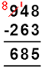
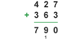

Short multiplication Long multiplication

Short division
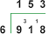

Other activities you could use to support your child in maths:
- Kaboom – a game which can be used to practice their times tables. Ask your child to show you how to play this game – we started using it last year and the children loved it
- Use computer games working on number facts, multiplication facts and number bonds to strengthen number understanding
- Use counters, cubes and other physical objects to help understanding when calculating
For the confident mathematicians
For those children who are extremely confident with maths, I would advise them to start to use these skills on a mastery level, solving a range of puzzles and problems. The nrich, NACE and ncetm websites provide a range of different activities.
Encourage your child to create problems which involve working systematically. Get them to create problems for you to solve.

They also need to develop their ability to reason. Use problems to encourage them to prove a theory right or wrong.
Other techniques I use for this include…prove it; always, sometimes and never true and odd one out.
Finally, encourage children to find mistakes in calculations and give advice on how the mistake could be corrected.

Curriculum
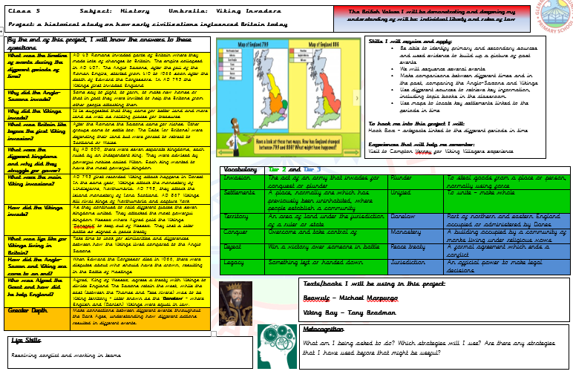
Our first unit this year will be ‘Invaders’. Here we will be learning all about the period in time when the Romans left Britain and the Anglo-Saxons and Vikings invaded. Year 5 will be learning about the battle for kingdoms during this time, Alfred the Great and The Battle of Hastings.

The second half term will be ‘Extreme Earth’ where we will learn more about how the earth forms, tectonic plates and the impact that natural disasters can have upon countries around the world.

You will be sent home our Knowledge Organisers and all our lessons will be based upon this.

Science
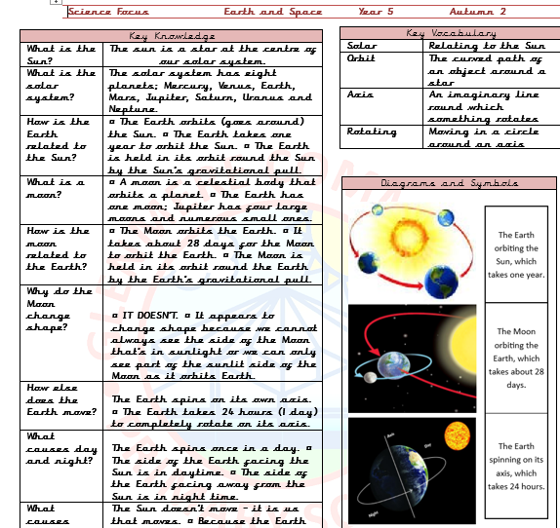
For science we also have Knowledge Organisers. The first half term is ‘forces’ where children will learn about gravity, water and air resistance as well as levers and pulleys. A lot of this will involve practical activities and there will be a big focus on fair testing. The second part of the term is ‘Earth and Space’ and the science behind it, including learning about the sun, Earth and moon and how they relate to each other as well as day and night and how the Earth moves – plus more.

Personal Growth
Our personal growth will focus on ‘Garden to Plate’. This will build upon the work children previously learnt about when in Year 3. The aim of this is to work on developing children’s life skills so here we will be developing skills in relation to growing food and cooking healthy recipes so it will be very hands on (possibly a little messy) but a great session. Then later in the term will be peace and conflict – linked nicely with Remembrance day – developing our own skills with how to deal with conflict in everyday life.

If you want to encourage your child to research linked to our projects, science or personal growth they could do some of the following activities:
- Create a power point based on an element of the curriculum,
- Make a presentation,
- Make a 3d model of planet Earth, the Titanic, a Volcano
- Grow some vegetables in the garden
- Use the vegetables to cook
- Create a parachute to test air resistance, try dropping it from different heights (safely)
- Create a fact file
- Create an information text

Year 5 have PE on a Tuesday, Swimming Wednesday and Tennis/Basketball alternate on Thursday. Children will need to ensure they are wearing the appropriate PE kit. A small reminder that during PE sessions, hair needs to be tied back and all jewellery must be removed, including earrings.

Homework
Like last year, children will be given homework via the Google Classroom Work will be set on a Thursday and it will be based upon the work we are covering in class. The additional homework is aimed to help the children prepare for the amount of homework given in year 6. We do, however, understand that children have clubs after school and do still value these. If children find it difficult and would like support, we will happily run through it with children during lunchtimes. There will be rewards on a weekly basis for those who complete their homework.

I also understand that some elements of the Year 5 curriculum can be challenging so if there are any elements you are unsure on and I haven’t mention them in this letter, please do not hesitate to come and speak to me.

Spelling and Multiplication
Spellings will be given using the Spelling Shed and Multiplication will be given with Times Tables Rockstars – which a letter will be sent out shortly with further details. Children will have their own logins and will be able to practice using different games.

Reading
Children will be given books as usual matched at their reading ability. As well as this, children will also be given the chance to read a book of their own choice - this is called their ‘Reading for Pleasure’ book. These are available in our class library where children can choose books and sign them out – just like a library. Year 5 will be given time to read for pleasure in school.

Recommending Reading Books
As your child grows in confidence with their reading, it is essential that they are given the opportunity to read a wide variety of book. Below of some of my favourites for Year Six children.
- Kensuke’s Kingdom by Michael Morporgo
- Journey to Johannesburg by Beverley Naidoo
- The Lion, The Witch and The Wardrobe by C.S Lewis
- The Invention of Hugo Cabret by Brain Selznick
- Artemis Fowl by Eoin Colfer
- All the David Walliams Books
- Holes by Louis Sachar
- The Considine Curse by Terry Jones
For children who find reading challenging at times, Diary of a Wimpy Kid Doodle Yourself is a great book for getting them engaged as it is a mixture of reading and drawing.

If you have any queries, please do not hesitate to come and speak with us at the start or end of the school day.

Many thanks,
Mrs Carton and Mrs Bushbeck

