By the end of this project, I will know the answers to these questions
What are the main six regions of North America? | Canada, Greenland, United States of America, Mexico, Central America, Caribbean.  There are 38 countries in North America
Countries within the United Kingdom | England, Scotland, Wales and Northern Island
Capital cities of countries in United Kingdom | England – London; Scotland – Edinburgh; Wales – Cardiff; Northern Island; Belfast.  London is the Capital of the UK and where the country is run from
Major physical features of North America | Physical features vary across north America  Rocky mountains, Everglades, Yellowstone national park – geysers, Mississippi river, Great Salt Lake, The Great Lakes
Landscapes in North America | Coastal plains, mountains, mountain ranges, deserts, forest, volcanoes, taiga, wetland, rainforest, glaciers
Major physical features of United Kingdom | Northwest highlands, Mountain ranges  Ben Nevis (Grampian Mountains), Scafell Pike (Lake District – Cumbrian Mountains), Snowdon (Snowdonia)  Snowdonia  The Pennines  Lake district  Dartmoor National Park (wild open moorlands)  Exmoor (moorland, woodland, valleys and farmland)
Landscapes in United Kingdom | Coast, cliffs, moors, shrub lands, forests, woodland, mountains
Climate zone of United Kingdom | Temperate which means moderate rainfall spread across the year or proportion of the year with sporadic drought, mild to warm summers and cool to cold winters
Climate zones of North America | Ice cap, tundra, subarctic, alpine, warm temperate, subtropical, desert, tropical climate
What is the climate like in different climate zones? | Ice cap – polar climate where monthly temperatures don’t exceed 0degrees Celsius  Tundra – very cold and dry (level terrain and devoid of trees)  Subarctic (coniferous forest) – long, usually very cold and dry with snowy winters and short, cool to mild summers  Alpine (mountain) – cold, windy and snowy. Winter from October to May with temperatures below freezing and mild summers  Warm temperate (deciduous forests) –cold winters and warm summers – distinct summer and winter season  Subtropical (grassland) – hot and humid summers and cold to mild winters  Desert – warm to high temperatures with very little rainfall  Tropical (rainforests) – remains similar all year round with high day time temperatures
Why does North America have more climate zones than UK? | North America is the third largest continent in the world, which means it is incredibly large, stretching over the northern hemisphere from the equator, which means its climate will vary. Whereas, the UK is small in comparison, covering a small part of the Earth.
Can you compare North America and the United Kingdom? | Children will be able to make comparisons between different locations, drawing in evidence linked to climate, physical geography and location in relation to Earth
Class 5 Subject: Geography Umbrella: Oceans Apart

Project: a geographical study comparing the physical features of North America and the United Kingdom
The British Values I will be demonstrating and deepening my understanding of will be: rules of law and mutual respect
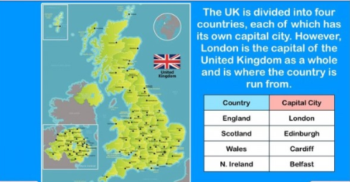
Skills I will require and apply:
- Investigate places with more emphasis on the larger scale. I will collect and record evidence and analyse evidence and draw conclusions.
- Compare maps with aerial photographs, choosing maps for specific purposes.
- Begin to use atlases to find out about other features of places, especially looking at the physical features of the land
- Use relative vocabulary to describe different countries and their physical features.
To hook me into this project I will:
Complete a mapping mystery within school

Experiences that will help me remember:
Use of ICT to read maps, using aerial photographs and concepts like google maps to make the experience more interaction

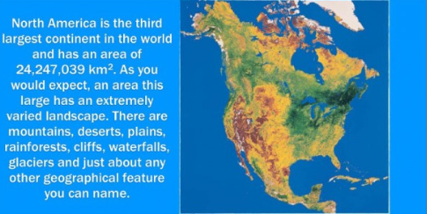

Vocabulary | Tier 2 and Tier 3
Physical features | A natural features of the Earth’s surface e.g. mountains | Moor | An area of open uncultivated upland, usually covered with heather
Landscape | An area of land as one can see it | Plains | A large area of flat land with few trees
Geographical | Based on the physical features of an area | Topographical | Accurate representations of the physical features of an area
Climate | The average measurements of temperature, wind, humidity, snow and rain in a place over the course of years. | Climate zones | Areas with distinct climates
Region | An area of land that has common features | Geographical regions | An area of land that has common physical features
Grasslands | a large open area of country covered with grass | Temperate | A region or climate characterised by mild temperatures

Texts/books I will be using in this project:
Holes – Louis Sachar
Under Earth, Under Water – Aleksandra Mizielinski and Daniel Mizielinski
National Geographic World Atlas
Metacognition
What am I being asked to do? Which strategies will I use? Are there any strategies that I have used before that might be useful?
Life Skills
Key map reading skills, developing understanding of different cultural backgrounds

