By the end of this project, I will know the answers to these questions
What are tectonic plates? | They are the crust of the earth split into parts – a bit like a jigsaw. They are able to move.
What is the ring of fire? | Is a path along the Pacific Ocean with active volcanoes and frequent earthquakes. 90% of the world’s earthquakes occur here.
Which continents are affected by the ring of fire? | North America, South America, Australasia and Asia
How are volcanoes formed? | Volcanoes are formed when magma from within the Earth's upper mantle works its way to the surface. At the surface, it erupts to form lava flows and ash deposits. Over time as the volcano continues to erupt, it will get bigger and bigger
What causes earthquakes? | Earthquakes are usually caused when rock underground suddenly breaks along a fault. This sudden release of energy causes the seismic waves that make the ground shake. When two blocks of rock or two plates are rubbing against each other, they stick a little. They don't just slide smoothly; the rocks catch on each other. The rocks are still pushing against each other, but not moving. After a while, the rocks break because of all the pressure that's built up
How are countries affected by volcanoes and earthquakes | Here we will look in detail at the different impacts, including physical impacts on buildings etc but also impacts on communities
Greater Depth | Explain how the impact from different disasters impacts different communities
 | If you had live in either and earthquake zone or near an volcano, which would you choose and why?
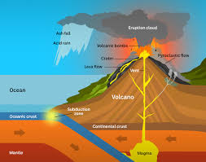
Skills I will require and apply:
- Understanding and using atlases to locate the Ring of Fire, and countries and continents impacted
- Using subject specific vocabulary: northern and southern hemisphere, latitude, longitude and equator
- Geographical skills to locate key locations
- Identify the difference between natural and human features
- Study different recounts and pieces of evidence

To hook me into this project I will:
Take part in a Volcanoes VR workshop

Experiences that will help me remember:
Volcano experiments, including making own volcanic eruptions
Carrying out earthquake drills
Teaching session for parents to end the unit
Class 5 Subject: Geography Umbrella: Extreme Earth

Project: a geographical study on the formation of planet earth
The British Values I will be demonstrating and deepening my understanding of will be: mutual respect of those with different faiths and beliefs

Vocabulary | Tier 2 and Tier 3
Continents | Any of the world’s main expanses of land (seven continents) | Mantel | A layer of rock between the crust and the outer core
Crust | Outer layer of the planet | Active volcano | A volcano which has had at least one eruption during the past 10,000 years
Equator | The equator divides the Earth in the norther and southern hemisphere | Tectonic Plate | Earth’s outer layers is made up of large moving pieces called plates
Dormant | A dormant volcano is an active volcano that is not erupting but supposed to erupt again | Hemisphere | Hemisphere means half (hemi) the earth (sphere)
Earth’s Core | The part of the earth in the middle of our planet | Vortex | A mass of wind or water that spins around so fast that it pulls objects down
Eruption | Pouring out of fumes or lava | Seismic waves | An elastic wave in the earth produced by an earthquake
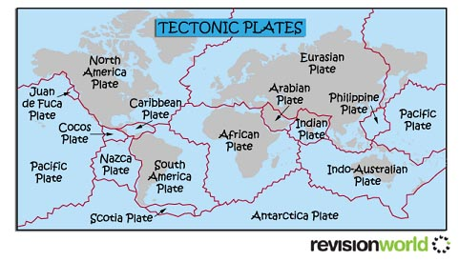
Texts/books I will be using in this project:
Escape from Pompeii – Christina Balit
I survived the destruction of Pompeii – Lauren Tarshis

Life Skills
Environmental responsibility – how do our actions affect the world in which we live in?

Metacognition
What am I being asked to do? Which strategies will I use? Are there any strategies that I have used before that might be useful?

